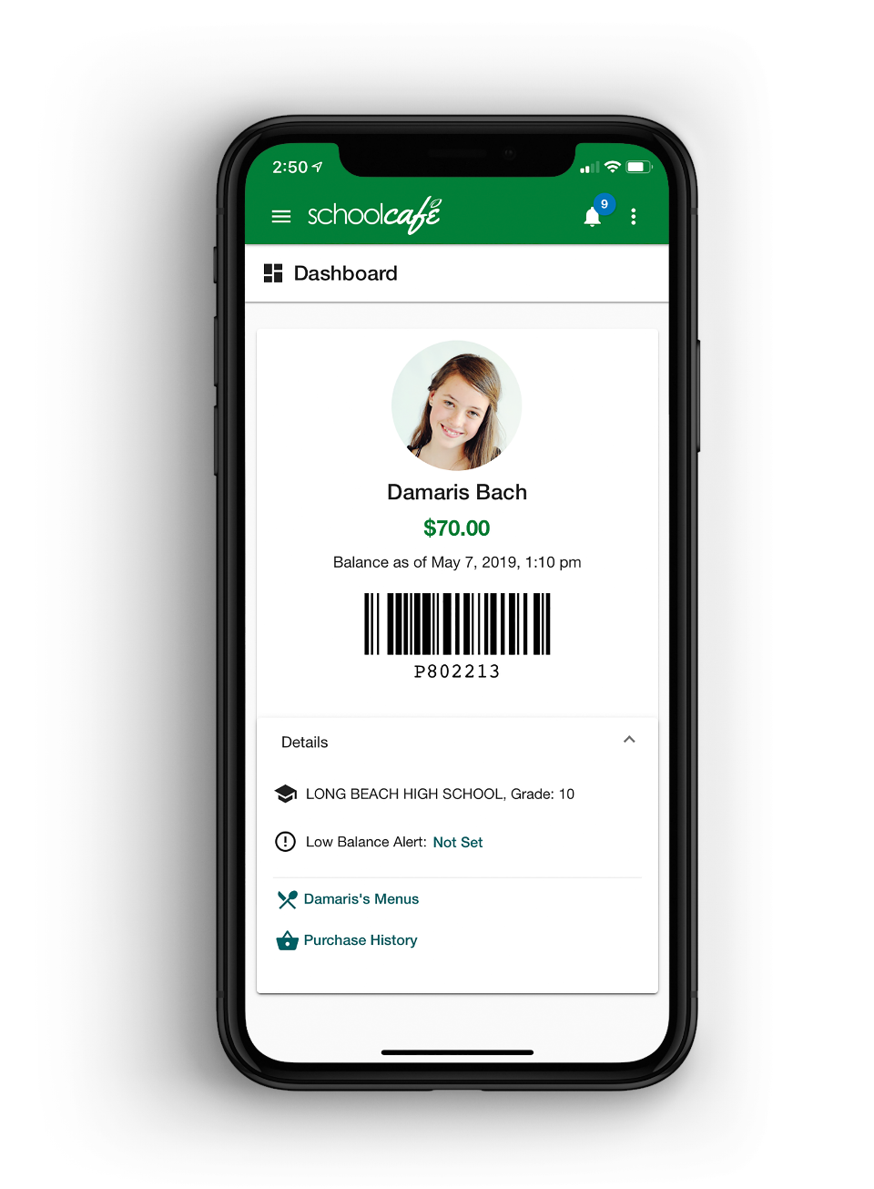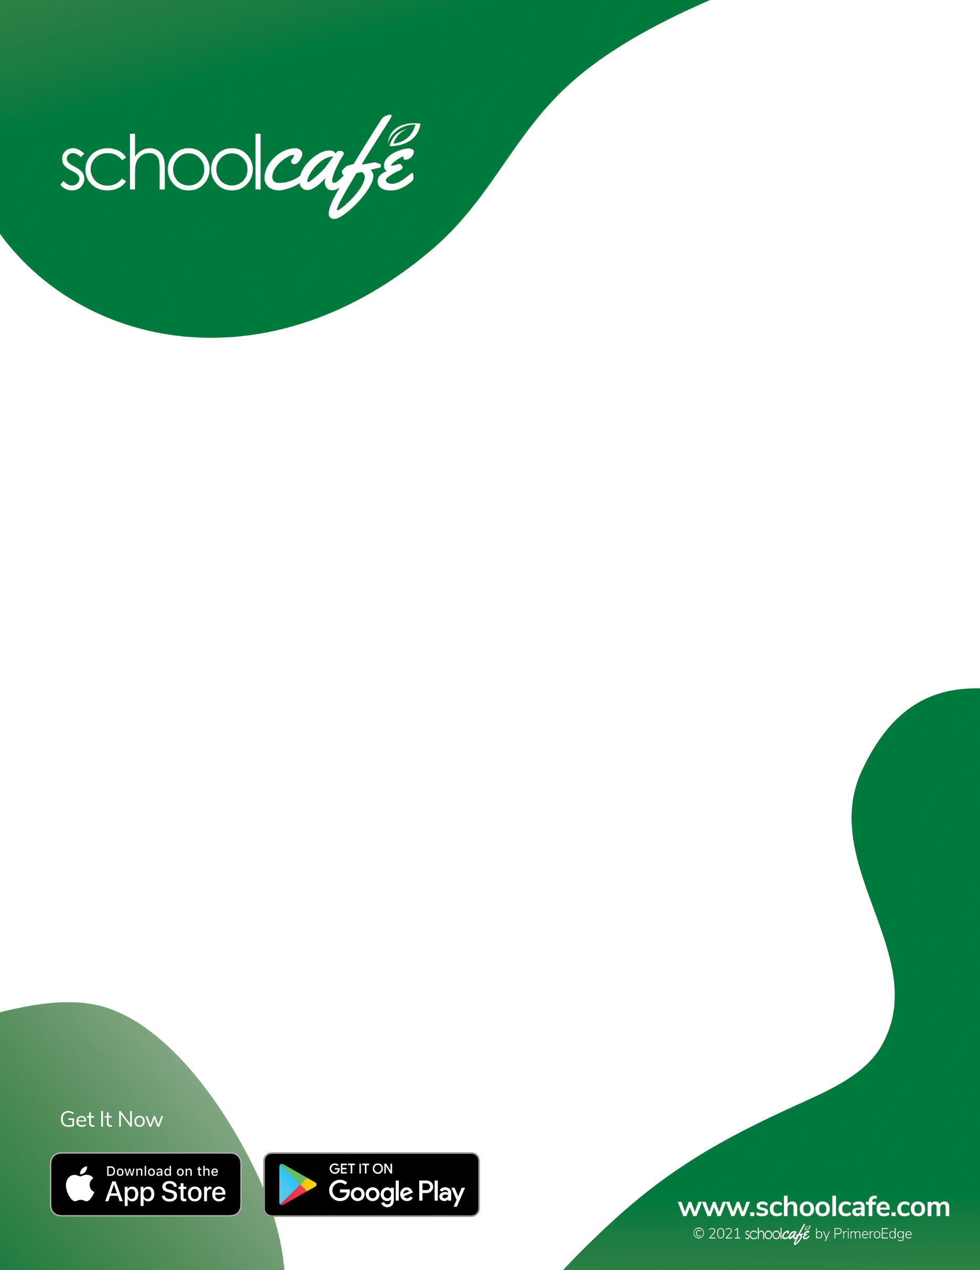 ­­

With email and push notifications, parents can stay on top of their student's account balance. Low balance reminders make sure parents never miss a payment and students always have adequate funds in their account.

**PAYMENTS MADE EASY**

**One app for your entire cafeteria.**