Heart Rate and Physical Fitness
The circulatory system is responsible for the internal transport of many vital substances in humans, including oxygen, carbon dioxide, and nutrients. The components of the circulatory system include the heart, blood vessels, and blood. Heartbeats result from electrical stimulation of the heart cells by the pacemaker, located in the heart’s inner wall of the right atrium. Although the electrical activity of the pacemaker originates from within the heart, the rhythmic sequence of impulses produced by the pacemaker is influenced by nerves outside the heart. Many things might affect heart rate, including the physical fitness of the individual, the presence of drugs such as caffeine or nicotine in the blood, and the age of the person.
As a rule, the maximum heart rate of all individuals of the same age and sex is about the same. However, the time it takes individuals to reach that maximum level while exercising varies greatly. Since physically fit people can deliver a greater volume of blood in a single cardiac cycle than unfit individuals, they can usually sustain a greater work level before reaching the maximum heart rate. Physically fit people not only have less of an increase in their heart rate during exercise, but their heart rate recovers to the resting rate more rapidly than unfit people.
In this experiment, you will evaluate your physical fitness. An arbitrary rating system will be used to “score” fitness during a variety of situations. Tests will be made while in a resting position, in a prone position, as well as during and after physical exercise.
Important: Do not attempt this experiment if physical exertion will aggravate a health problem. Inform your instructor of any possible health problems that might be affected if you participate in this exercise.
Objectives
In this experiment, you will
- Determine the effect of body position on heart rates.
- Determine the effect of exercise on heart rates.
- Determine your fitness level.
- Correlate the fitness level of individuals with factors such as smoking, the amount of daily exercise, and other factors identified by students.
MATERIALS
LabQuest | stepping stool, 45 cm (18 inches) high
LabQuest App | dropper bottle with saline solution
Vernier Hand-Grip Heart Rate Monitor or | (only for use with the Exercise HRM)
Vernier Exercise Heart Rate Monitor

PROCEDURE
Each person in a lab group will take turns being the subject and the tester. When it is your turn to be the subject, your partner will be responsible for recording the data on your lab sheet.
1. Connect the receiver module of the Heart Rate Monitor to LabQuest and choose New from the File menu.
2. On the Meter screen, tap Length. Change the data-collection length to 600 seconds. Select OK.
3. Set up the Heart Rate Monitor. Follow the directions for your type of Heart Rate Monitor.
Using a Hand-Grip Heart Rate Monitor
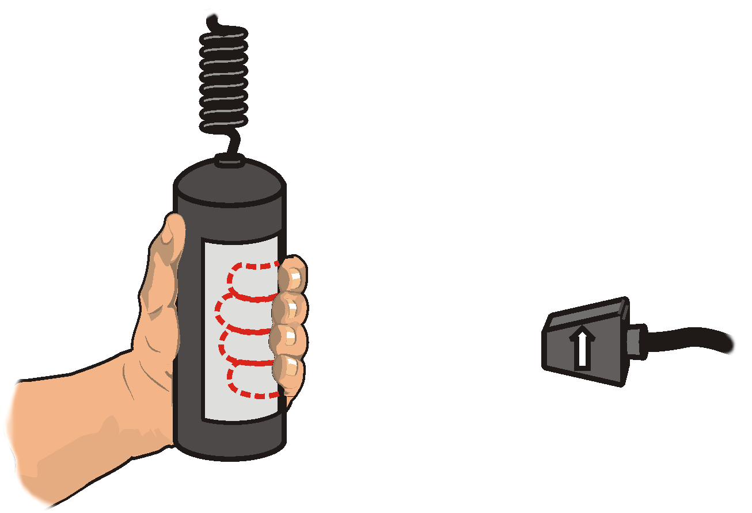
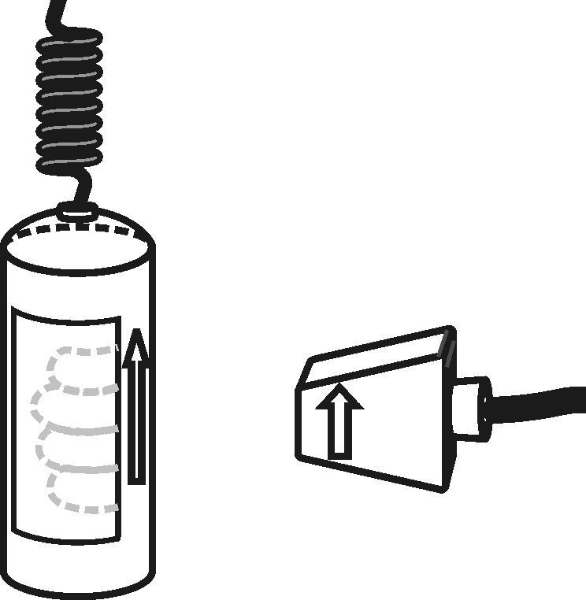
- Grasp the handles of the Hand-Grip Heart Rate Monitor. Place the fingertips of each hand on the reference areas of the handles (see Figure 1).
Figure 1
- The left hand grip and the receiver are both marked with an alignment arrow. When collecting data, be sure that the arrow labels on each of these devices are in alignment (see Figure 2) and that they are not too far apart. The reception range of the plug-in receiver is 80–100 cm, or 3 feet.
Figure 2

Using an Exercise Heart Rate Monitor
Figure 3
- If you have an older sensor that does not auto-ID, manually set up the sensor.
- Depending upon your size, select a small- or large-size elastic strap. Secure one of the plastic ends of the elastic strap to the transmitter belt. It is important that the strap provide a snug fit of the transmitter belt.
- Wet each of the electrodes (the two textured oval areas on the underside of the transmitter belt) with 3 drops of saline solution.
- Secure the transmitter belt against the skin directly over the base of the rib cage (see Figure 3). The POLAR logo on the front of the belt should be centered. Adjust the elastic strap to ensure a tight fit.
- Take the receiver module of the Heart Rate Monitor in your right hand. Remember that the receiver must be within 80 cm of the transmitter in the Heart Rate Monitor belt.

4. Start data collection. Determine that the sensor is functioning correctly. The readings should be consistent and within the normal range of the individual, usually between 55 and 80 beats per minute. When you have determined that the equipment is operating properly, stop data collection and proceed to Step 5.
Standing heart rate
5. Instruct the subject to stand upright for 2 minutes. Start data collection. When the 2 minutes have passed, record the subject’s heart rate in Table 6.
6. Locate the subject’s heart rate in Table 1 and record the corresponding fitness point value in Table 6.
Table 1
Beats/min | Points | Beats/min | Points
60–70 | 12 | 101–110 | 8
71–80 | 11 | 111–120 | 7
81–90 | 10 | 121–130 | 6
91–100 | 9 | 131–140 | 4

Reclining heart rate
7. Instruct the subject to recline on a clean surface or table for 2 minutes. When the 2 minutes have passed, record the subject’s heart rate in Table 6.
8. Locate the subject’s heart rate in Table 2 and record the corresponding fitness point value in Table 6.
Table 2
Beats/min | Points | Beats/min | Points
50–60 | 12 | 81–90 | 8
61–70 | 11 | 91–100 | 6
71–80 | 10 | 101–110 | 4

Heart rate change from reclining to standing
9. Instruct the subject to quickly stand up and remain standing still.
10. Immediately record the subject’s peak heart rate in Table 6.
11. Subtract the reclining rate heart rate recorded in Step 6 from the heart rate in Step 9 to find the heart rate increase after standing. Locate the row corresponding to the reclining heart rate in Table 3 and use the heart rate increase value to determine the proper fitness points. In Table 6, record the fitness points. Stop data collection. Instruct the subject to rest for 2 minutes then proceed to Step 11.
Table 3
Reclining heart rate | Heart rate increase after standing
 | 0–10 | 11–17 | 18–24 | 25–33 | 34+
50–60 | 12 | 11 | 10 | 8 | 6
61–70 | 12 | 10 | 8 | 6 | 4
71–80 | 11 | 9 | 6 | 4 | 2
81–90 | 10 | 8 | 4 | 2 | 0
91–100 | 8 | 6 | 2 | 0 | 0
101–110 | 6 | 4 | 0 | 0 | 0
Step test
12. Start data collection. Before performing the step test, record the subject’s heart rate (Pre-exercise) in Table 6.
13. Perform a step test using the following procedure:
- Place the right foot on the top step of the stool.
- Place the left foot completely on the top step of the stool next to the right foot.
- Place the right foot back on the floor.
- Place the left foot completely on the floor next to the right foot.
- This stepping cycle should take 3 seconds to complete.

14. When five steps have been completed, record the heart rate in Table 6. Quickly move to Step 15.
Recovery rate
15. With a stopwatch or clock, begin timing to determine the subject’s recovery time. During the recovery period, the subject should remain standing and relatively still. Monitor the heart rate readings and stop timing when the readings return to the pre-exercise heart rate value recorded in Step 11. Record the recovery time in Table 6.
16. Stop data collection.
17. Locate the subject’s recovery time in Table 4 and record the corresponding fitness point value in Table 6. If the subject’s heart rate did not return to within 10 beats/min from their pre-exercise heart rate, record a value of 6 points.
Table 4
Time (sec) | Points
0–30 | 14
31–60 | 12
61–90 | 10
91–120 | 8

Step test for endurance
18. Subtract the subject’s pre-exercise heart rate (from Step 11) from their heart rate after 5 steps of exercise. Record this heart rate increase in the endurance row of Table 6.
19. Locate the row corresponding to the pre-exercise heart rate in Table 5 and use the heart rate increase value to determine the proper fitness points. In Table 6, record the fitness points.
Table 5
Pre-exercise  heart rate | Heart rate increase after exercise
Pre-exercise  heart rate | 0–10 | 11–20 | 21–30 | 31–40 | 41+
60–70 | 12 | 12 | 10 | 8 | 6
71–80 | 12 | 10 | 8 | 6 | 4
81–90 | 12 | 10 | 7 | 4 | 2
91–100 | 10 | 8 | 6 | 2 | 0
101–110 | 8 | 6 | 4 | 1 | 0
111–120 | 8 | 4 | 2 | 1 | 0
121–130 | 6 | 2 | 1 | 0 | 0
131+ | 5 | 1 | 0 | 0 | 0

20. Total all the fitness points recorded in Table 6. Determine the subject’s personal fitness level using the scale below.

DATA
Table 6
Condition | Rate or time | Points
Standing heart rate | beats/min
Reclining heart rate | beats/min
Reclining to standing | beats/min
Pre-exercise heart rate | beats/min
After 5 steps | beats/min
Recovery time | seconds
Endurance | beats/min
 |  | Total points:

QUESTIONS
1. How did your heart rate change after moving from a standing position to a reclining position? Is this what you expected? How do you account for this?
2. How did your heart rate change after moving from a reclining position back to a standing position? Is this what you expected? How do you account for this?
3. Predict what your heart rate might be if you had exercised for twice the length of time that you actually did. Explain.
4. How does your maximum heart rate compare to other students in your group. Is this what you expected? How do you account for this?
5. Why would athletes need to work longer and harder before their heart rates were at the maximum value?
6. How do you evaluate your physical fitness? Do you agree with the rating obtained from this experiment? Explain.
7. Current research indicates that most heart attacks occur as people get out of bed after sleep. Account for this observation.

Extension
1. Using a sphygmomanometer, learn how to measure blood pressure. Compare a person’s blood pressure when reclining, to that of the same person immediately after standing from a reclined position. Relate the change in blood pressure to the heart rate values measured when going from reclining to standing.
2. Design an anonymous survey to be taken by each member of your class. In the survey, ask questions that you think might influence the test results. Examples might include:
- Did you have more than 6 hours of sleep last night?
- Do you smoke? If so, how many packs per week do you smoke?
- Gender? Age?

3. Try to determine whether any of the variables from your survey show a statistical link to fitness. You may want to use a statistical T-Test to determine whether a relationship between the variable and physical fitness is due to chance.

