Monitoring EKG
An electrocardiogram, or EKG, is a graphical recording of the electrical events occurring within the heart. A typical EKG tracing consists of five identifiable deflections. Each deflection is noted by one of the letters P, Q, R, S, or T. The P wave is the first waveform in a tracing and represents the depolarization of the heart’s atria. The next waveform is a complex and consists of the Q, R, and S deflection. The QRS complex represents the depolarization of the heart’s ventricles. The deflection that represents the repolarization of the atria is usually undetectable because of the intensity of the QRS waveform. The final waveform is the T wave and it represents the repolarization of the ventricles.
Because an EKG is a recording of the heart’s electrical events, it is valuable in diagnosing diseases or ailments that damage the conductive abilities of the heart muscle. When cardiac muscle cells are damaged or destroyed, they are no longer able to conduct the electrical impulses that flow through them. This causes the electrical signal to terminate at the damaged tissue or be directed away from the flow of the signal. The termination or redirection of the electrical signal will alter the manner in which the heart contracts. A cardiologist can look at a patient’s electrocardiogram and determine the presence of damaged cardiac muscle based on the time interval between electrical events.
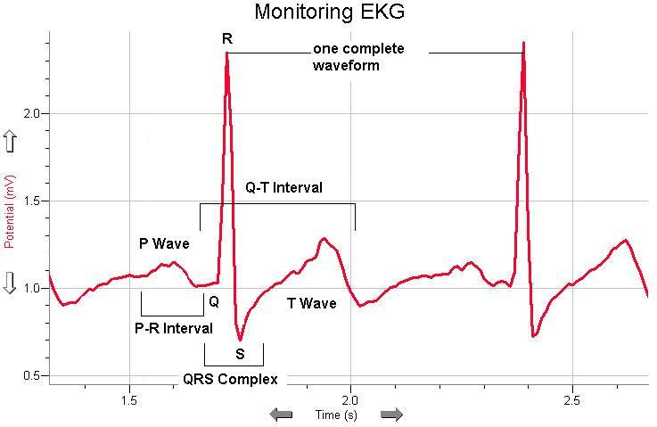
In this activity, you will use the EKG Sensor to make a two-second graphical recording of your heart's electrical events. From this recording, you will identify the previously mentioned waveform components and determine the time intervals associated with each.
Figure 1

Objectives
In this experiment, you will
- Use the EKG Sensor to graph your heart’s electrical activity.
- Determine the time interval between EKG events.
- Calculate heart rate based on your EKG recording.
MATERIALS
LabQuest | Vernier EKG Sensor
LabQuest App | disposable electrode tabs

Figure 2
PROCEDURE
1. Connect the EKG Sensor to LabQuest and choose New from the File menu. If you have an older sensor that does not auto-ID, manually set up the sensor.
2. Attach three electrode tabs to your arms, as shown in Figure 2. A single tab should be placed on the inside of the right wrist, on the inside of the right upper forearm (below elbow), and on the inside of the left upper forearm (below elbow).
3. Connect the three sensor leads to the electrode tabs as shown in Figure 2. Sit in a reclined position in a chair or lay flat on top of a lab table. Your arms should be hanging at the side unsupported.
4. Another member of the lab group should start data collection.
5. Once data have been collected, a graph will be displayed. To examine the data pairs on the displayed graph, tap any data point. As you tap each data point, the voltage and time values of each data point are displayed to the right of the graph. For at least two heartbeats, identify the various EKG waveforms using Figure 3 on the next page and determine the time intervals listed below. Record the average for each set of time intervals in Table 1.
- P-R interval: time from the beginning of P wave to the start of the QRS complex.  - QRS interval: time from Q deflection to S deflection.  - Q-T interval: time from Q deflection to the end of the T wave. | 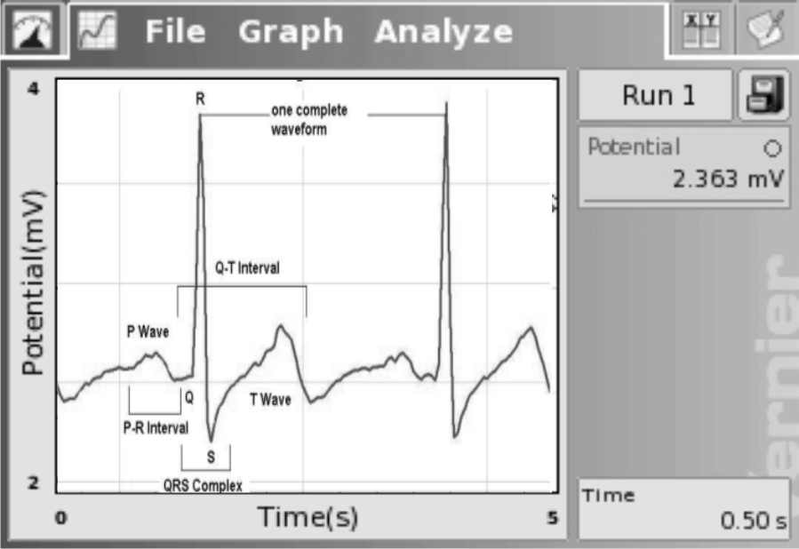  Figure 3
6. Calculate the heart rate in beats/min using the EKG data. Record the heart rate in Table 1.
7. If your EKG was unsatisfactory, repeat Steps 4–6.
8. (optional) Print a copy of your EKG graph. Identify and label the various waveforms on the graph. For a better resolution graph, import the data into Logger Pro and print your graph.

DATA
Table 1
Interval | Time (s)
P - R
QRS
Q - T
Heart Rate | ___________ beats/min

Table 2
Standard resting electrocardiogram interval times
P - R interval | 0.12 to 0.20 s
QRS interval | less than 0.10 s
Q - T interval | 0.30 to 0.40 s

QUESTIONS
1. The electrocardiogram is a powerful tool used to diagnose certain types of heart disease. Why is it important to look at the time intervals of the different waveforms?
2. What property of heart muscle must be altered in order for an EKG to detect a problem? Explain.
3. Based on what you have learned regarding electrocardiograms, can they be used to diagnose all heart diseases or defects? Explain.
4. Describe a cardiovascular problem that could be diagnosed by a cardiologist using an electrocardiogram.

EXTENSION
Using data collected with the EKG Sensor, it is possible to determine a more accurate maximum heart rate value for an individual. The commonly used formula for calculating maximum heart rate is:
220 bpm – Individual’s Age = Max Heart Rate
While this formula is sufficient for general purposes, it fails to take into account physical differences such as size, and fitness level. For example, an individual that engages in regular exercise will likely have a heart that operates more efficiently due to the effects of athletic training.
To calculate your maximum heart rate, do the following:
- Run in place or perform some type of exercise, such as jump-n-jacks, for 1 minute.
- Repeat Steps 1–7 to collect and analyze your electrocardiogram. When analyzing the data in Step 7, only determine the average Q-T interval.
- Divide 60 seconds by the Q-T interval to calculate your maximum heart rate.

