Oxygen Gas and
Human Respiration
The process of breathing accomplishes two important tasks for the body. During inhalation, oxygen-rich air is brought into your lungs. During exhalation, air depleted in oxygen and rich in carbon dioxide is forced out. Oxygen is then transported to the cells where it is used in the process of respiration, yielding carbon dioxide as a product.
C₆H₁₂O₆ + 6 O₂ → 6 CO₂ + 6 H₂O + energy
glucose oxygen carbon water
dioxide
Gas exchange takes place in the lungs at the membrane between the alveoli and the pulmonary capillaries. It is here that oxygen diffuses into the bloodstream and carbon dioxide diffuses out. Under normal circumstances, there is an equilibrium between the oxygen and carbon dioxide levels in the blood. Several mechanisms are involved in maintaining this balance. One such mechanism involves chemoreceptors. These specialized cells respond to changes in carbon dioxide, oxygen and H⁺ concentrations and influence the body’s ventilation patterns to maintain the proper balance of blood gases.
In this experiment, you will determine what factors affect how long you can hold your breath. You will be tested under two different conditions. The first condition is normal breathing. The second condition is immediately following hyperventilation. Hyperventilation is when your breathing rate is greater than what is necessary for proper exchange of oxygen and carbon dioxide. This will be achieved by a period of rapid breathing prior to holding your breath.
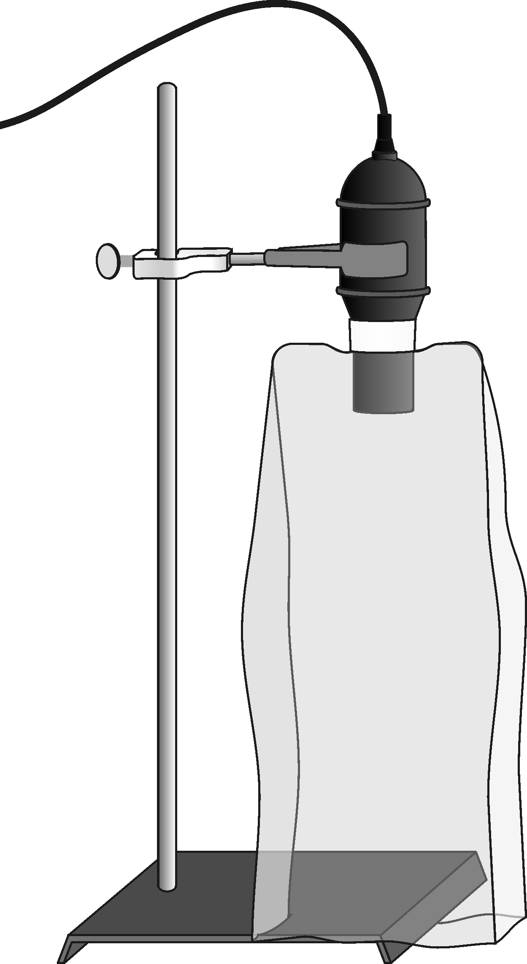
Figure 1
MATERIALS
LabQuest | ring stand
LabQuest App | test tube clamp
Vernier O₂ Gas Sensor | bread bag
Preliminary questions
1. How long do you think you can hold your breath?
2. When you hold your breath, what do you think happens to the oxygen concentration in your lungs? Explain.
3. When you hold your breath, what do you think happens to the carbon dioxide concentration in your lungs? Explain.
4. On average, people can hold their breath for a minute. What do you think prevents people from holding their breath for 2 or 3 minutes?

PROCEDURE
Each person in a lab group will take turns being the subject and the tester. When it is your turn to be the subject, your partner will be responsible for operating the equipment.
1. Secure the O₂ Gas Sensor using a test tube clamp and ring stand as shown in Figure 1. The plastic bread bag should already be taped to the sensor.
2. Connect the O₂ Gas Sensor to LabQuest and choose New from the File menu. If you have an older sensor that does not auto-ID, manually set up the sensor.
3. On the Meter screen, tap Rate. Change the data-collection rate to 1 sample/second and the data-collection length to 120 seconds.
4. When you begin collecting data, it is important that data collection begins at the same point the subject begins to hold his breath.
- Have your lab partner take a deep breath and hold it. Immediately start data collection. Your lab partner should hold his or her breath as long as possible.
- When your lab partner can no longer hold his or her breath, he or she should blow his or her breath into the bread bag and twist the open end shut. This should result in the bread bag filled with the air your lab partner was holding in his or her lungs. Allow data collection to proceed for the full 2 minutes.
- When data collection has finished, open the bread bag and pull it back over the sensor exposing the sensor to room air. Leave the bag in that position until you are prepared to collect data again.
- Examine the graph. To examine the data pairs on the displayed graph, tap any data point. As you tap each data point, the oxygen concentration and time values of each data point are displayed to the right of the graph.
- Using the graph, determine how long your lab partner’s breath was held as well as the maximum and minimum oxygen concentration. Record your data in Table 1.

5. Store the data from the first run by tapping the File Cabinet icon.
6. Collect data following mild hyperventilation.
- Pull the bread bag back down off of the sensor in preparation for data collection.
- Have your lab partner take 10 quick deep breaths, forcefully blowing out all air after each breath. Your lab partner should then take an 11th breath and hold it. Immediately start data collection. Your lab partner should again hold his or her breath as long as possible.
- When your lab partner can no longer hold his or her breath, he or she should blow his or her breath into the bread bag and twist the open end shut. This should result in the bread bag filled with the air your lab partner was holding in his or her lungs. Allow data collection to proceed for the remainder of the data-collection period.
- When data collection is complete, open the bread bag and pull it back over the sensor exposing the sensor to room air.
- Using the graph, determine how long your lab partner’s breath was held as well as the maximum and minimum oxygen concentrations. Record your data in Table 1.

7. Graph both runs of data on a single graph.
- Tap Run 2 and select All Runs. Both runs will now be displayed on the same graph.
- Examine the data points along the displayed curves. As you tap each data point, the oxygen concentration and time values of both Run 1 and Run 2 are displayed to the right of the graph.
- Use the displayed graph and the data in Table 1 to answer the questions below.

DATA
Table 1
 | Breath  held  (s) | Maximum O₂ concentration (%) | Minimum O₂ concentration (%) | Change in oxygen  (%)
Normal
Hyperventilation

QUESTIONS
1. Did the oxygen concentration change as you expected? If not, explain how it was different.
2. Did the amount of time you held your breath change after hyperventilation (taking the 10 quick breaths)? If so, did the time increase or decrease? Explain.
3. After hyperventilation, was the resulting concentration of oxygen in your exhaled breath higher or lower than in the first attempt? How much did it change? What do you contribute this to?
4. On the first trial, what do you believe forced you to start breathing again?
5. On the second trial, what do you believe forced you to start breathing again?
6. Based on your answers to questions 4 and 5, does the concentration of oxygen or carbon dioxide have a greater influence on how long one can hold his breath?

