**Chemistry IB – Organic Chemistry Notes**

- Organic Chemistry

- organic chemistry—the study of molecular compounds containing

CARBON

- most organic molecules also contain H, O, N, S, P or the halogens

- organic molecules contain COVALENT BONDS (sharing electrons)

- not all sharing of electrons is equal (which is determined by the

ELECTRONEGATIVITY of the atoms sharing) and can produce POLAR

BONDS

- organic chemistry uses condensed structural formulas called LINE

DRAWINGS (represents the basic structural formula but does NOT show C

or H atoms)

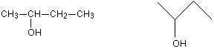

- in a LINE DRAWING, anywhere that LINES END or LINES CONNECT is a

CARBON ATOM (unless some other atom is specifically drawn in)

- also EACH CARBON MUST form FOUR BONDS, so since each line

represents a bond, any missing lines would represent bonds to

HYDROGEN

- Alkanes:

- ALKANE—compounds that contain ONLY C—C and C—H bonds (ALL of

which are SINGLE BONDS!!)

- General Formula: **CnH2n+2**

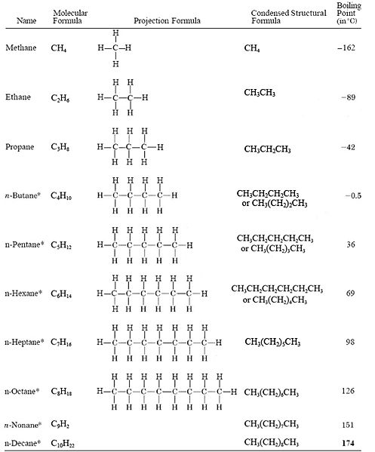

- Naming Alkanes:

- the alkane is named for the LONGEST continuous chain of Carbon atoms

(PARENT CHAIN)

- numbers are assigned to each carbon in the parent chain starting on the

side that is the nearest to the first point of branching

- substituent groups are named and numbered according to their position

on the parent chain

—CH3 (methyl) —CH2CH3 (ethyl) —CH2CH2CH3 (propyl)

- substituent groups are named ALPHABETICALLY

- the alkane always ends in “-ANE”

- Cycloalkanes:

- CYCLOALKANE—alkanes in which the carbons are connected in a RING

structure

- General Formula: CnH2n

- 2 H atoms are ELIMINATED when the end C atoms join together

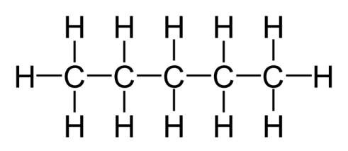 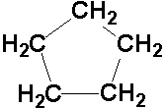

- Alkenes:

- ALKENE—an organic molecule that contains at least ONE C=C (DOUBLE

BOND!!)

- General Formula: **CnH2n**

- names end in “-ENE”

- Alkynes:  
 - ALKYNE—an organic molecule that contains at least ONE CΞC (TRIPLE

BOND!!)

- General Formula: **CnH2n-2**

- names end in “-YNE”

- Naming Alkenes & Alkynes:

- PARENT CHAIN = the longest continuous C chain containing the C=C or

CΞC

- number the chain starting at the end NEAREST the C=C or CΞC (if distance

is the SAME, then start numbering at side nearest first branch point)

- list substituents ALPHABETICALLY with their numbers

- the C=C or CΞC is numbered using the carbon with the LOWEST number in

the bond

- if there is MORE THAN ONE C=C or CΞC, then the compound is referred to   
 as –*diene* or –*triene* and so forth

- Functional Groups:

- organic molecules are classified according to their FUNCTIONAL GROUPS

(substituted atoms where the REACTIONS OCCUR)

A. HALOALKANES (ALKYL HALIDES)

- **R—X** (where X = F, Cl, Br, I)

- F = fluoro- Cl = chloro- Br = bromo- I = iodo-

- NAME: number carbon chain so X has lowest number / use prefix /

name the alkane chain

- can be synthesized by FREE RADICAL HALOGENATION

or by HYDROHALOGENATION of an ALKENE

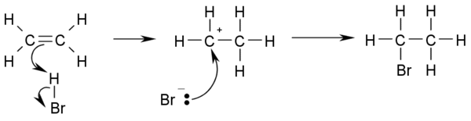

B. ALCOHOLS

- **R—OH**

- NAME: number carbon chain so C—OH has lowest possible

number / root name of alkane chain + ending “-OL”

- can be synthesized by NUCLEOPHILIC SUBSTITUTION of R—X

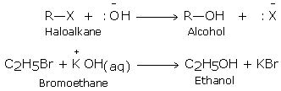

- can also be formed by HYDRATION (adding water) of an alkene

hydration of alkenes

C. ETHERS

- **R—OR’**

- NAME: find longest C chain / prefix + OR’ becomes “alkOXY-“

where alk is the smaller chain prefix

- COMMON NAME: name R and R’ alphabetically as alkyl groups +

“ether”

- synthesis of ethers can occur by SN2 of an ALKOXIDE ION (RO-) on

an ALKYL HALIDE (RX)

**RO- + R’—X 🡪 R’—O—R + X-**

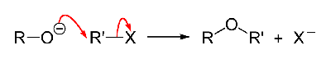

- synthesis of ether can also occur by DEHYDRATION of ALCOHOL

Preparation of ether

**R—O—H + R’—O—H 🡪 R—O—R’ + H—O—H**

- Ethers are fairly unreactive which make them very good solvents

for other reactions

- Have a tendency to spontaneously form PEROXIDES (explosive!!)

D. Aromatic Hydrocarbons

- AROMATIC—class of ring shaped molecules that have a structure

based on BENZENE (C6H6)

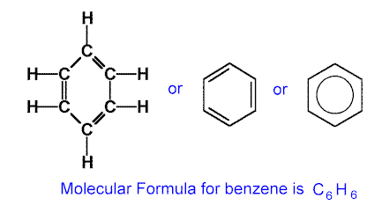

- BENZENE has a resonance structure so the double bond electrons

are DELOCALIZED

- NAME: for monosubstituted “substituent”-BENZENE

(bromobenzene, chlorobenzene, etc.)

- for disubstituted, you can number the C in the benzene ring or use

PREFIXES

1) ortho- = 1,2

2) meta- = 1,3

3) para- = 1,4

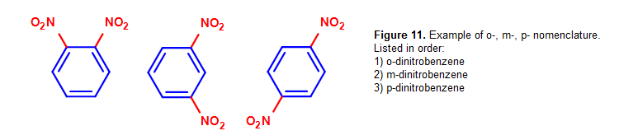

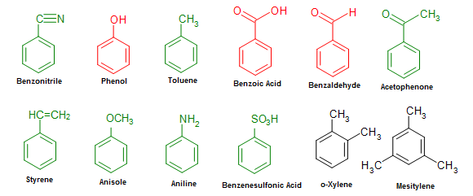

E. AMINES

- AMINE—an organic compound that is derived from ammonia (NH3)

- **R—NH2**

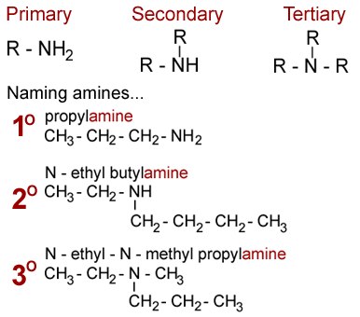

- amines are named just like alcohols but the “-ol” ending is replaced

by “-AMINE”

- another way of naming is to use the prefix “AMINO-” if there are

other substituents that have to be named also

- since the N has a LONE PAIR of electrons it can accept a proton

from another molecule and act as a BRONSTED or LEWIS BASE

- synthesis of amines happens by reducing other compounds

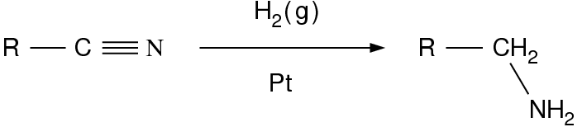

F. ALDEHYDES & KETONES

- ALDEHYDYE: **R—CO—H**

- KETONE: **R—CO—R’**

- aldehydes and ketones have a CARBONYL CARBON (C=O) as a part

of their functional group

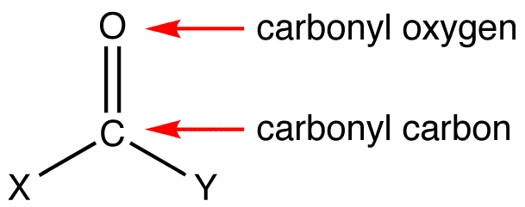

- naming aldehydes: “prefix of substituent (R) name-” + “-aldehyde”

- naming ketones: “name of R and R’” (in order of increasing mass)

as ALKYL GROUPS + “KETONE”

- IUPAC names of aldehydes have the ROOT of the R chain with the

ending “-al”

- IUPAC names of ketones have the C=O numbered (lowest #) named

for the longest continuous C chain and the ending “-one”

- Ketones may be synthesized by oxidation of 2o ROH

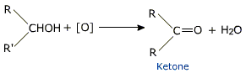

- Ketones may also be synthesized by DEHYDROGENATION

(loss of H2) of a 2o ROH

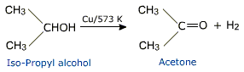

G. CARBOXYLIC ACIDS

- **R—COOH**

- acts as an acid!!

- RCOOH 🡪 H+ + RCOO-

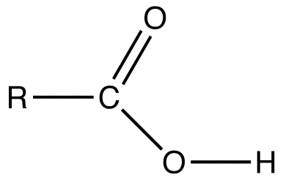

**Carboxylic acids used in 
this experiment**

- Names of Carboxylic acids 🡪 name the longest carbon chain as an

ALKYL group prefix + “-OIC ACID”

H. ESTERS

- **R—CO—O—R’**

- NAME: Esters are named after the alcohol and carboxylic acids that

they are derived from (SEE REACTION #1 above for reactions of

Carboxylic acids!!!)

- the ALKYL GROUP (R’) from the ALCOHOL is named first followed by

the name of the CARBOXYLIC ACID (R—CO) ending in “-OATE” or

just “-ATE”

[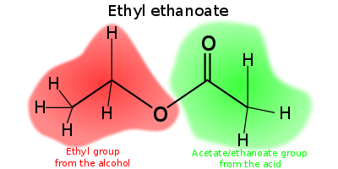](http://en.wikipedia.org/wiki/File:Ethylethanoate-parts.svg)