**Chemistry IA—Chemical Reactions**

- **Describing Chemical Change:**

- in chemical reactions reactants form products

- bonds are broken and reformed (matter is REARRANGED)

- Reactants 🡪 Products

- **Word Equations**—reactants are written (NAME) to the left of the

arrow and products (NAME) to the right

- *Iron + Oxygen 🡪 Iron (II) oxide*

*- Hydrogen peroxide 🡪 Water + Oxygen*

*- Methane + Oxygen 🡪 Carbon dioxide + Water*

- **Chemical Equations**—use SYMBOLS and FORMULAS instead

of words

*-*  *Fe(s) + O2(g) 🡪 Fe2O3(s)*

*- H2O2(aq) 🡪 H2O(l) + O2(g)*

*- CH4(g) + O2(g) 🡪 CO2(g) + H2O(l)*

***- s = solid; l = liquid; aq=aqueous solution; g=gas***

- **BALANCING CHEMICAL EQUATIONS:**

- atoms cannot be created or destroyed, so you MUST make sure that

there are the SAME NUMBER of each atom on BOTH SIDES of

the equation

- \*\*\*\*\****YOU CANNOT CHANGE***

***SUBSCRIPTS TO BALANCE A CHEMICAL REACTION!!!!***\*\*\*\*\*

- **Coefficients**—small whole numbers placed in front of the chemical

formula in order to balance a chemical reaction

*-* ***4*** *Fe(s) +* ***3*** *O2(g) 🡪* ***2*** *Fe2O3(s)*

*-* ***2*** *H2O2(aq) 🡪* ***2*** *H2O(l) + O2(g)*

*- CH4(g) +* ***2*** *O2(g) 🡪 CO2(g) +* ***2*** *H2O(l)*

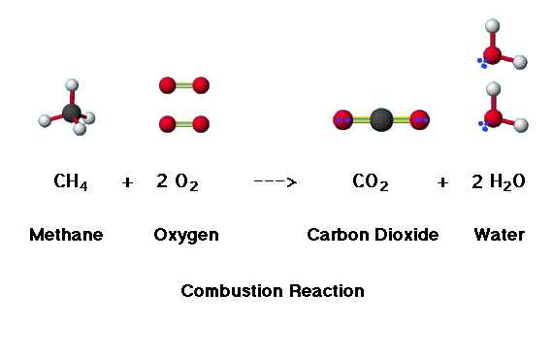

- **Helpful Hints:**

1) Make SURE that you have the ***correct chemical formula*** for

all reactants and products

2) Begin balancing elements that only appear in ***ONE formula***

on either side of the reaction

3) Elements like O may appear in several different compounds

on both sides—***balance O LAST***!

4) Make sure you ***DOUBLE CHECK all atoms*** when you are

done (balancing one element in a compound will affect all

other elements in that compound)

5) Be sure that all COEFFICENTS are in the ***smallest whole***

***number ratio***

- **Balancing Equations by the ALGEBRAIC METHOD**:

- useful for difficult equations that are not working by the sight

method

- CH4 + O2 🡪 CO2 + H2O

- **STEP 1:** *Write the given equation with LETTERS for the*

*coefficients*

***a*** CH4 + ***b*** O2 🡪 ***c*** CO2 + ***d*** H2O

- **STEP 2:** *For every type of ATOM, write an algebraic equation*

*using the coefficient letters as variables*

C: a = c

H: 4a = 2d

O: 2b = 2c + d

- **STEP 3:** *Pick the easiest letter from the equations and assume that*

*letter is equal to 1*

assume a = 1

- **STEP 4:** *Substitute and solve for all the other variables*

*(coefficients)*

if a=1 then c=1 because a=c

and since 4a = 2d, 4(1)=2d so d = 2

then substitute in the equation for O:

2b = 2c + d

2b = 2(1) + 2

2b = 4

b = 2

so a=1, b=2, c=1, and d=2

- **STEP 5:** *Replace the letters with the numbered coefficients in the*

*chemical equation*

CH4 + ***2*** O2 🡪 CO2 + ***2*** H2O

- **STEP 6:** *Double check to see that it is balanced*

C 🡪 1 atom on both sides

H 🡪 4 atoms on both sides

O 🡪 4 atoms on both sides

- **Types of Chemical Reactions:**

- although there are many possibilities of combining and reacting

compounds, all reactions can be classified into one of 5 basic

categories

- this allows us to make predictions about what the products will be

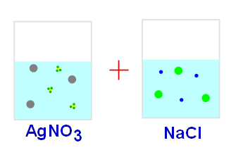

**= ?**

- **5 types of reactions:**

**1) Combination (SYNTHESIS) reaction**—2 or more simple

substances combine to form ONE more complex product

- general form: **A + X 🡪 AX**

- A and X may be elements or simple compounds

- AX is a compound

- 2 K(s) + Cl2(g) 🡪 2 KCl(s)

- H2O(l) + CO2(g) 🡪 H2CO3(aq)

- CaO(s) + H2O(l) 🡪 Ca(OH)2(aq)

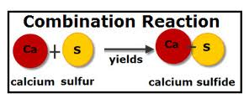

**2) Decomposition reaction**—ONE single compound is broken

down into 2 or more simpler products

- general form: **AX 🡪 A + X**

- A and X may be elements or simple compounds

- AX is a compound

- CaCO3(s) 🡪 CaO(s) + CO2(g)

- H2CO3(aq) 🡪 H2O(l) + CO2(g)

- 2 HgO(s) 🡪 2 Hg(l) + O2(g)

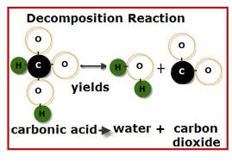

**3) Single Replacement reaction**—one element replaces

another element in a compound

- general form: **A + BX 🡪 AX + B**

- A is a stronger element in the ACTIVITY SERIES

- B is a weaker element in the ACTIVITIY SERIES

- AX and BX are compounds

- need to consult the activity series to see if the reaction

will occur or not

- *THE STRONGER ELEMENT ALWAYS ENDS UP*

*IN THE COMPOUND!!!!*

- Mg(s) + Zn(NO3)2(aq) 🡪 Mg(NO3)2(aq) + Zn(s)

- Mg(s) + LiNO3(aq) 🡪 *no reaction*

- Mg is HIGHER (STRONGER) on the activity series

than Zn so it replaces Zn in the compound, BUT Mg is

LOWER (WEAKER) than Li so Li STAYS in the

compound and that reaction does NOT OCCUR

- nonmetals can also replace nonmetals

- F2 + 2 NaCl 🡪 2 NaF + Cl2

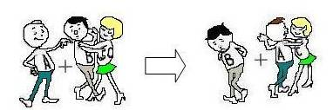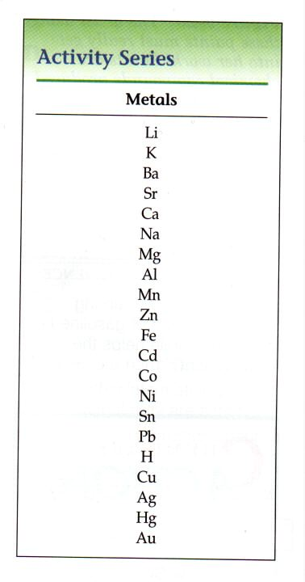

**4) Double Replacement reaction**—involve an exchange of

positive ions between 2 reacting ionic compounds in

aqueous solution

- general form: **AX + BY 🡪 BX + AY**

- all are ionic compounds

- usually occurs in aqueous solution

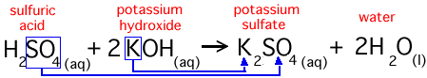

- for double replacement reactions, one of the following

is usually true:

1) formation of a **PRECIPITATE** (ionic

compound that will NOT dissolve in water)

Na2S(aq) + Cd(NO3)2(aq) 🡪 CdS(s) + 2 NaNO3(aq)

2) formation of a **GAS** product that bubbles out of

solution

2 NaCN(aq) + H2SO4(aq) 🡪 Na2SO4(aq) + 2 HCN(g)

3) formation of a **molecular compound** (such as

water)

Ca(OH)2(aq) + 2 HCl(aq) 🡪 CaCl2(aq) + 2 H2O(l)

**5) Combustion reaction**—an element or compound reacts

with Oxygen often producing heat and light

- general form: **A + O2 🡪 AxOy**

- A is an element or compound

- 2 Mg(s) + O2(g) 🡪 2 MgO(s)

- S(s) + O2(g) 🡪 SO2(g)

- C3H8(g) + 5 O2(g) 🡪 3 CO2(g) + 4 H2O(g)

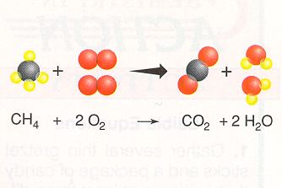

5 Types of Reactions:

**Combination/Synthesis**

A + X 🡪 AX

**Decomposition**

AX 🡪 A + X

**Single Replacement**

A + BX 🡪 AX + B

**Double Replacement**

AX + BY 🡪 AY + BX

**Combustion**

A + O2 🡪 AxOy