**Chemistry IB – Acid/Base Chemistry Notes**

**- Properties of Acids:**

1) taste sour (Latin *acere* “sour”)

2) turn litmus paper RED

3) react with active metals to form H2 gas

4) conduct electric current in aqueous solution

5) react with bases to form a salt and water (neutralization)

**- Properties of Bases:**

1) taste bitter

2) turn litmus paper BLUE

3) feel slippery (actually react with oils from the skin that reduces the

friction as you rub your fingers together!!)

4) conduct electric current in aqueous solution

5) react with acids to form a salt and water (neutralization)

- **Acid/Base Theories:**

- most theories of acids and bases are defined in terms of each other

- there are 3 theories (each one is needed to give a complete definition of

an acid or a base)

**1) Arrhenius Theory:**

- **acid** – produces H+ in aqueous solution

**HA 🡪 H+ + A**-

- **base** – produces OH- in aqueous solution

**XOH 🡪 X+ + OH-**

- problems with Arrhenius Theory:

- does not take into account the SOLVENT (HCl will NOT

dissociate in benzene but does dissociate very well in

water!!)

- does NOT accurately predict the acidity/basicity of SALTS

- does NOT account for AMMONIA (NH3)

- H+ do NOT really exist in aqueous solution!!! (they will react

with water!!)

**H+ + H2O 🡪 H3O+** (hydronium ion)

**2) Bronsted-Lowry Theory:**

- **acid**—a proton (H+) DONOR

- **base** – a proton (H+) ACCEPTOR

- always react TOGETHER (in pairs!!) {can’t have one without the

other}

- **conjugate acid**—substance formed when a Bronsted-Lowry BASE

accepts a proton

- **conjugate base**—substance formed when a Bronsted-Lowry ACID

donates a proton

- the ACID forms a conjugate base

- the BASE forms a conjugate acid

**A + B 🡪 CA + CB**

HCl + H2O 🡪 H3O+ + Cl-

NH3 + H2O 🡪 NH4+ + OH-

- according to Bronsted-Lowry theory, water is AMPHOTERIC (can act

as either an acid or a base)

- Problems with Bronsted-Lowry theory:

- does not explain acid-base behavior in APROTIC solvents (like   
 benzene)

**3) Lewis Theory**

- **acid**—electron pair ACCEPTOR in order to form a coordinate

covalent bond

- **base**—electron pair DONOR in order to form a coordinate covalent

bond

- once again, they always react in PAIRS!!

- possible Lewis Acids:

1) positive ions

2) atoms without an octet in valence shell

3) δ+ end of a polar double bond

4) expandable valence shells (d hybridizations)

- possible Lewis Bases:

1) negative ions

2) having one or more UNSHARED PAIRS of electrons in

valence shell

3) δ- end of polar double bond

4) presence of a double bond

- Lewis theory is much more general than Bronsted-Lowry or

Arrhenius and CAN be used in aprotic solvents

- **Self Ionization of Water:**

- water can behave as an acid or a base (amphoteric)

- water can actually react with ITSELF in an acid base reaction

- **H2O(l) + H2O(l) <🡪 H3O+(aq) + OH-(aq)**

- since everything reacts in a 1:1 mole ratio you form EQUAL AMOUNTS of

H3O+ and OH- (so just as much acid as base!!) {this means that pure water

is NEUTRAL!!}

- the ***ion product constant for water*** comes from an equilibrium expression

[H3O+] [OH-]

KEQ = -----------------

[H2O]2

***but since no pure LIQUIDS or SOLIDS are included in the expression…***

**Kw = [H3O+] [OH-] = 1.0 x 10-14 @ 25oC**

- now since *in PURE WATER* the [H3O+] = [OH-] …

Let x = [H3O+] = [OH-]

Kw = [H3O+] [OH-]

Kw = x2 = 1.0 x 10-14

so… ***x = 1.0 x 10-7M = [H3O+] = [OH-]***

- that Kw equation works for ANY AQUEOUS SOLUTION of ACID or

BASE!!!

- a solution is **ACIDIC** if **[H3O+] > [OH-]**

- a solution is **BASIC** if **[H3O+] < [OH-]**

- a solution is **NEUTRAL** if **[H3O+] = [OH-]**

- *If a solution contains 1.0 x 10-4M H3O+ then what is the [OH-] and is the*

*solution acidic, basic or neutral??*

**So … the solution is acidic because [H3O+] >> [OH-]**

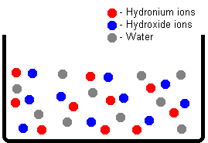 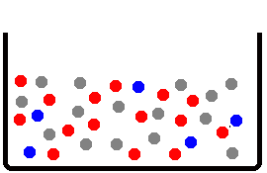

NEUTRAL SOLUTION ACIDIC SOLUTION

**[H3O+] = [OH-] [H3O+] > [OH-]**

- pH Scale: The Power of Hydrogen

- pH scale—measures the acidity or basicity of a solution

- developed by Soren Sorensen in 1909

- pH stands for *power of hydrogen*

- **pH = – log[H3O+]**

***NOTE: some books just list pH = – log[H+] even though H+ does

not really exist in aqueous solution, IF it did the [H+] = [H3O+] so it

really is the same thing

- ONLY works for DILUTE solutions!!! (LESS THAN or EQUAL to 1.00 M)

- numbers range from 0 – 14 (0 to 7 is ACIDIC and 7 to 14 is BASIC)

- logarithmic scale {each pH number is a POWER of TEN!!!}

[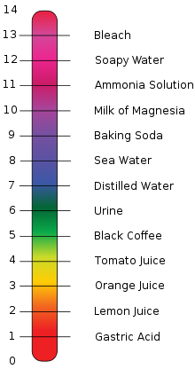](http://en.wikipedia.org/wiki/File:PH_Scale.svg)

**Some typical substances and their pH values**. A pH LESS than 7.00 is ACIDIC. A pH GREATER than 7.00 is BASIC. Distilled water has a pH of 7.00 which is NEUTRAL

- *Ex. What is the pH of a solution with a [H3O+] of 1.0 x 10-5M?*

*- Ex. What is the pH of a solution with a [OH-] of 1.0 x 10-5M?*

- **Determining [H3O+] from the pH of the solution:**

- pH = – log[H3O+]

- (-) pH = log[H3O+]

- 10-pH = 10log[H3O+]

- **10-pH = [H3O+]**

- *Ex. The pH of a solution is 5.36. What is the [H3O+]?*

*­­*

- **pOH and [OH-]:**

- **pOH = – log[OH-]**

- **10-pOH = [OH-]**

- this is sometimes more convenient to use with BASES since bases give or

produce OH- in solution

- however BASES are still measured on the pH scale (NOT the pOH!!!)

- pH and pOH are related in the following way:

**[H3O+][OH-] = Kw = 1.0 x 10-14**

{ taking the log of both sides: }

**log([H3O+][OH-]) = log Kw = log (1.0 x 10-14)**

{ since the *log (ab) = log a + log b* }:

**log[H3O+] + log[OH-] = log Kw = – 14.00**

{ multiplying everything by NEGATIVE ONE (-1) } :

**( - log[H3O+] ) + ( - log[OH-] ) = - log Kw = + 14.00**

**pH + pOH = pKw = 14.00**

- *Ex. What is the pH of 4.5 x 10-4M NaOH???*

This can be solved 2 ways:

NaOH 🡪 Na+ + OH-  NaOH 🡪 Na+ + OH-

4.5 x10-4M 4.5 x10-4M 4.5 x10-4M 4.5 x10-4M 4.5 x10-4M 4.5 x10-4M

- **Strong vs. Weak Acids:**

- strong acids are STRONG electrolytes because they undergo 100%

ionization

- HCl + H2O 🡪 H3O+ + Cl

- this reaction ONLY goes in the forward direction so ALL of the HCl is made

into H3O+

- since there is a 1:1 mole ratio of HCl : H3O+ then the [HCl] = [H3O+]

{because they are the SAME number of moles in the SAME volume!!}

- strong acids are HCl, HBr, HI, H2SO4, H3PO4, HClO4, HClO3 and HNO3

- weak acids are WEAK electrolytes because they do NOT completely

dissociate {reversible equilibrium reaction}

- HC2H3O2 + H2O <🡪 H3O+ + C2H3O2-

- HA + H2O <🡪 H3O+ + A-

**[H3O+][A-]**

**Ka = -------------------**

**[HA]**

- *Ex. What is the [H3O+] and pH of a 1.00 M HC2H3O2 if the Ka = 1.8 x 10-5*

I 1.00 M 0 0

C - x + x + x

E 1.00 – x ≈ 1.00 M x M x M

- Neutralization Reactions & Titrations:

- **neutralization**—a reaction between an acid and a base in which the

products would be water and a salt

- **salt**—an ionic compound that is formed from the (+) ion of a base and the

(-) ion of an acid

- **HA + BOH 🡪 HOH + BA**

- in a neutralization reaction, H+ reacts with OH- and forms HOH (H2O)

- **titration**—the process of taking a KNOWN amount and concentration of

acid (or base) {STANDARD} and reacting it with a carefully measured

amount of an UNKNOWN concentration of base (or acid) until the

EQUIVALENCE POINT is reached

- at the equivalence point, the MOLES of H+ = MOLES of OH-

- indicator—a weak acid or base whose color is pH sensitive

**HIn <🡪 H+ + In-**

- the indicator should change its color right around the pH where the

equivalence point is

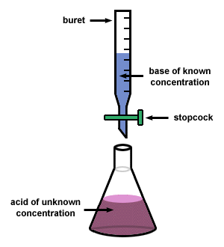 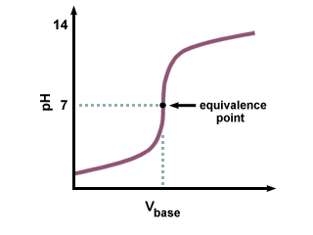

- Molarity Titrations:

- 3 steps to solving molarity titration problems

- to make it easier to follow we will use the specific example of

titrating an UNKNOWN ACID with a KNOWN (STANDARD)

BASE

1) take the VOLUME in LITERS and MOLARITY of the

STANDARD (known concentration) and solve for MOLES

base

2) using the BALANCED REACTION solve for the MOLES of

ACID by stoichiometry

3) moles of ACID divided by LITERS of ACID = MOLARITY of

ACID

- *Ex. 25.00 ml of an unknown concentration of HC2H3O2 is titrated with*

*15.75 ml of 0.100 M NaOH. What is the concentration of the acid??*

**25.00 mL 15.75 mL**

**?? M 0.100 M**

- Normality & Normality Titrations:

- Normality (N)—equivalents of H+ (or OH-) per LITER of solution (for an

acid or base)

- acids will have equivalents of H+ and bases have equivalents of OH-

- 1 mole HCl = 1 equiv H+

- 1 mole H2SO4 = 2 equiv H+

- 1 mole H3PO4 = 3 equiv H+

- 1 mole NaOH = 1 equiv OH-

- 1 mole Ca(OH)2 = 2 equiv OH-

- for titrations (since at the equivalence point the equiv acid = the

equiv base):

# of equivalents of acid = Nacid x Vacid

# of equivalents of base = Nbase x Vbase

At the equivalence point: ***equivalents of acid = equivalents of base***

***So….***

**Na Va = Nb Vb**

- *If 35.0 ml of 0.20N HCl are needed to neutralize 25.0 ml of an*

*unknown base, what is the normality of the base?*

**Va = 35.0 mL Na = 0.20 N Vb = 25.0 mL Nb = ??**

- *How many ml of 0.500N sulfuric acid are needed to neutralize*

*50.0 ml of 0.200N KOH?*

**Va = ?? Na = 0.500 N Vb = 50.0 mL Nb = 0.200 N**