**Chemistry I – Early Models of the Atom**

**- Evolution of Atomic Theory:**

- first concept of the atom dates back to the Greek philosophers

- Aristotle did not believe in atoms

- Democritus named the atom ATOMOS (cannot be divided) (400

B.C.)

- most people followed the ideas of Aristotle

- 1800s:

- John Dalton comes up with the Modern Atomic Theory:

- **5 components to Dalton’s Theory:**

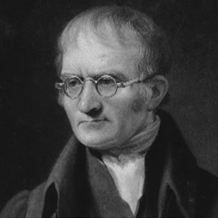 1) ALL matter is made of atoms

2) Atoms are INDIVISIBLE (cannot be

divided)

3) ALL atoms of the SAME element

are the SAME but atoms of

DIFFERENT elements are

DIFFERENT from each other

4) Compounds are formed by a

combination of atoms in

SIMPLE, SMALL WHOLE

NUMBERED RATIOS

5) A chemical reaction is a

REARRANGEMENT of atoms

(bonds break, atoms rearrange

and then bonds reform to other

atoms from the original mix)

- SOME components to Dalton’s theory are incorrect today

- Dalton’s model fits with the Law of Conservation of Matter (matter

cannot be created or destroyed) – atoms simply REARRANGE in

chemical reactions!!

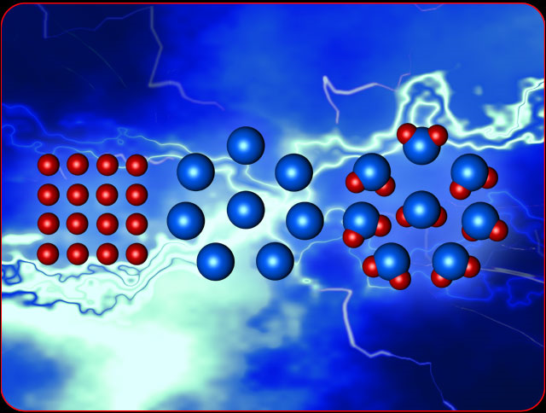

- **Law of Definite Composition** – *a chemical compound always*

*contains the SAME RATIO of its elements BY MASS*

- Joseph Proust

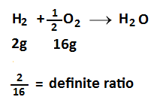

- **Law of Multiple Proportions --** *If two elements combine to form*

*more than one possible compound, then the MASSES of one*

*element that combine with a FIXED MASS of the second element are*

*in a ratio of SMALL WHOLE NUMBERS*

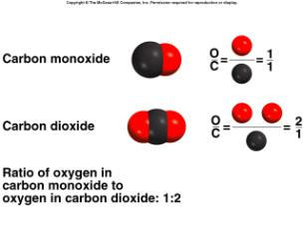

- **Discovering the Subatomic Particles:**

**- Discovering the Electron:**

- William Crookes—studied behavior of gases when electric

current was passed through them

- developed a “Crookes Tube”

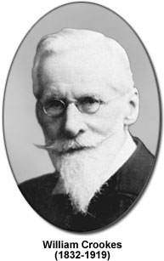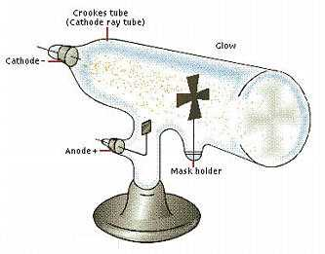

- J.J. Thomson (1897)—discovered that what Crookes called

CATHODE RAYS were actually ELECTRONS

- also found that these electrons were exactly the same no

matter what metal or gas was used in the CRT

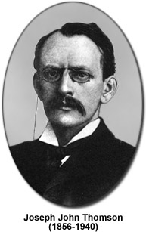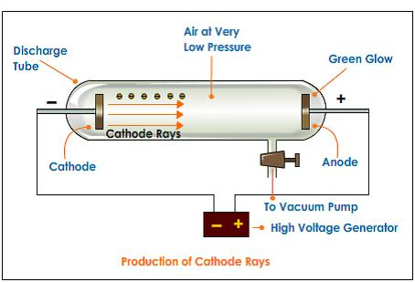http://www.kentchemistry.com/links/AtomicStructure/JJThompson.htm

- concluded that electrons are negatively charged subatomic

particles of ALL ATOMS

- electrons have very small mass (1/1840 of the mass of a H

atom)

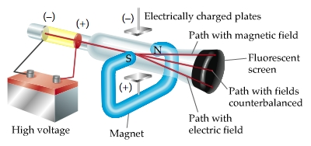

- Thomson also came up with the “Plum Pudding Model” of

the atom to describe where the (-) charge was located

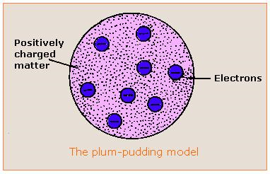

Since atoms are NEUTRAL there has to be some (+) charge somewhere, so the atom was viewed as a sphere of (+) charge with these (-) electrons dispersed throughout

- Robert Millikan—oil drop experiment found the mass of an

electron

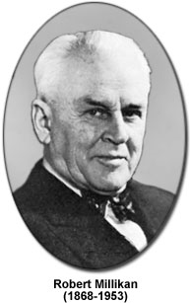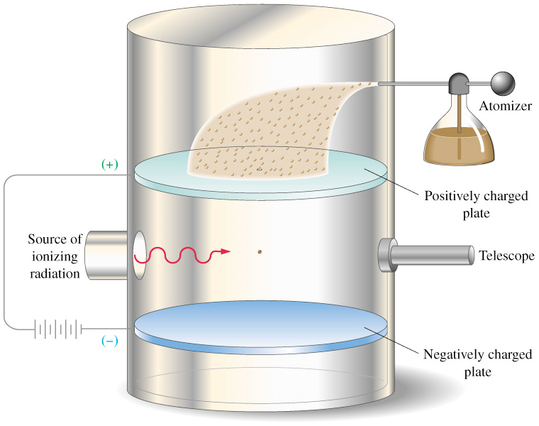

- **Discovering the Proton:**

- if atoms are neutral and electrons are (-), then there MUST be

some (+) charged particle to balance that charge

- Goldstein—discovered rays traveling in the opposite

direction as cathode rays

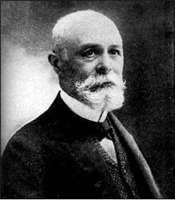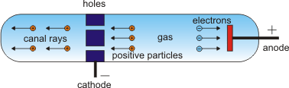

- concluded that this was a stream of (+) charged particles

called protons

- **Discovering the Neutron:**

- discovered by James Chadwick in 1932

- found the mass EQUAL to a proton but much heavier than

Electrons

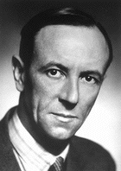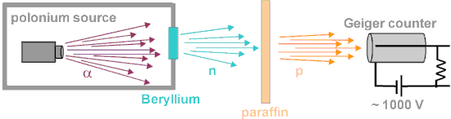 neutron equation.gif

- The Atomic Nucleus:

- discovered in 1911 by Ernest Rutherford

- used a beam of ALPHA PARTICLES (+ charged He nucleus)

aimed at a piece of GOLD FOIL surrounded by a fluorescent

screen

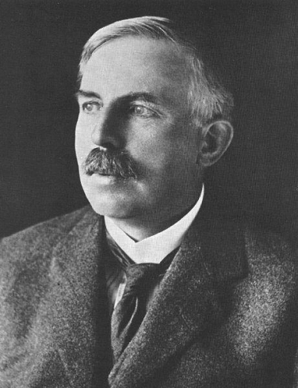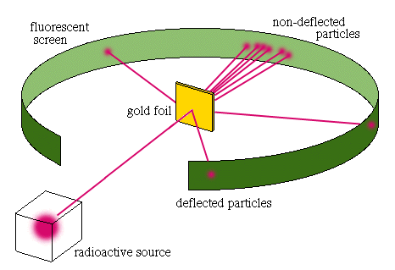

- RESULTS:

1) most of the alpha particles passed STRAIGHT

through the foil

- concluded the atom is made up of mostly

EMPTY SPACE!!

2) some alpha particles passed through with only some

slight deflection

- concluded they must have come near a proton in

the atom and been repelled

3) a very small number of alpha particles were

DEFLECTED BACKWARDS!!

- Rutherford said this was as if he had fired a 15

inch artillery shell at a piece of tissue paper and

it bounced back to hit him!!

- concluded that there MUST be a very small and

dense body in the atom containing (+) charge

and most of the mass

- discovered the NUCLEUS of the atom

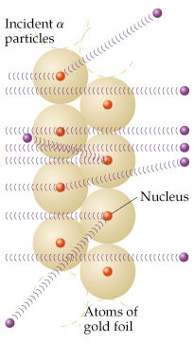 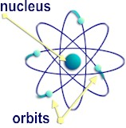

- **Distinguishing Elements:**

- atoms are made up of subatomic particles:

1) PROTONS – have a (+) charge [found in the NUCLEUS]

2) NEUTRONS – have no charge [found in the NUCLEUS]

3) ELECTRONS – have a (-) charge [found revolving around the

nucleus]

- Atomic Number (Z) – identifies an element

- atomic number is a COUNTING number that counts the total

number of PROTONS in the nucleus

- identifies an element as that element (all Carbon atoms have 6

protons!!)

- MUST be a whole number (can’t have half of a proton!!)

- Z = # of protons

- Mass Number (A) – identifies an isotope

- isotope – a different form of the same element with a different mass

(because of a different number of neutrons)

- mass number is also a COUNTING number that counts the total

number of particles in the nucleus (PROTONS + NEUTRONS)

- A = # of protons + # of neutrons

- so # of neutrons = A – Z

- 3 isotopes of Hydrogen:

|  |  |  |  |
| --- | --- | --- | --- |
| **Name** | **# of protons** | **# of electrons** | **# of neutrons** |
| **Protium (H-1 or 1H)** | **1** | **1** | **0** |
| **Deuterium (H-2 or 2H)** | **1** | **1** | **1** |
| **Tritium (H-3 or 3H)** | **1** | **1** | **2** |

- each isotope of H has 1 proton but a different number of

neutrons and therefore it has a DIFFERENT MASS (but the

charge is not affected because neutrons are neutral!!)

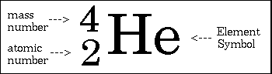

- atomic mass – the MASS of the atom based on a relative scale where the

mass of 12C is exactly 12.000 amu (atomic mass units)

- atomic masses on the Periodic Table are a WEIGHTED average

based on the relative abundance and masses of all of the isotopes

making up a particular element

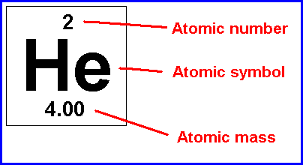

*Find the average atomic mass of Oxygen from the following data:*

O – 16: 99.759% 15.995 amu

O – 17: 0.037% 16.995 amu

O – 18: 0.204% 17.999 amu

- **The Periodic Table:**

**- Development of the Periodic Table:**

- Dmitri Mendeleev—organized the elements in order of their

increasing atomic MASS

- made the first periodic table (an organized arrangement of elements

according to similar properties)

- actually predicted physical and chemical properties of missing

elements

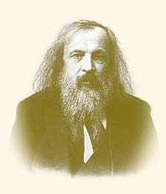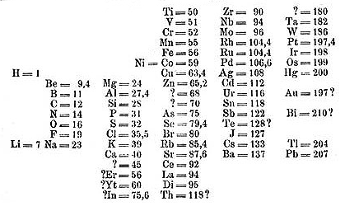

- Henry Moseley—arranged the elements according to atomic

NUMBER

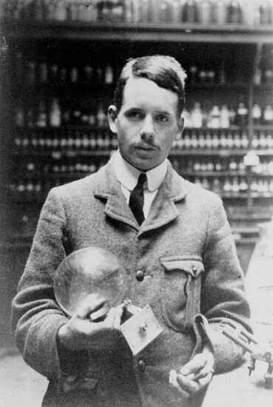 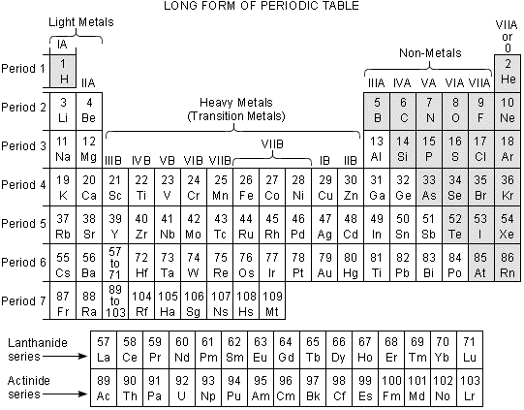

- Periodic Table:

- periods—horizontal rows (7)

- groups or families—vertical columns (18)

- elements in the same group have similar properties

- PERIODIC LAW—when elements are arranged according to

their **atomic number**, there is a periodic repetition of

physical and chemical properties

- metals—located at the LEFT side of the table

1) good conductors of heat & electricity

2) luster—shine

3) malleable—can be hammered into sheets

4) ductile—can be pulled into wires

- nonmetals—located at the RIGHT side of the table

- opposite characteristics of metals

- metalloids—along a STEPWISE line (B, Si, Ge, As, Sb, Te)

- also called semiconductors

- some characteristics of metals and nonmetals combined

- Group 1 – Alkali metals

- Group 2 – Alkaline Earth metals

- Groups 3 – 12 – Transition metals

- Lanthanide series—numbers 57 – 70

- Actinide series—numbers 89 – 102

- Group 17—Halogens

- Group 18—Noble Gases (UNREACTIVE!!!)

