**Chemistry IA – Periodic Trends**

**- Classification Of The Elements:**

- Dmitri Mendeleev—organized the elements in the first periodic

table

- arranged according to ATOMIC MASS

- Henry Mosely—organized the elements according to ATOMIC

NUMBER

- The ELECTRON is the most important subatomic particle for

determining chemical and physical properties

- PERIODIC LAW—the chemical and physical properties of the

elements are periodic functions of their atomic number

**- Periodic Trends:**

**- Atomic Radius:**

- atomic radius—half the distance between the nuclei of 2

IDENTICAL bonded atoms

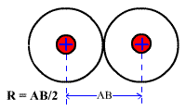

- atomic radius INCREASES down a group because the atoms

have electrons in higher energy levels (farther away from the

nucleus)

- atomic radius DECREASES across a period because outer

electrons are in same energy level but pulled closer to

the nucleus by more protons

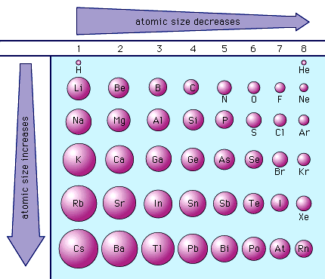

**- Ionization Energy:**

- ionization energy—the energy required to remove an electron

from an atom in the gas phase

A 🡪 A+ + 1 e-

- CATION—a (+) charged ion

- IE always forms a cation(removing e-)

- always INCREASES as you go from 1st IE to 2nd IE to 3rd IE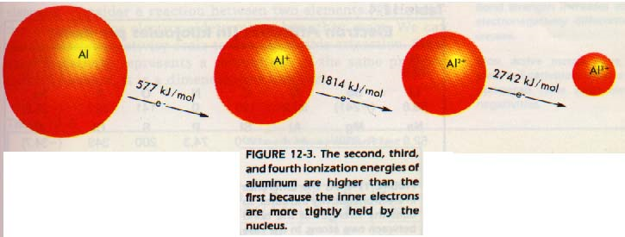

- IE DECREASES down a group because it is easier to pull

electrons from the atom when they are farther from the

nucleus

- IE INCREASES across a period because of a greater pull

towards the nucleus due to more protons

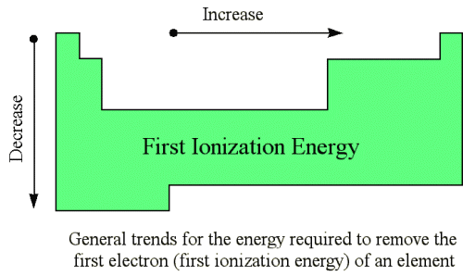

**- Electron Affinity:**

- electron affinity—the energy required to add an electron to a

neutral atom in the gas phase

A + 1 e- 🡪 A-

- ANION—a (-) charged ion

- EA always forms anions

- EA DECREASES down a group because electrons are not as

attracted to the nucleus when they are farther away

- EA INCREASES across a period because the electrons are

pulled closer to the nucleus by more protons

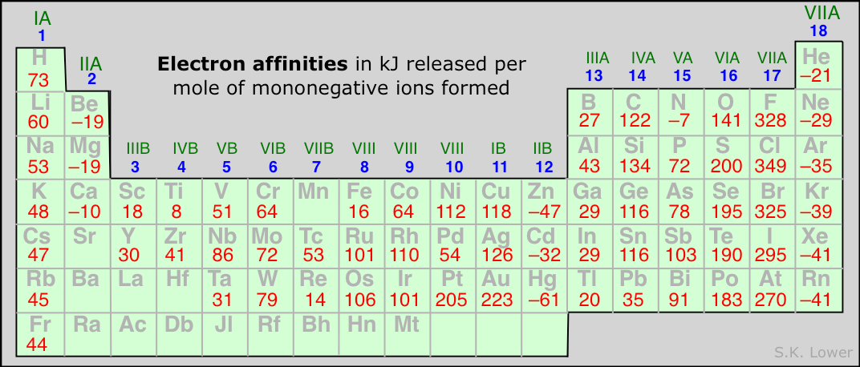

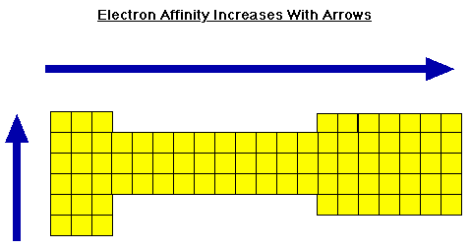

**- Ionic Radius:**

- metal atoms tend to form cations

- nonmetal atoms tend to form anions

- forming a cation DECREASES the radius (losing e-)

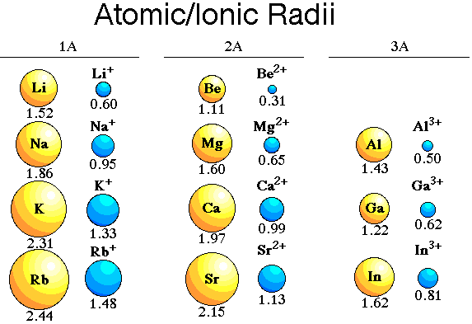

- forming an anion INCREASES the radius (gaining e-)

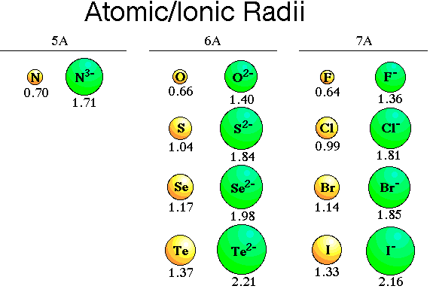

- IR INCREASES as you go down a group because the valence

electrons are in a higher energy level (farther from the

nucleus)

- IR in a period has NO CLEAR TREND

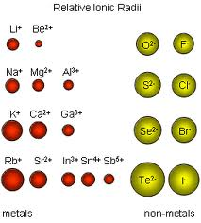

**- Electronegativity:**

- electronegativity—the tendency for an atom to attract

electrons when it is bonded to another atom

- scale of electronegativities by Linus Pauling

- 0.7 (Fr)—lowest

- 4.0 (F)—highest

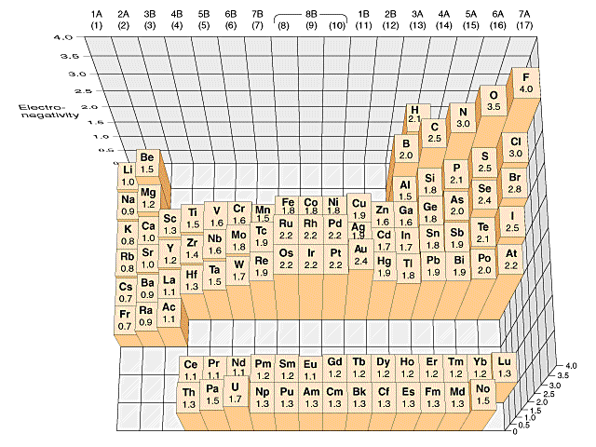

- Group 18 (Nobel gases) do NOT have any EN values because

they do NOT form compounds!

- EN difference is used to predict BOND CHARACTER

- EN DECREASES as you go down a group because the

valence electrons that are further away from the nucleus are

less attracted to it

- EN INCREASES as you go across a period because the

electrons are closer to the nucleus and are attracted more to it

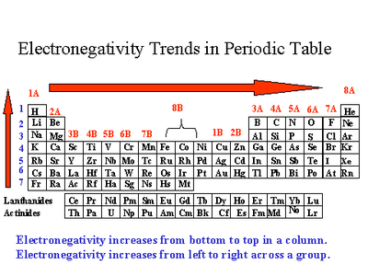

***Ionization Energy, Electron Affinity and Electronegativity are***

***ALL OPPOSITE OF ATOMIC RADIUS!!!!!***

