Categories | 4 Points | 3 Points | 2 Points | 1 Point
Sentences | Writes more than 8 sentences on topic and provides an introduction and closing sentence 100% pf the time | Writes 6-8 sentences on topic and provides an introduction and a closing sentence 80% of the time | Writes 4-5 sentences on topic and provides an introduction and closing sentence 50% of the time | Writes less than 4 sentences and is inconsistent with an introduction and closing sentence
Capitalization: (first word of sentence, I, and proper nouns) | Uses correct capitalization 100% of the time | Uses correct capitalization 80% of the time | Uses correct capitalization inconsistently | Does not use capitalization
Punctuation | End punctuation is used correctly 100% of the time | End punctuation is used correctly 80% of the time | End punctuation is used incorrectly and inconsistently | Does not use end punctuation
Spacing | Spacing is correct 100% of the time | Spacing is correct 80% of the time | Spacing is inconsistent | Does not use spacing
Words: (cvc words, blends, digraphs, etc.) | Words are spelled correctly based on phonics skills taught 100% of the time | Words are spelled correctly based on phonics skills taught 80% of the time | Words are spelled correctly based on phonics skills taught 50% of the time | Does not spell words correctly based on phonics skills taught
High Frequency Words: (students can utilize word walls, student dictionaries, etc. | Spells HF words correctly 100% of the time | Spells HF words correctly 80% of the time | Spells HF words correctly 50% of the time | Does not spell HF words correctly
Illustration | Illustration matches text (See Picture Drawing Rubric Below) | Illustration matches text (See Picture Drawing Rubric Below) | Illustration matches text (See Picture Drawing Rubric Below) | Illustration does not match text

_____ out of 28 Points BOY _____ out of 28 Points MOY _____ out of 28 Points EOY
(In order to formulate a percentage, you must give each of the 7 categories an individual score of 1-4 points based on the rubric above.
Then divide the total number of points by 28 (max. points). Ex. 26 out of 28 Points = 93%
*Aligns with the Conventions of Writing Developmental Scale from the Kid Writing Manual by Eileen Feldgus Ed.D.

4  - Background is evident  - Variety of colors used correctly (ex. sun is yellow)  - Many details are evident  - Colored neatly and appropriately  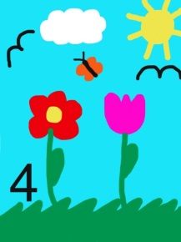 | 2  - No background  - No details  - Beginning to use different colors  - Beginning to color inside the lines  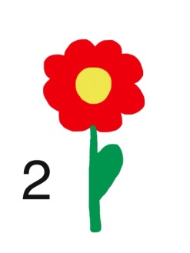
3  - Background is evident  - Variety of colors used correctly (ex. sun is yellow)  - Some details are evident  - Colored neatly and appropriately  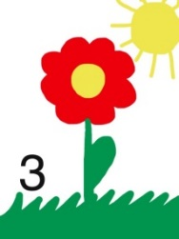 | 1  - No background  - No details  - Single color  - Often scribbled  