**Organic Chemistry – Chemistry Review**

**Organic Chemistry:**

- inorganic chemistry – the study of compounds that do not contain carbon

- organic chemistry – the study of compounds that contain carbon

- all organic molecules contain carbon which will always form 4 bonds and

surprisingly can form MANY different compounds because of its nature to

form long chains or ring like structures

**Bonding:**

- atom—the smallest part of an element that still has the properties of that

element

- atoms are made of protons (+), neutrons (neutral) and electrons (-)

- protons and neutrons are located in the nucleus of the atom

- electrons are located in ORBITALS surrounding the nucleus (regions of

space representing where electrons are found)

- these orbitals have different shapes and can hold a maximum of 2 e-

- electron configuration—the arrangement of electrons in orbitals

- electrons always occupy the LOWEST possible energy orbitals first

- maximum of 2 e- in an orbital (and must have opposite spins!!)

- each orbital in a sublevel must have at least one electron before

any pairing occurs!

- Ex. OXYGEN

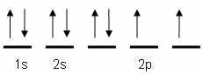

Image courtesy of <http://www.sciencegeek.net/Chemistry/taters/Unit1ElectronNotations.htm>

- valence electrons—the electrons in the OUTER energy level of the atom

- these are the electrons involved in BONDING!!

- Lewis Dot Structures – show the valence electrons for an element

- used to build structural formulas for molecules

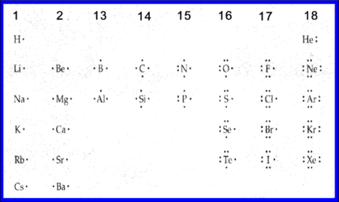

Image courtesy of <http://rlhonorschem3.wikispaces.com/Mary>

- Octet Rule—atoms will gain, lose or share electrons in order to get a

stable set of 8 (OCTET) (Hydrogen will get 2!) when they form bonds

- Metals have a tendency to LOSE electrons and form CATIONS (+)

- Nonmetals have a tendency to GAIN electrons and form ANIONS (-)

- ELECTRONEGATIVITY – a measure of how much an atom wants to keep

electrons to itself when involved in bonding

- IONIC bonding – the complete transfer of electron(s) from a metal to an

nonmetal causing the formation of cations and anions that are strongly

attracted to each other

- Ex.: NaCl

- COVALENT bonding – the SHARING of electrons between 2 atoms that

both want electrons (usually nonmetals and metalloids)

- Drawing Lewis Structural Formulas for Molecules:

- H2 O2  N2

H: 2 x 1e- = 2e- O: 2 x 6e- = 12e- N: 2 x 5e- = 10e-



CH3OH:



C: 1 x 4e- = 4e-



H: 4 x 1e- = 4e-



O: 1 x 6e- = 6e-



---------------------



14e-



- not all sharing of electrons is equal 🡪 leads to POLARITY!!

- polar bond – unequal sharing of electrons between 2 atoms causing the

electrons to spend more time with the MORE EN atom (δ-) and less time

with the LESS EN (δ+)

- Ex. HF



- use EN difference to determine polarity!

- 0.0 – 0.3 🡪 NONPOLAR

- 0.3 – 1.7 🡪 POLAR

- 1.7 – 4.0 🡪 IONIC

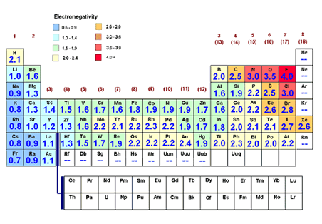

Image courtesy of <http://www.rpdp.net/sciencetips_v3/P8A2.htm>

- FORMAL CHARGE – the amount of charge that an individual atom has in a

molecule or ion

- **FORMAL CHARGE = # of valence e- – # of BONDS – # of nonbonding e-**

- Ex. NH4+



H 🡪 1 valence e- – 1 bond – 0 unshared e- = 0



N 🡪 5 valence e- – 4 bonds – 0 unshared e- = +1



- Line Drawings:

- line drawings are commonly used in Organic Chemistry for

molecules

- every END of a line or INTERSECTION of lines represent a CARBON

atom (unless an atom is specifically written in)

- also every Carbon must form 4 bonds (so any bonds that are not

shown it is understood to be a HYDROGEN attached at that point)

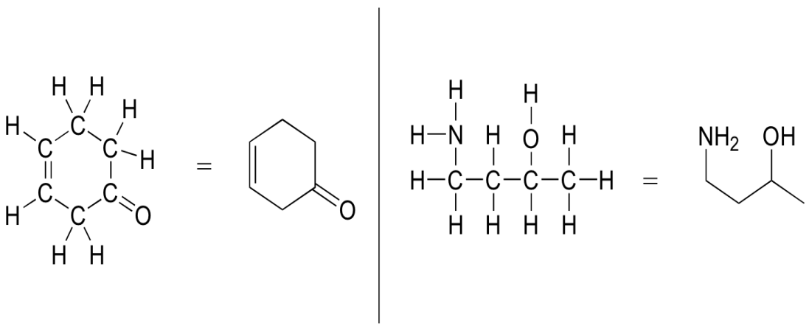

Image courtesy of <http://chemwiki.ucdavis.edu/Organic_Chemistry/Organic_Chemistry_With_a_Biological_Emphasis/Chapter__1%3A_Chapter_1%3A_Introduction_to_organic_structure_and_bonding_I/Section_1.3%3A_Drawing_organic_structures>

- **Electrons in Organic Chemistry:**

- chemistry is all about moving electrons to break and form bonds

- in NEUTRAL molecules, sometimes electrons are gained, sometimes

electrons are lost

- in ANIONS there is an excess of electrons so they have a tendency to give

electrons or share them to form bonds

- in CATIONS there is a shortage of electrons so they have a tendency to

gain electrons

- organic chemistry uses ARROWS to show the movement of electrons

(where they originate to where they finish)

1) an arrow drawn from one ATOM to another ATOM indicates the

forming of a COVALENT bond

2) arrows move from MORE NEGATIVE to LESS NEGATIVE charge

(including FORMAL charge)

3) the TOTAL CHARGE of the products must EQUAL the TOTAL

CHARGE of the reactants!

4) bonding rules are not broken in the reaction

5) a double arrow (🡪) is used to show 2 electrons moving and a

single arrow (–`) shows the movement of 1 electron (free radicals)

- **Ex.: NH4+ + OH-**



- Resonance Structures – when more than one structural formula can be

drawn for the same molecule (because of electrons moving in the

structure)

- true representation is called a resonance hybrid which takes into

account all possible resonance structures

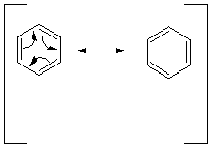

Image courtesy of <http://research.cm.utexas.edu/nbauld/teach/notes3.html>

1) the order in which the atoms connect is the SAME for ALL

resonance structures (electrons move not atoms!!)

2) ALL resonance structures must be valid Lewis structures!

3) the NET charge of the molecule or ion must be the SAME!

4) arrows show the movement of electrons between resonance

structures

5) double headed arrows show resonance between structures

6) not all resonance structures are equally stable (usually the lowest

formal charges are more stable than higher formal charges!!).

The more stable structure usually predominates!!

- **Hybridization of Orbitals:**

- hybrid orbitals – a mix of orbitals from 2 or 3 sublevels that are very

similar in energy

- hybrid orbitals are used in the formation of single bonds and to hold

LONE PAIRS of electrons

- double and triple bonds do NOT use hybrid orbitals

- Ex. CH4

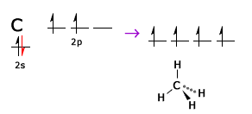

Image courtesy of <http://www.chegg.com/homework-help/questions-and-answers/diagram-shows-electron-configuration-carbon-atom-carbon-hybridized-methane-molecule-hybrid-q3768297>

- sp hybridization—combines one “s” and one “p”

- sp2 hybridization—combines one “s” and two “p”

- sp3 hybridization—combines one “s” and three “p”

- sp3d hybridization—combines one “s” and three “p” and one “d”

- sp3d2 hybridization—combines one “s” and three “p” and two “d”

- sigma (σ) bond—single bond caused by the overlap of hybridized orbitals

- Ex. Ethane

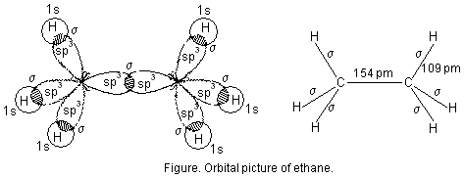

Image courtesy of <http://www.goiit.com/posts/show/815571/chemical-bonding-bond-length-805352.htm>

- pi (π) bond—formed by the overlap of non-hybridized “p” orbitals making

the second bond of a double bond or the 2nd and 3rd bond of a triple bond

- Ex: ethane

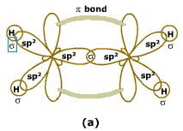 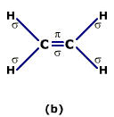

Images courtesy of <http://www.homeworkassignmenthelp.com/AlkenesOnline.aspx>

- Ex: ethyne

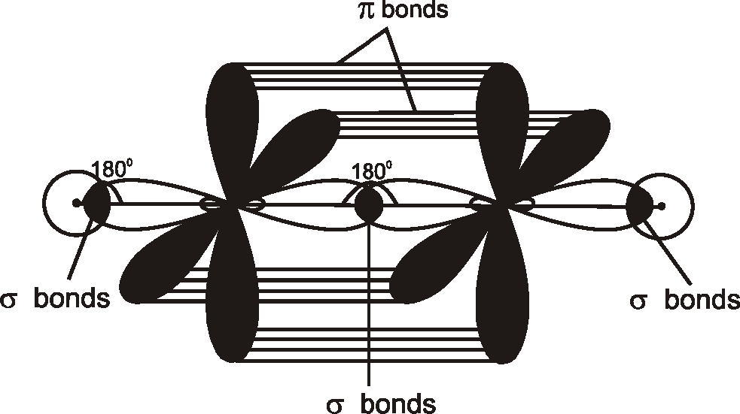 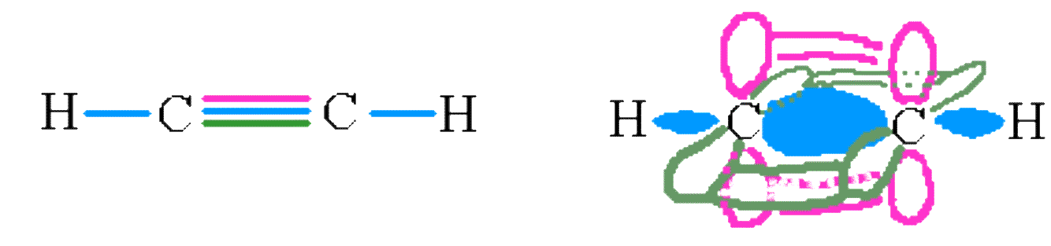

Image courtesy of <http://socratic.org/questions/how-many-sigma-bonds-are-there-in-c2h2-1>

- how to determine the hybridization of the CENTER ATOM:

- TOTAL = # of SINGLE BONDS + # of LONE PAIRS of e-

- TOTAL = 4 then sp3

- TOTAL = 3 then sp2

- TOTAL = 2 then sp

- do NOT count π bonds in double or triple bonds

- **Acids & Bases:**

- Arrhenius acid—molecule that contains H and produces H3O+ in water

- Arrhenius base—contains OH and produces OH- in water

- Bronsted-Lowry Acid—proton (H+) donor

- Bronsted-Lowry Base—proton (H+) acceptor

- conjugate acid—substance formed when the base accepts H+

- conjugate base—substance formed when the acid donates H+

**HA + H2O 🡪 H3O+ + A-**

**H2O + B: 🡪 BH+ + OH-**

**A + B 🡪 CA + CB**

- Strengths of Acids & Bases:

**[H3O+] [A-] [BH+] [OH-]**

**Ka = ----------------- and Kb = ------------------**

**[HA] [B]**

**pKa = - log Ka and pKb = - log Kb**

- the stronger the acid, the HIGHER the Ka is (LOWER pKa)

- the weaker the acid, the LOWER the Ka (HIGHER pKa)

- in general, the stronger the acid, the weaker the conjugate base

- in general, the stronger the base, the weaker the conjugate acid

- whatever side has an acid with a HIGHER pKa (WEAKER ACID) will

be favored in a reversible reaction

- Factors affecting the strength of an acid:

- in general, anything that makes the resulting anion stable

will make the acid stronger!!

1) if an acid has lots of EN groups, it will be more stable

(INDUCTIVE EFFECT!!)

CF3OH > CH3OH

2) if you can make resonance structures out of the conjugate

base, the acid will be stronger!!

- Lewis Acid—an electron pair acceptor to form a coordinate covalent bond

- a LEWIS ACID is an ELECTROPHILE (loves (-) charge)

- Lewis Base—an electron pair donor to form a coordinate covalent bond

- a LEWIS BASE is a NUCLEOPHILE (loves (+) charge)

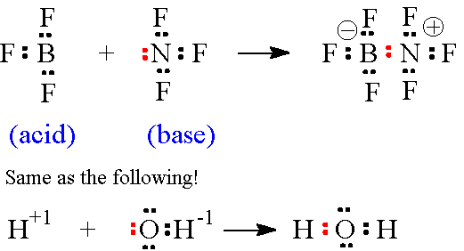



Image courtesy of <http://www.uwplatt.edu/~sundin/354-7/l547-04.htm>