**Scientific Measurement**

- **Scientific Notation:**

- scientific notation – shorthand method of writing very small or very large

numbers

- written as a coefficient (M) times 10 raised to an exponent (n)

- **M x 10n**

- 1 ≤ M < 10

- n = any integer

- move the decimal point in the original number until only ONE NONZERO

digit is to the left of the decimal (this becomes the coefficient – M)

- the NUMBER OF PLACES the decimal point was moved becomes the

exponent (n)

- if decimal is moved to LEFT then n = (+)

- if decimal is moved to RIGHT then n = (-)

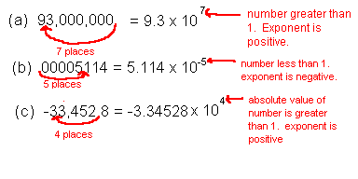

Image courtesy of <http://onlinephys.com/scientificnotation.html>

- **Scientific Notation in Mathematical Calculations:**

1) Addition & Subtraction

- to add or subtract numbers in scientific notation, the exponents

MUST be the same!!!

- if the exponents are different one of the numbers will have to be

rewritten so the exponent is the same

- ADD (or SUBTRACT) the coefficients and KEEP the exponent the

SAME

4,000 4.0 x 103 **4.0 x 103**

+ 500 + 5.0 x 102 **+ 0.5 x 103**

--------------- ---------------- **-----------------**

4,500 [exponents not same] **4.5 x 103**

2) Multiplication

- MULTIPLY the coefficients and ADD the exponents

- if the new coefficient is 10 or greater, it must be rewritten (and the

exponent changed) so that the coefficient is less than 10)

**(M1 x 10n1) x (M2 x 10n2) = M1 x M2 x 10(n1 + n2)**

**(4.0 x 102) (2.0 x 103) = (4.0 x 2.0) x 102+3 = 8.0 x 105**

**(4.0 x 102) (3.0 x 103) = (4.0 x 3.0) x 102+3 = 12.0 x 105 🡪 1.2 x 106**

3) Division

- DIVIDE the coefficients and SUBTRACT the exponents (numerator

MINUS denominator)

- if the new coefficient is less than 1, it must be rewritten (and the

exponent changed) so that it is 1 or more

**(M1 x 10n1) / (M2 x 10n2) = M1 / M2 x 10(n1 - n2)**

**(4.0 x 105) / (2.0 x 103) = (4.0 / 2.0) x 105-3 = 2.0 x 102**

**(4.0 x 105) / (3.0 x 103) = (4.0 / 3.0) x 105-3 = 0.75 x 102 🡪 7.5 x 101**

- **Uncertainty in Measurements:**

- ACCURACY – how close a measurement is to the ACTUAL accepted value

- PRECISION – how close each measurement to the other measurements in

the set

- you can be precise but not accurate!!

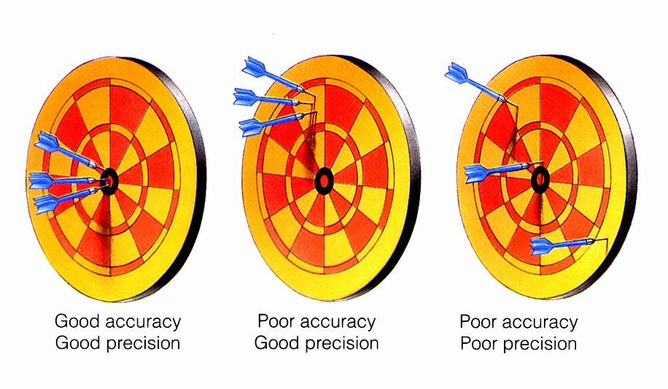

Image courtesy of <http://www.physicsinfo.co.uk/?page=view&id=733>

- accepted value (ACC) – the actual value based on a reliable reference

- experimental value (EXP) – the value that YOU measured in the lab

- Percent Error:

**| ACC – EXP |**

**% error = --------------------------- x 100**

**ACC**

- use the absolute value of the difference of ACC – EXP so the %

error is always a (+) value

- just as bad to be 5% too high as 5% too low

- the units are %

- **Significant Digits in Measurements:**

- you can always ESTIMATE a value that is one place PAST the smallest

marking on any ANALOG measuring device

- for a DIGITAL readout – use ALL of the digits from the machine

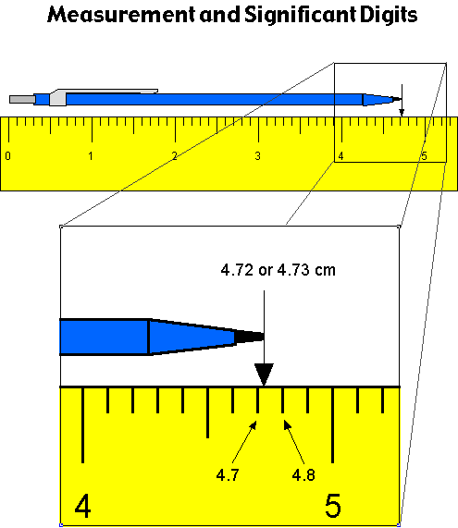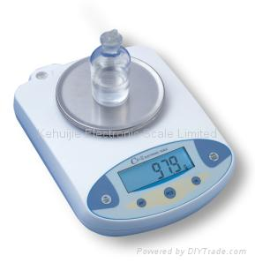

Images courtesy of <http://www.concord.org/~ddamelin/chemsite/b_measurement/images/ruler.gif>

<http://www.szkhj.com/sdp/109916/4/pd-1088714/3147303.html>

- Rules for Assigning Significant Digits:

1) any number that is NOT zero is significant

2) any ZERO between two NONZERO numbers are significant

3) any ZEROS before a nonzero that is -1 < # < 1 are NOT significant

(they are PLACEHOLDERS)

4) ZEROS after a number with a decimal point are significant

5) ZEROS after a number with no decimal point are NOT significant

6) counted numbers and exact equalities have an UNLIMITED

number of significant digits

- The Atlantic-Pacific Rule:



- if the decimal point is ABSENT, start counting digits from the

ATLANTIC ocean in towards the U.S. (from the first NONZERO digit

in the number from RIGHT 🡪 LEFT)

- if the decimal point is PRESENT, start counting digits from the

PACIFIC ocean in towards the U.S. (from the first NONZERO digit

in the number from LEFT 🡪 RIGHT)

- Examples: [significant digits are in *ITALICS*]

4 *5,281* 3 *6.23*

3 *107* 4 *2,003*

3 *10.0* 1 *1*0

2 0.000*56* 5 *10.004*

1 *5*00 3 *500*.

3 *2.00* 4 *10.70*

- **Significant Digits in Calculations:**

- Rules for rounding off significant digits:

- ALWAYS look at the digit to the RIGHT of the place that you want to

round off

1) if the following digit is LESS than 5, then leave the place digit as is

**4.62 🡪 4.6**

2) if the following digit is GREATER than 5, then increase the place

digit by 1

**4.68 🡪 4.7**

3) if the following digit IS 5 followed by a nonzero, then increase the

place digit by 1

**4.651 🡪 4.7**

4) if the following digit IS 5 exactly, then increase OR leave the place

digit in order to make the PLACE digit an EVEN number

**4.65 🡪 4.6**

**4.75 🡪 4.8**

- Multiplication and Division Calculations:

- the answer CANNOT have more significant digits than ANY of the

measured values used to calculate the answer

- round off the answer to the # of significant digits of the

measurement with the LEAST # of sig digs.

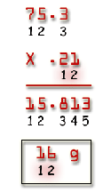 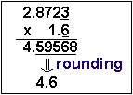 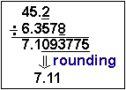

Images courtesy of <http://invsee.asu.edu/nmodules/sizescalemod/unit2/unit2.htm>

<http://www.chem.tamu.edu/class/fyp/mathrev/mr-sigfg.html>

- Addition and Subtraction Calculations:

- the answer should be rounded to the LEFTMOST uncertain place

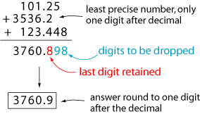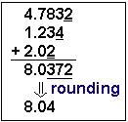 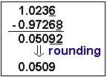

Images courtesy of

<http://www.grandinetti.org/Teaching/Chem121/Lectures/SigFigCalcs>

<http://www.chem.tamu.edu/class/fyp/mathrev/mr-sigfg.html>

- **System Internationale (SI System) of Units:**

- SI System – revised version of the metric system (base 10)

T = Tera (1,000,000,000,000)

G = Giga (1,000,000,000)

M = Mega (1,000,000)

k = kilo (1,000)

h = hecto (100)

da = deca (10)

BASE UNIT = 1 (GRAMS, LITERS, METERS)

d = deci (0.1)

c = centi (0.01)

m = mili (0.001)

µ = micro (0.000 001)

n = nano (0.000 000 001)

p = pico (0.000 000 000 001)

GRAMS

LITERS

METERS

T G M k h da d c m µ n p

1012 109 106 103 102 10 1 10-1 10-2 10-3 10-6 10-9 10-12

- move the DECIMAL POINT in the original measure the number of places

AND in the direction as indicated by the line above

- when converting to a LARGER UNIT, move decimal point LEFT

- when converting to a SMALLER UNIT, move decimal point RIGHT

- SI Base Units:

- meter (m) – SI base unit of length (distance)

- originally defined as 1/10,000,000th of the distance from the

Equator to the North Pole (at sea level)

- now defined as the distance that light travels in a vacuum in

1/299,792,458th of a second

- based on an established constant standard that will NEVER

CHANGE

- liter (L) – SI base unit of volume

- volume – the amount of space that an object occupies

- volume is actually a DERIVED unit (length in 3 dimensions)

- 1 L = vol occupied by a 10 cm x 10 cm x 10 cm cube

- V = l x w x h

- V = 10cm x 10cm x 10cm = 1,000 cm3 = 1,000 mL

- so 1 mL = 1 cm3

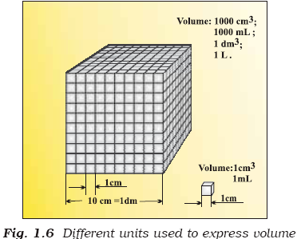

Image courtesy of <http://textbook.s-anand.net/ncert/class-11/chemistry/1-some-basic-concepts-of-chemistry>

- kilogram (kg) – SI base unit for mass

- this is the ONLY base unit that has a PREFIX!!!

- mass – a measure of the amount of matter that an object has

- weight – a measure of the force of GRAVITY on a mass

- W = m g

- mass is constant everywhere in the universe, weight depends

on your location!!!

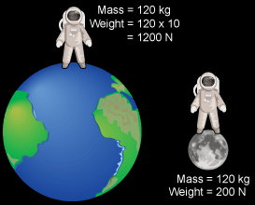

Image courtesy of <http://staff.slcschools.org/jsnow/Labs/8Labs/GravityLab/MassvsWeight.html>

- Table of SI base units

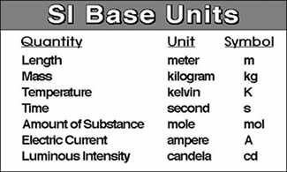

Image courtesy of <http://www.hcc.mnscu.edu/chem/V.03/page_id_2644.html>

- **Density:**

- density – the ratio of an object’s mass to its volume

- measured in g/cm3 (DERIVED unit)



Image courtesy of <http://leifchemistry.blogspot.com/2010/11/lab-2-e.html>

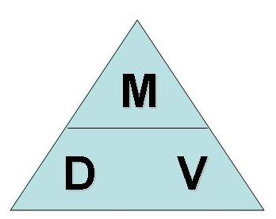

Image courtesy of <http://chemistryshenanigans.blogspot.com/2009_11_01_archive.html>

- water has a defined density of 1.000 g/cm3 at 4oC

- Density varies with temperature because VOLUME DOES

- anything that is LESS DENSE than water will FLOAT

- anything MORE DENSE than water will SINK

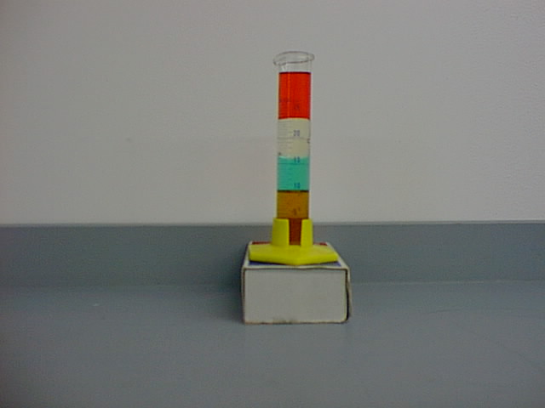

Alcohol

Vegetable Oil

Water

Honey

Image courtesy of <http://www.phys.ufl.edu/demo/2_FluidMechanics/B_StaticsFluids/FluidDensity.html>

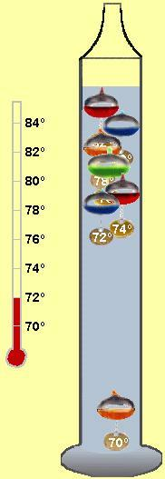

A Galileo Thermometer measures temperature by using DENSITY!!!! As the temperature changes, the **volume of the LARGE LIQUID EXPANDS**…this LARGER VOLUME creates a LOWER DENSITY. The individual bulbs are made and calibrated so that AT THOSE TEMPERATURES they now become MORE DENSE than the water and SINK once that temperature is reached. So the actual temperature is between the LOWEST bulb that is FLOATING and the HIGHEST bulb that has SUNKEN.

Image courtesy of <http://www.sodahead.com/fun/which/question-1180159/?link=ibaf&q=&imgurl=http://4physics.com/phy_demo/Galileo_thermometer/galileo-thermometer-at-72-degrees.jpg>

- **Temperature:**

- **temperature** – measures the AVERAGE kinetic energy (energy of motion)

of all the particles in a sample of matter

- **heat** – measures the TOTAL amount of kinetic energy of all the particles in

a sample of matter

- remember, heat is a measure of ENERGY (measured in J or cal)

- temperature is a reading on a temperature scale

- as HEAT increases, particles have more energy, move faster 🡪

temperature INCREASES

- as HEAT decreases, particles have less energy, slow down 🡪 temperature

DECREASES

- heat always flows from HIGH 🡪 LOW temperature

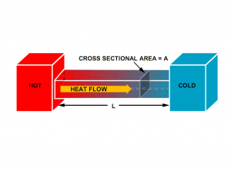

Image courtesy of <http://www.eeweb.com/design-articles/temperature-measurement-theory-and-practical-techniques>

- Temperature Scales:

1) Celsius – developed by Anders Celsius

- measured in oC (1/100th of the distance between the boiling

& freezing points of water on the thermometer)

- freezing point = 0oC

- boiling point = 100oC

2) Fahrenheit – developed by Fahrenheit

- measured in oF (1/180th of the distance between the boiling

& freezing points of water on the thermometer)

- freezing point = 32oF

- boiling point = 212oF

3) Kelvin – delveloped by Thompson (Lord Kelvin)

- measured in Kelvin (K)

- 1 K = 1 Co distance on thermometer

- freezing point = 273.15 K

- boiling point = 373.15 K

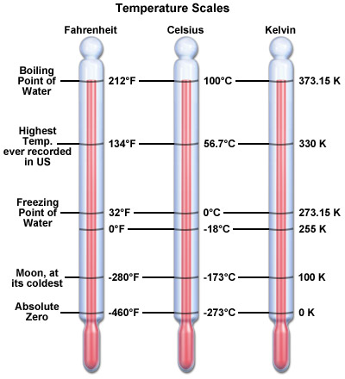

Image courtesy of <http://www.nc-climate.ncsu.edu/edu/k12/.Temperature>

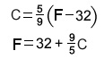

Image courtesy of <http://www.insbearing.com/images/gs5.jpg>

**K = C + 273.15**