* **Molecules and Molecular Compounds:**
  + Molecules have 2 or more atoms combined together by covalent bonds (sharing pairs of electrons)
  + Molecules may be elements (DIATOMIC ELEMENTS – **H2, O2, N2, Cl2, Br2, I2, F2**)
  + Molecules may also be molecular compounds that are sharing electrons between atoms of different elements (H2O, NH3, CO2, etc)
  + Molecules are almost always made of ONLY NONMETALS (and sometimes metalloids)
  + Molecules are always identified by their MOLECULAR FORMULA (shows the exact number of each atom in one molecule) that is NEVER reduced as a formula
  + Empirical formula – shows a chemical formula with the SMALLEST WHOLE NUMBER RATIO of elements in the formula (may be reduced)
  + Empirical formulas are NOT typically used for molecules
* **Ionic Compounds:**
  + Ionic compounds are made from the attraction of (+) and (-) ions which are formed by a TRANSFER of electrons from a metal to a nonmetal atom
  + Results in FULL charges and is a much stronger bond than a covalent bond
  + Periodic table is very helpful in determining the CHARGE on a monatomic ion (can figure out from what group the element is in)

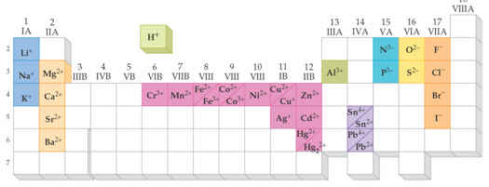

* + Ions in ionic compounds are arranged in 3-D structures called a crystal lattice and therefore only EMPIRICAL formulas are used to show the smallest whole # ratio of ions in the compound

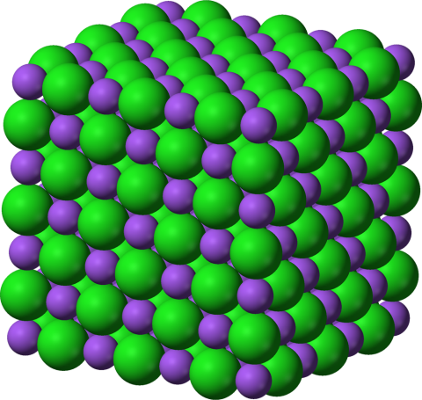

* + Each Na+ in sodium chloride is surrounded by 6 Cl- and each Cl- is surrounded by 6 Na+ so we actually have a 1:1 ratio 🡪 NaCl
  + Although ionic compounds are made up of (+) and (-) ions, the compounds themselves have a total charge of ZERO and are NEUTRAL
  + That means the (+) and (-) charge has to balance so when figuring out the empirical formula for an ionic compound we CRISS-CROSS the charges to become the subscripts on the opposite ion and then reduce the formula (if needed)

http://schoolbag.info/chemistry/central/central.files/image213.jpg

* + If you have more than one unit of a polyatomic ion it must be placed in PARENTHESIS with the subscript after the parenthesis

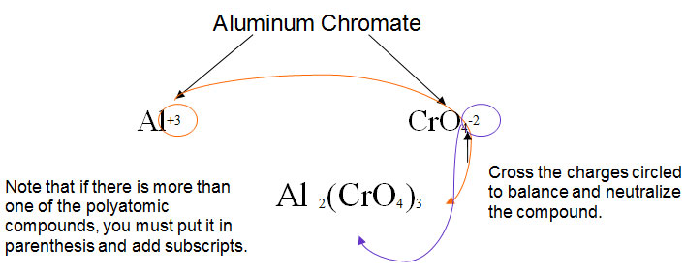

* + No parenthesis are needed if your subscript is ONE on a polyatomic ion
* **Naming Inorganic Compounds:**
  + Chemical nomenclature is used for naming compounds
  + System of assigning a unique name to every individual compound
  + Some compounds are known for their common names (NH3 – ammonia)
  + Organic molecules have their own system for naming
  + Inorganic based on the following system and depend on the type of compound that is involved
  + **Names and Formulas of IONIC compounds:**
    - Naming Ionic Compounds is easy – they are all made of (+) and (-) ions so to name any ionic compound--***Name the (+) ion first and the (-) ion last***
    - The trick is knowing HOW to name the IONS!!!
    - CATIONS formed from metal atoms have the same name as the metals plus the word “ION”

http://schoolbag.info/chemistry/central/central.files/image217.jpg

* + - If a metal can form CATIONS with different charges (most transition metals and post-transition metals) then the (+) charge is indicated by a ROMAN NUMERAL in parentheses following the name of the metal

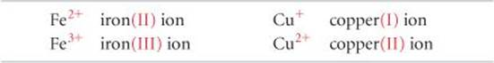

* + - Old system used suffixes (“-IC” for HIGHER charge and “-OUS” for LOWER charge) and the Latin root name of the metal

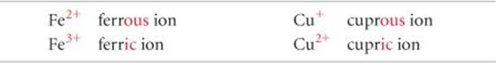

* + - CATIONS formed from nonmetal atoms that end in “-IUM”

http://schoolbag.info/chemistry/central/central.files/image221.jpg

***COMMON CATIONS***

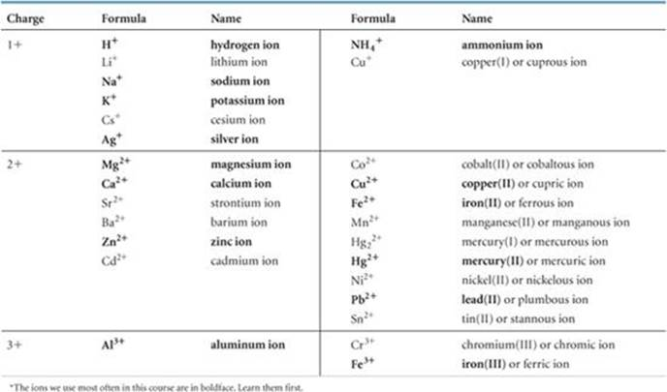

* + - ANIONS of monatomic ions are named by replacing the ending of the element name with “-IDE”

http://schoolbag.info/chemistry/central/central.files/image223.jpg

* + - A few POLYATOMIC IONS also end in “-IDE”

http://schoolbag.info/chemistry/central/central.files/image224.jpg

* + - POLYATOMIC IONS that contain O (OXYANIONS) have the endings “-ATE” (MORE) and “-ITE” (LESS) to indicate how many oxygen atoms the ion contains

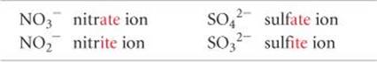

* + - When there is more than just 2 possibilities of number of O atoms then the prefixes “PER-“ (ABOVE) and “HYPO-“ (UNDER) are used

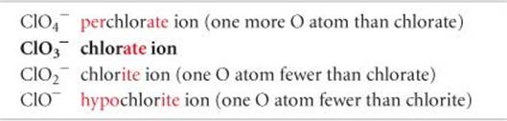

***Procedure for Naming Anions***

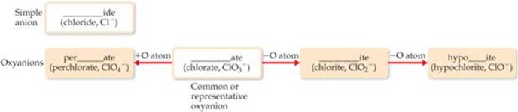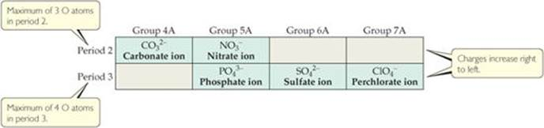

* Anions derived by adding H+ are named by adding the prefix hydrogen or dihydrogen. The old method uses the prefix “bi-“

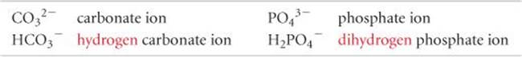

**Names of Common Anions**

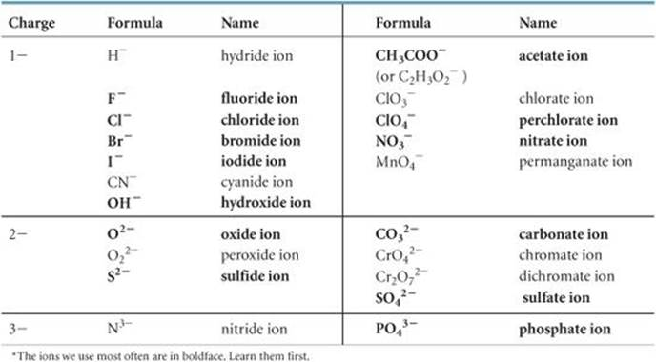

* Names of IONIC COMPOUNDS are named by naming the (+) ion then the (-) ion
  + **Names and Formulas of ACIDS:**
    - Acid is a molecule that produces H+ when dissolved in water
    - Generic formula: HA
    - Acids containing anions whose names end in “-IDE” are named by using the prefix “HYDRO-“ then the root of the anion and change the ending to “-IC ACID”

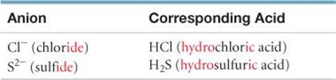

* + - Acids containing anions whose names end in “-ATE” or “-ITE” (OXYACIDS) are named by changing ATE 🡪 IC and ITE 🡪 OUS and then adding the word ACID

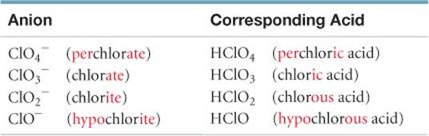

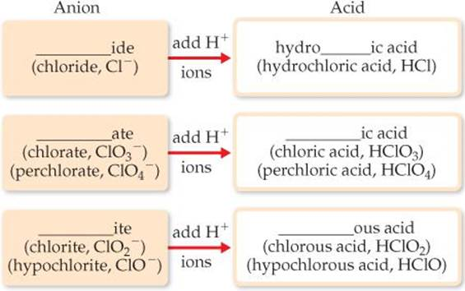

* + **Names and Formulas of BINARY MOLECUES:**
    - Name the element that is farther LEFT on the Periodic Table (except when O is combined with a HALOGEN, the halogen is named first)
    - If both elements are in the same group, the LOWER one is named first
    - The name of the second element is given the “-IDE” ending
    - Greek prefixes indicated the number of atoms of each element in ONE MOLECULE. (Mono- is never used at the start of the name!)

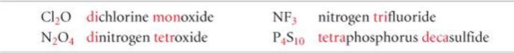

**Prefixes used for Molecules:**

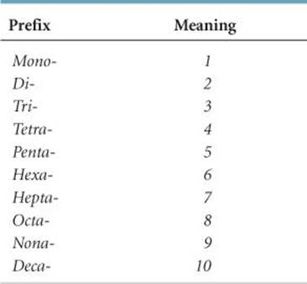

* Some Simple Organic Compounds:
  + Organic chemistry—study of compounds containing Carbon
  + Also contain H, and sometimes O, N, or halogens
  + Alkanes
    - Hydrocarbons—contain only C and H
    - Alkanes – simplest hydrocarbons containing only C—C single bonds
    - Alkanes are SATURATED hydrocarbons
    - Names end in “-ANE”

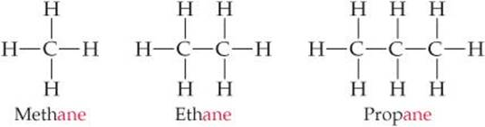

* + Some Derivatives of Alkanes
    - Alcohol—has the functional group –OH in the formula
    - Names end in “-OL

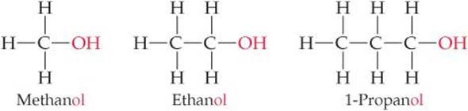

* + - Compounds with the same molecular formula but different structural formulas are called ISOMERS

