Categories | 4 Points  S-Satisfactory | 3 Points  S-Satisfactory/I-Improving | 2 Points  N-Needs Improvement | 1 Point  U-Unsatisfactory
Sentences | Writes more than 5 sentences on topic | Writes 4-5 sentences on topic | Writes 1-3 sentences on topic | Writes random words or letters
Capitalization: (first word in sentence, I, and proper nouns) | Uses correct capitalization 100% of the time | Uses correct capitalization 80% of the time | Uses capitalization inconsistently | Does not use capitalization
Punctuation | Correct end punctuation is used 100% of the time | Correct end punctuation is used 80% of the time | Correct end punctuation is used inconsistently | Does not use end punctuation
Spacing | Spacing is correct 100% of the time | Spacing is correct 80% of the time | Spacing is inconsistent | Does not use spacing
Words: (cvc, blends, digraphs) | Words are spelled correctly based on phonics skills taught 100% of the time | Words are spelled correctly based on phonics skills taught 80% of the time | Words are spelled correctly based on phonics skills taught 50% of the time | Does not spell words correctly based on phonics skills taught
High Frequency Words: (students can utilize word walls, student dictionaries, etc.) | Spells HF words correctly 100% of the time | Spells HF words correctly 80% of the time | Spells HF words correctly 50% of the time | Does not spell HF words correctly
Illustration | Illustration matches text (See Picture Drawing Rubric Below) | Illustration matches text (See Picture Drawing Rubric Below) | Illustration matches text (See Picture Drawing Rubric Below) | Illustration does not match text
_____ out of 28 Points BOY _____ out of 28 Points MOY _____ out of 28 Points EOY
(In order to formulate a percentage, you must give each of the 7 categories an individual score of 1-4 points based on the rubric above.
Then divide the total number of points by 28 (max. points). Ex. 26 out of 28 Points = 93%
*Aligns with the Conventions of Writing Developmental Scale from the Kid Writing Manual by Eileen Feldgus Ed.D.
4  - Background is evident  - Variety of colors used correctly (ex. sun is yellow)  - Many details are evident  - Colored neatly and appropriately  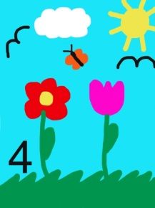 | 2  - No background  - No details  - Beginning to use different colors  - Beginning to color inside the lines  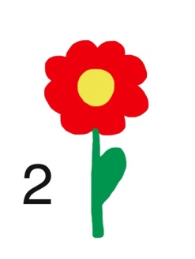
3  - Background is evident  - Variety of colors used correctly (ex. sun is yellow)  - Some details are evident  - Colored neatly and appropriately  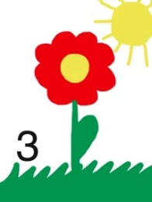 | 1  - No background  - No details  - Single color  - Often scribbled  