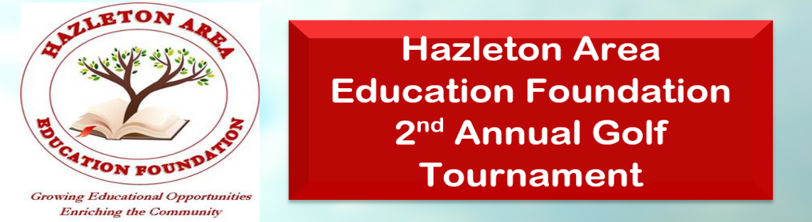
Tournament Date: June 21st, 2025
Sponsorship Packages
Red Package ($3000)
- (4) Yard Signs
- Recognition on The Foundation's website
- Logo displayed in program
- Logo displayed on T-shirt (Includes 3 T-shirt)
- Sponsoring a table or contest (Call for Available Options)
- Ad at High School Sporting Events (2024-2025 Season)
- Includes 4 golfers
- (1) Sponsorship for Teacher of the Month
Silver Package ($1500)
- (3) Yard Sign
- Recognition on The Foundation's website
- Logo displayed in program
- Logo displayed on T-shirt (Includes 1 T-shirt)
- Includes 4 golfers
White Package ($500)
- (2) Yard Sign
- Recognition on The Foundation's website
- Logo displayed in program
- Includes 2 dinner tickets
Hole Sponsorship Package ($200)
- (1) Yard Sign
- Recognition on The Foundation's website
Hazleton Area Education Foundation Sponsorship Form
Please Circle One
Red Package: $3000 Silver Package: $1500 White Package: $500 Hole Sponsorship Package: $200
Name: Business:
Address: Phone:
Email:
Please Return Registration Form and Payment to:
Hazleton Area Education Foundation
1515 West 23rd Street Hazle Township, PA 18202
For more information, please contact: Wister Yuhas at 570-751-6264

