**Chemistry IA - Quantum Model of the Atom & Electron Arrangements**

**- Problems with Earlier Atomic Models:**

- Dalton’s atomic theory stated that the atom was the smallest particle

EVER, but when the electrons were discovered (along with the other

subatomic particles) that had to be changed

- also, when the neutron was discovered and isotopes then it was possible

to have different atoms of the same element with a different mass

- Rutherford showed that the Plum Pudding model of J.J. Thomson was

wrong when he discovered the nucleus

- Rutherford’s model of the atom has a dense (+) charged core where

almost all of the mass is concentrated (NUCLEUS) but just has the (-)

electrons somewhere outside of the nucleus

- What keeps the electrons from crashing into the nucleus (since NEGATIVE charge is ATTRACTED to POSITIVE charge)?????

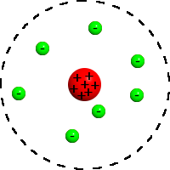

- **Bohr’s Atomic Model – The Planetary Model:**

- Neils Bohr came up with the Planetary Model of the atom that had the

electrons (based on the quantum rule of Max Planck) assigned to

particular ORBITS called energy levels or SHELLS

- electrons would maintain a certain amount of energy (QUANTUM) in

these orbits and revolve around the nucleus at the center of the atom

much like the planets revolve around the sun

- Bohr used quantum mechanics to assign particular energy levels that an

atom would have and said that electrons would only be located in these

particular energy levels

- ENERGY LEVELS are like the rungs of a ladder… electrons cannot be found

in between (only on the energy levels)

- the problem with the Bohr Model is that the mathematics ONLY work for

HYDROGEN and its single electron but not for the other elements and the

multiple electrons

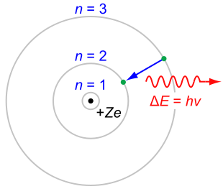

- **Some Background Information about Waves & Wave Theory:**

- Electromagnetic Radiation (EMR) – has an electric component and a

magnetic component

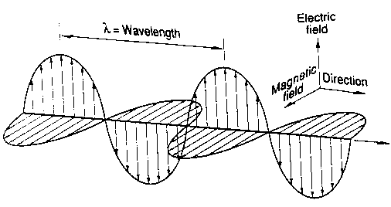

- light is a part of the EMR spectrum

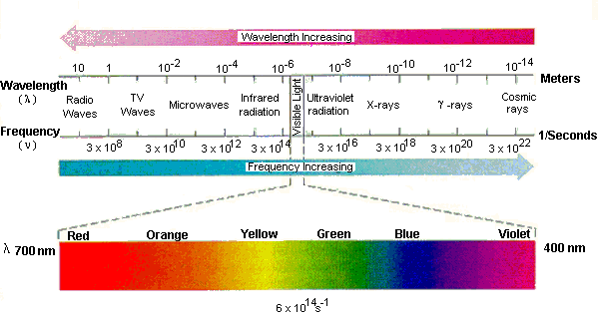

- Components of a Wave:

1) **wavelength** (λ) – the distance between corresponding points on

adjacent waves (crest 🡪 crest or trough 🡪 trough)

2) **frequency** (ν) – the number of waves passing a particular point in

space in a given amount of time (measured in Hertz (Hz or /sec))

3) **amplitude** – the distance from the origin to the peak of a wave

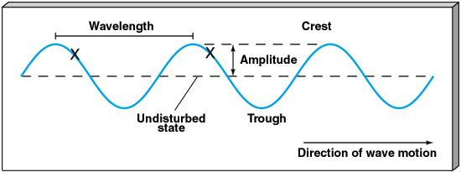

- the WAVELENGTH and FREQUENCY of EMR waves are

INVERSELY PROPORTIONAL to each other (if one increases,

the other decreases)

- **c = λ·ν**

where “c” is the speed of light in a vacuum (3.0 x 108 m/sec)

- if λ INCREASES, then ν will DECREASE

- **Contributors to the Quantum Model of the Atom:**

- Max Planck - energy is released and absorbed by atoms is certain FIXED

AMOUNTS called QUANTA

- Albert Einstein - determined that radiant energy is quantized in discrete

energy packets called PHOTONS

- light can behave as both a WAVE and a PARTICLE

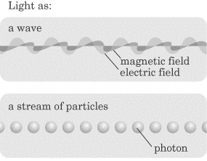

- Einstein also explained the PHOTOELECTRIC EFFECT using quantum

mechanics since it could NOT be explained by wave theory

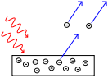

The photoelectric effect. Incoming photons on the left strike a metal plate (bottom), and eject electrons, depicted as flying off to the right.

- from Einstein’s work on the photoelectric effect, he said that electrons can receive energy from an electromagnetic field ONLY in

discrete portions called PHOTONS

- the amount of energy (E) is determined by the equation

E = hν

where h is Planck’s constant (h = 6.626 x 10-34 J·sec)

- An explanation of Atomic Spectra:

- GROUND STATE – electrons in their normal LOWEST possible

energy level

- EXCITED STATE – electrons in HIGHER energy levels than can

possibly be in

- it takes a quantum of energy (E = hν) to raise an electron to the

excited state and it gives off a PHOTON of energy as it drops back

down to the ground state

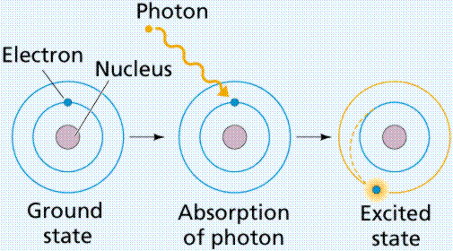 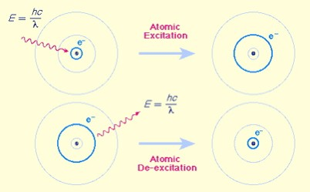

- 3 Atomic Emission Spectra Series:

1) LYMANN – formed when electrons fall to the FIRST ENERGY

LEVEL [UV spectrum]

2) BALMER – formed when electrons fall to the SECOND

ENERGY LEVEL [visible light part of spectrum]

3) PASCHEN – formed when electrons fall to the THIRD

ENERGY LEVEL [IR spectrum]

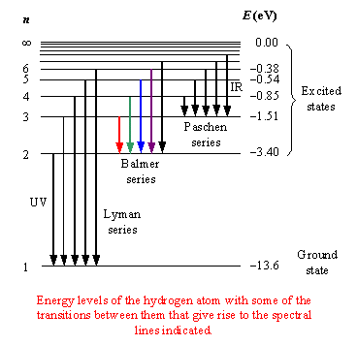

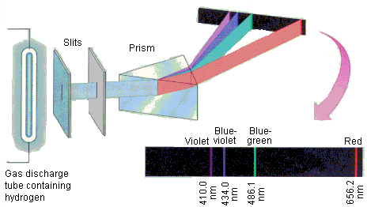

- Other contributors to Quantum Theory:

- Louis de Broglie—developed an equation that described the

wavelength of moving particles (WAVE MECHANICS)

- said motions of subatomic particles and atoms are as waves

- Werner Heisenberg – came up with the Heisenberg Uncertainty

Principle (***it is impossible to know the position and the speed of a***

***particle at the same time***)

- Erwin Schrodinger—made mathematical formulas for finding an

electron’s position within the atom (deals with PROBABILITY)

- ELECTRON CLOUD – region of 90% probability of finding an electron

- Atomic Orbitals:

- PRINCIPAL ENERGY LEVEL—the average distance of an electron

from the nucleus

- principal energy levels are made up of SUBLEVELS which are made

up of ORBITALS

- SUBLEVELS—give information about the SHAPE of the electron

cloud where the electron is

- ORBITALS—give information about the 3-D ORIENTATION of the

electron cloud with respect to the x, y and z axes

- these electron positions are given by a set of 4 QUANTUM #s:

1) PRINCIPAL quantum number—tells the main energy level

an electron is in

- symbol = n

- values are n = 1, 2, 3, …7

- if n = 1, 1st energy level and so on…

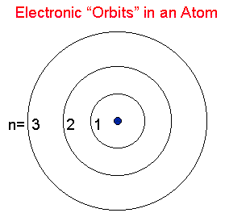

2) ORBITAL quantum number—tells the sublevel type (shape)

- symbol = L

- values are L = 0, 1, 2, 3, … (n – 1)

- only 4 important values:

- L = 0 🡪 “s” sublevel (sphere)

- L = 1 🡪 “p” sublevel (dumbbell)

- L = 2 🡪 “d” sublevel (double rosette)

- L = 3 🡪 “f” sublevel (complex shapes)

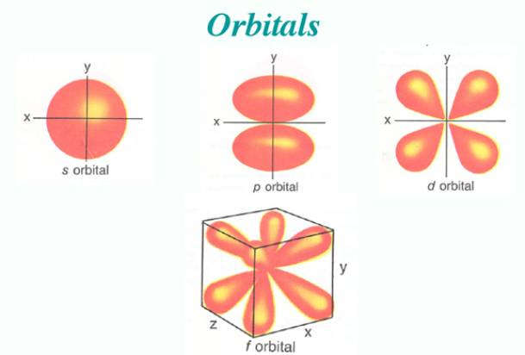

3) MAGNETIC quantum number—tells the orientation of the

sublevel in space (3-D)

- symbol = ML

- values are ML = – L to + L

- it is the NUMBER of possible values that are important

- tells how many orbitals make up a sublevel!!!!

- “s” sublevels 🡪 1 orbital (0)

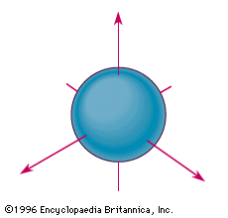

- “p” sublevels 🡪 3 orbitals ( -1, 0, 1)

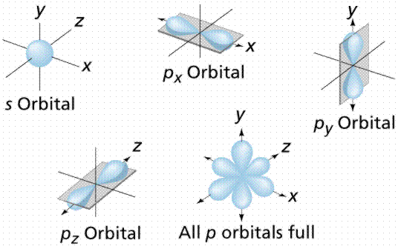

- “d” sublevels 🡪 5 orbitals ( -2, -1, 0, 1, 2)

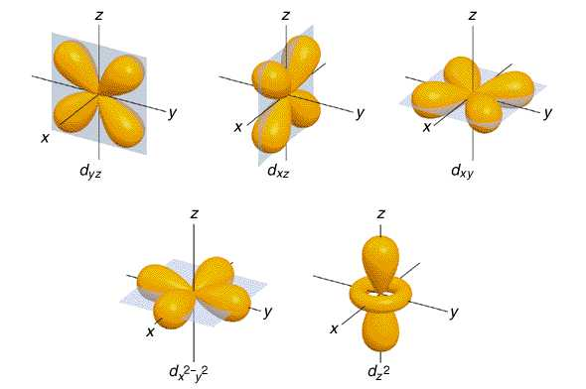

- “f” sublevels 🡪 7 orbitals ( -3, -2, -1, 0, 1, 2, 3)

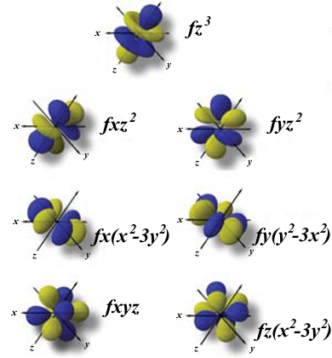

4) SPIN quantum number—tells the spin of the electron in an

orbital

- symbol = MS

- values are MS = +1/2 (clockwise) or –1/2 (counter)

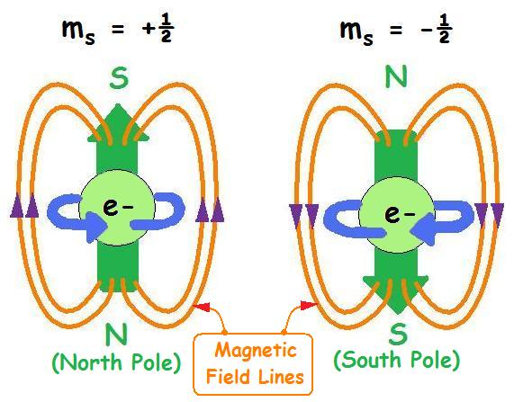

- Electron Arrangement in Atoms:

- Electron Configurations:

- electron configurations—the way that electrons are arranged

around the nucleus of the atom

- 3 Rules:

1) Aufbau Principle—electrons always enter orbitals of

LOWEST energy first

- fill the orbitals in sublevels according to the Aufbau Series

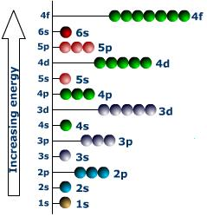 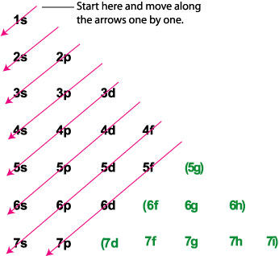

So series goes ***1s, 2s, 2p, 3s, 3p, 4s, 3d, 4p, 5s, 4d, 5p, 6s, 4f, 5d, 6p, 7s, 5f, 6d, 7p***

2) Pauli Exclusion Principle—no 2 electrons in the SAME

ATOM can have the same set of all 4 quantum numbers

- orbitals hold a maximum of 2 electrons

- for 2 electrons to be in the same orbital they MUST

have opposite spins (different spin quantum numbers)

3) Hunds Rule—when electrons are filling orbitals in a

sublevel, ALL orbitals must have at least one SINGLE

electron with the SAME spin as the others before any

pairing of electrons occur

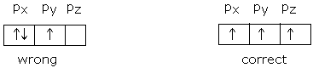

**Some Helpful Numbers**

|  |  |  |  |  |
| --- | --- | --- | --- | --- |
| **ORBITAL QUANTUM NUMBER** | **SUBLEVEL TYPE** | **SHAPE of SUBLEVEL** | **# of orbitals making up sublevel** | **TOTAL # of electrons in sublevel (Filled)** |
| 0 | s | Sphere | 1 | 2 |
| 1 | p | Peanut | 3 | 6 |
| 2 | d | Double rosette | 5 | 10 |
| 3 | f | Complex shapes | 7 | 14 |

|  |  |  |  |  |
| --- | --- | --- | --- | --- |
| **ENERGY LEVEL** | **PRINCIPAL QUANTUM NUMBER (n)** | **# of SUBLEVELS in ENERGY LEVEL** | **Sublevels making up energy level** | **TOTAL # of electrons in Energy Level** |
| 1 | n = 1 | 1 | s | 2 |
| 2 | n = 2 | 2 | s, p | 8 |
| 3 | n = 3 | 3 | s, p, d | 18 |
| 4 | n = 4 | 4 | s, p, d, f | 32 |

**- Arrangement of Electrons in Atoms:**

**- Electron Configuration Notation:**

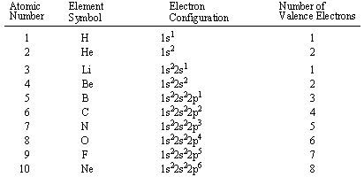

**- Orbital Notation:**

**H**

**1s**

**He**

**1s**

**Li**

**1s 2s**

**Be**

**1s 2s**

**B**

**1s 2s 2p**

**C**

**1s 2s 2p**

**N**

**1s 2s 2p**

**O**

**1s 2s 2p**

**F**

**1s 2s 2p**

**Ne**

**1s 2s 2p**