Categories | 4 Points | 3 Points | 2 Points | 1 Point
Sentences | Writes more than 3 sentences on topic | Writes 3 sentences on topic | Writes 1-2 sentences on topic | Writes or draws to convey a message
Capitalization of first word | Capitalizes the first word and the pronoun I 100% of the time | Capitalizes the first word and the pronoun I 80% of the time | Capitalizes first word inconsistently | Often does not capitalize the first word of the sentence
Punctuation | End punctuation is used correctly 100% of the time | End punctuation is used correctly 80% of the time | End punctuation is used incorrectly and inconsistently | Does not use end punctuation
Spacing | Spacing is correct 100% of the time | Spacing is correct 80% of the time | Spacing is inconsistent | No spacing
Words | Words are spelled phonetically (advanced and CVC words) | Words are spelled phonetically (CVC words only) | Writes some words phonetically | Uses letter-like forms or random letter strings
Vowels | Uses vowels correctly 100% of the time | Uses vowels correctly 75% of the time | Uses vowels correctly 50% of the time | Little or no use of vowels
Sight Words | Spells sight words correctly 100% of the time | Spells sight words correctly 75% of the time | Spells sight words correctly 50% of the time | Little or no sight words are spelled correctly
Illustration | Illustration matches text (See Picture Drawing Rubric Below) | Illustration matches text (See Picture Drawing Rubric Below) | Illustration matches text (See Picture Drawing Rubric Below) | Illustration does not match text, but draws a somewhat recognizable picture

_____ out of 32 Points BOY _____ out of 32 Points MOY _____ out of 32 Points EOY
(In order to formulate a percentage, you must give each of the 8 categories an individual score of 1-4 points based on the rubric above.
Then divide the total number of points by 32 (max. points). Ex. 28 out of 32 Points = 88%
*Aligns with the Conventions of Writing Developmental Scale from the Kid Writing Manual by Eileen Feldgus Ed.D.
4  - Background is evident  - Variety of colors used correctly (ex. sun is yellow)  - Many details are evident  - Colored neatly and appropriately  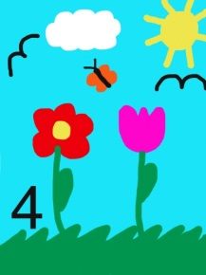 | 2  - No background  - No details  - Beginning to use different colors  - Beginning to color inside the lines  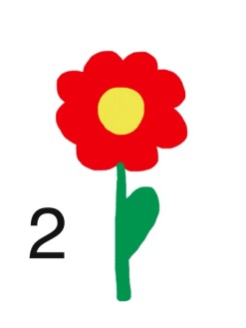
3  - Background is evident  - Variety of colors used correctly (ex. sun is yellow)  - Some details are evident  - Colored neatly and appropriately  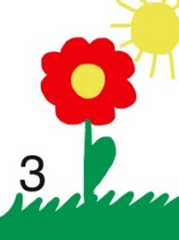 | 1  - No background  - No details  - Single color  - Often scribbled  