**Organic Chemistry – Alkanes & Cycloalkanes NOTES**

**- Alkanes (Aliphatic Hydrocarbons):**

- alkane—hydrocarbon compound (contains only C and H) that also contain

ONLY SINGLE bonds

- also called saturated hydrocarbons (because they contain the maximum

amount of H that will fit on the carbon chain

- also known as aliphatic hydrocarbons

- General Formula: **CnH2n+2**

- alkanes generally come from fossil fuels

**- Naming Alkanes:**

- names of alkanes serve as the foundation for naming everything else in

organic chemistry

- named for the number of carbons in the chain with the ending “-ANE”

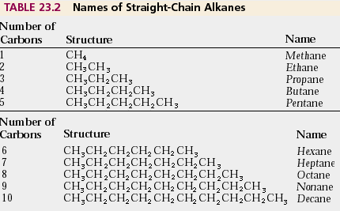

Image courtesy of <http://wps.prenhall.com/wps/media/objects/4681/4793602/ch23_05.htm>

- notice that the chains get longer by adding “-CH2-“ to the middle and

there are always “CH3”s on the ends

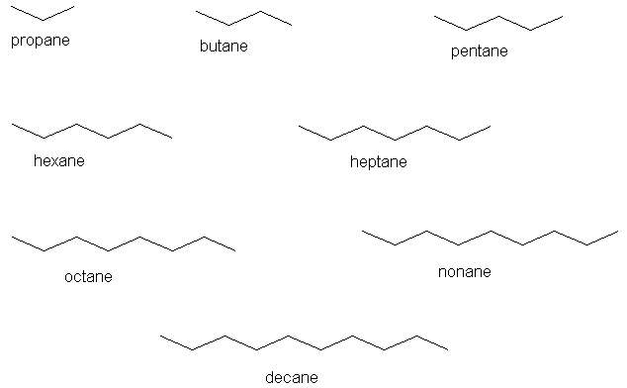

Image courtesy of <http://elchem.kaist.ac.kr/jhkwak/OkanaganPdb97/nomenclature/ane-100.htm>

**- Alkyl Groups (Side Chains):**

- alkyl groups—small alkane chains that “branch off” from the main chain

- these side groups are typically named after the root alkane but changing

the ending to “-YL”

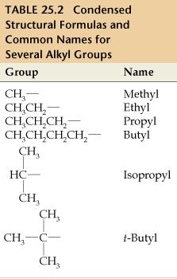

Image courtesy of <http://www.thaiblogonline.com/Goodfriend.blog?PostID=21382>

- the prefix **“ISO-“** means the same or equal (branch attachment at the

MIDDLE of the chain)

- the prefix **“N-“** (normal) refers to a STRAIGHT CHAIN

- there are also varying degrees of substitution:

1) PRIMARY (1o) carbon—bonded to only ONE other carbon atom

(this carbon is always at the END of the chain!)

2) SECONDARY (2o) carbon—bonded to 2 other carbon atoms (in the

middle of the chain) **{PREFIX 🡪 “SEC-“}**

3) TERTIARY (3o) carbon—bonded to 3 other carbon atoms (in the

middle of the chain with a branch attached to it) **{PREFIX 🡪**

**“TERT-“ or “t-“}**

4) QUARTERNARY (4o) carbon—bonded to 4 other carbon atoms

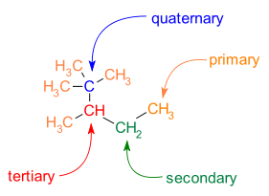

Image courtesy of <http://en.wikipedia.org/wiki/Carbon%E2%80%93carbon_bond>

**- IUPAC Names for Alkanes:**

- PARENT CHAIN—the longest unbroken chain of carbon atoms in the

molecule

- SUBSTITUENT—generic term for any group that does NOT belong to the

main chain

*\*\*NOTE: Right now, substituent will only refer to alkyl groups but in*

*later chapters this could be a lot of other groups as well!!\*\**

1) Root name for the alkane is the name of the PARENT CHAIN

2) Assign NUMBERS to each carbon in the PARENT CHAIN starting at the

side that is CLOSEST to the first point of branching

- this may NOT always be left 🡪 right!!

3) Identify the names of the SUBSTITUENT groups and NUMBER them

according to their position on the parent chain

4) Write the names of the substituents ALPHABETICALLY followed by the

name of the parent alkane

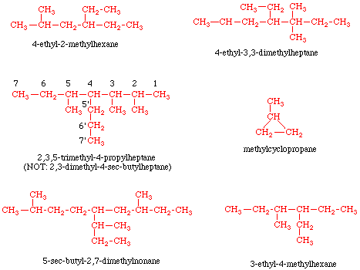

Image courtesy of <http://butane.chem.uiuc.edu/cyerkes/Chem104A_BFA05/Genchemref/nomenclature_rules.html>

*Ex. Name this molecule according to IUPAC rules:*

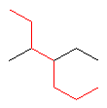

*Ex. Draw the line drawing for 2,3,4-trimethylheptane*

**- Constitutional Isomerism:**

- constitutional isomers—compounds which have the SAME molecular

formula but have different arrangements of atoms

- structure and properties of each compound are very different

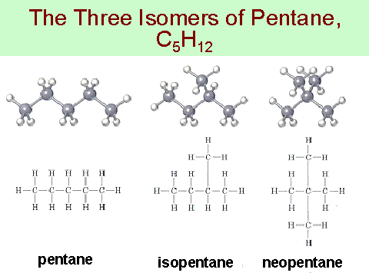

Image courtesy of <http://www6.miami.edu/chem/chm201c/notes/ch03/sld036.htm>

**- Conformations of Alkanes:**

- alkanes contain only σ bonds (SINGLE!)

- a C—C single bond is FREELY ROTATING

- if we consider the structure of ETHANE (C2H6) we can see that the C—C

bond freely rotates to give 2 possible conformations

- staggered conformation—H atoms are 60o rotated away from the plane

of the H atoms on the other C atom

- eclipsed—H atoms line up in the same plane as the H atoms on the other

C atom

- Newman Projections—give the point of view of looking down the C—C so

you may see how the H line up against each other

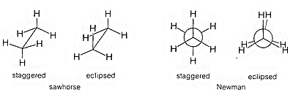

Image courtesy of <http://www.organicchemistry.com/representation-of-organic-structure-conformational-drawings/>

- molecules such as ethane prefer the STAGGERED conformation because

there is less repulsion between electron clouds in this configuration when

compared to the higher TORSIONAL STRAIN of the eclipsed conformation

- this becomes even more true when there are larger substituents than just

H atoms on the carbons!!

**- Physical Properties of Alkanes:**

- alkanes are NONPOLAR (hydrophobic!)

- have relatively LOW melting and boiling points in comparison with other

molecules

- this is because there are only London Dispersion forces holding

them together

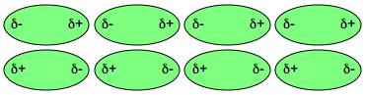

Image courtesy of <http://bdml.stanford.edu/twiki/bin/view/Rise/InvestigationOfVanDerWaalsForce.html>

- the bigger the alkane molecule, the HIGHER the melting and boiling

points

- bigger molecules will have stronger attractions to each other which

will make it harder to pull them apart in order to melt or boil

- **Reactions of Alkanes:**

- alkanes are not tremendously reactive

- major reactions that alkanes undergo are combustion reactions (burning

with O2 to release heat energy)

- the products from this reaction are CO2 and H2O vapor

**CnH2n+2 + O2 🡪 CO2 + H2O + energy**

**- Cycloalkanes:**

- cycloalkanes—alkanes in which the carbons are connected to form a ring

structure (still all SINGLE bonds!)

- General Formula: **CnH2n**

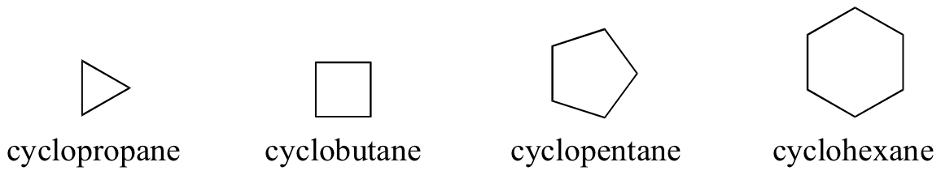

Image courtesy of <http://chemwiki.ucdavis.edu/Organic_Chemistry/Organic_Chemistry_With_a_Biological_Emphasis/Chapter__1%3A_Chapter_1%3A_Introduction_to_organic_structure_and_bonding_I/Section_1.4%3A_Functional_groups_and_organic_nomenclature>

- **Naming Cycloalkanes:**

- named just like alkanes but the prefix “CYCLO-“ is added to the parent

ring chain

- substituent groups are named simply by putting the name of the side

group in front of the parent alkane

- *Ex. propylcyclohexane*

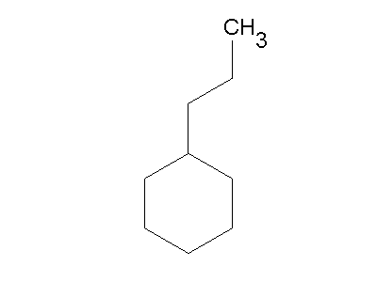

Image courtesy of <http://www.chemsynthesis.com/base/chemical-structure-8236.html>

- if there are 2 groups substituted on the ring, then rank them in

alphabetical order

- the C attached to the first group (alphabetically) is given the

number “1” and the rest of the carbons in the ring are numbered in

the direction that gives the LOWEST number to the C attached to

the second group (alphabetically)

- *Ex. 1-ethyl-3-methylcyclohexane*

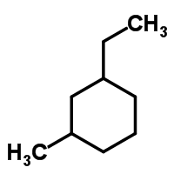

Image courtesy of <http://www.chemspider.com/Chemical-Structure.32594.html>

- for 3 or more groups, follow the same rules as for naming alkanes

- *Name the following molecule:*

*- Draw the structure (line drawing) for 1,1,2-trimethylcyclobutane*

**- Cis-Trans Isomerism in Cycloalkanes:**

**-** cis-trans isomerism—all atoms in the molecule are bonded to each other

in the SAME pattern but point in DIFFERENT directions

- these are NOT resonance structures because they differ in more than just

single/double bonds

- the prefix **“CIS-“** means on the SAME side

- the prefix **“TRANS-“** means on OPPOSITE sides (ACROSS)

- *Ex. 1,2 dimethylcyclopentane:*

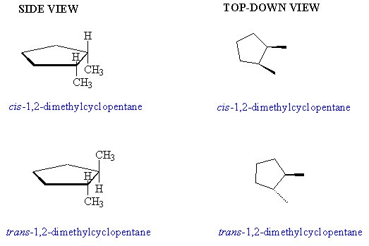

Image courtesy of <http://www.webgenchem.com/scI11024.htm>

- **Ring Strain:**

- ring strain—a measure of instability in a cyclic ring structure due to angle

strain caused by unfavorable C—C bond angles and torsional strain

(eclipsing substituents on adjacent C atoms)

- *Ex. Cyclopropane & Cyclobutane*

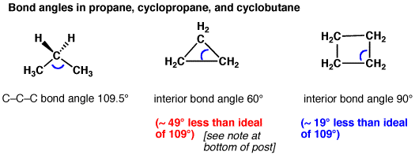

Image courtesy of <http://www.masterorganicchemistry.com/2014/04/03/cycloalkanes-ring-strain-in-cyclopropane-and-cyclobutane/>

- as the ring gets BIGGER (more Cs) the bond angles get BIGGER (so less

angle strain!!)

- the rings may BEND a bit to relieve torsional strain

- **Structure of Cyclohexane:**

- while cyclopropane, cyclobutane and cyclopentane all have some degree

of bond angle strain, cyclopentane is almost the exact desired 109.5o!!

- cyclohexane is not flat (or the bond angles would make it very unstable!)

- cyclohexane forms either the “CHAIR” or “BOAT” conformation!!

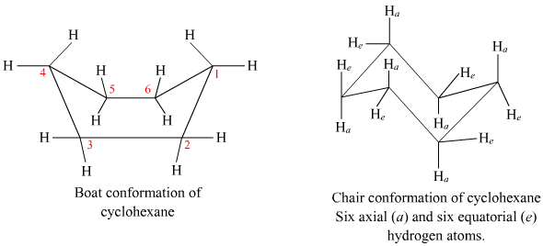

Image courtesy of <http://www.meritnation.com/ask-answer/question/explain-boat-and-chair-isomers-of-cyclohexane-in-detail/ha.../4339938>

- these 2 conformations may be converted into each other but the CHAIR

conformation is strongly favored

- in the CHAIR conformation there is NO torsional strain because all of the

hydrogens are STAGGERED and the hydrogens are either in the AXIAL

position (pointing straight UP and DOWN) or the EQUITORIAL position (in

the plane of the ring) and these 2 positions ALTERNATE!!

- in the BOAT conformation, there IS torsional strain because the

hydrogens are ECLIPSED and the HYDROGENS on carbons 1 and 4 are

pointed TOWARD each other which is an UNSTABLE conformation

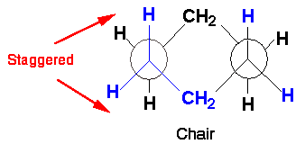 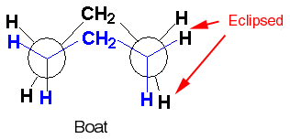

Image courtesy of <http://archives.library.illinois.edu/erec/University%20Archives/1505050/Organic/Alkanes/AlkaneText/sec1-14/1-14.htm>

- **Monosubstituted Cyclohexanes**

- if a CH3 or larger group is substituted for one of the H in cyclohexane it is

MORE STABLE in the EQUITORIAL position of the CHAIR conformation

- there is a tendency for a 1,3-DIAXIAL INTERACTION of the CH3 with the H

when it is in the AXIAL position that is LESS STABLE which is known as

STERIC HINDRANCE

- steric hindrance (steric strain)—instability caused by two substituent

groups bumping into each other (becomes LARGER as the groups get

LARGER)

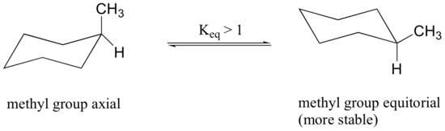 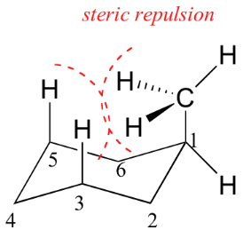

Images courtesy of <http://chemwiki.ucdavis.edu/Organic_Chemistry/UMM_chemwiki_project/Conformation_and_Stereochemistry/Conformational_isomerism%3A_cyclic_molecules>

- **Disubstituted Cyclohexanes:**

- *Ex. cis-1,2-dimethylcyclohexane vs. trans-1,2-dimethylcyclohexane*

- in the CIS formation ONE CH3 MUST be in the AXIAL position so

some STERIC HINDRANCE will always occur and no conformation is

favorable over the other

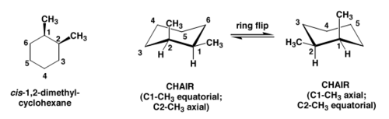

- in the TRANS formation, one conformation has BOTH CH3s in the

AXIAL and the other conformation has BOTH in EQUITORIAL and

the EQUITORIAL conformations are FAVORED!!

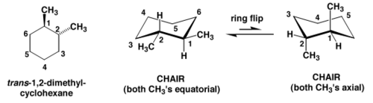

Images courtesy of <http://openwetware.org/wiki/Todd:Chem3x11_ToddL3>

- *Ex. cis-1,3-dimethylcycloalkane*

- in this molecule the diequitorial conformation will be much more stable

because there is a 1,3-diaxial interaction in the diaxial conformation

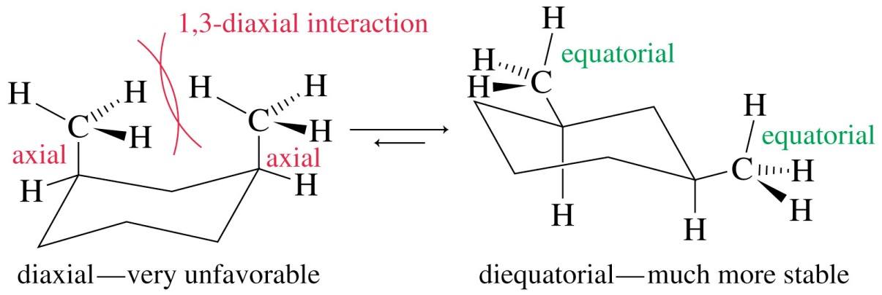

Image courtesy of <http://wps.prenhall.com/wps/media/objects/340/348272/wade_ch03.html>

- LARGE substituents definitely prefer to be in EQUITORIAL positions and

NOT AXIAL!!