**Chemistry IA – States of Matter & Gas Laws**

**- States of Matter:**

A. Solids:

- solid – has a definite volume and a definite shape

- particles closely packed together

- particles moving but only vibrating back and forth (do NOT change

location)

- particles arranged in a highly organized pattern

- most solids are crystalline with particles arranged in a CRYSTAL

LATTICE

- associated with RELATIVELY low temperatures

B. Liquids:

- liquid – has a definite volume but NO definite shape (takes the

shape of its container)

- particles are closely packed together

- particles FLOW past each other and change their location

- associated with RELATIVELY medium temperatures

C. Gases:

- gas – has NO definite volume and NO definite shape (fills whatever

container it is in)

- particles constantly moving in random directions

- associated with RELATIVELY high temperatures

**- Phase Changes:**

- a phase change is a change in the state of matter of a substance

- Phase Changes:

1) freezing – changing from LIQUID 🡪 SOLID

2) melting – changing from SOLID 🡪 LIQUID

3) vaporization – changing from LIQUID 🡪 GAS

4) condensation – changing from GAS 🡪 LIQUID

5) sublimation – changing from SOLID 🡪 GAS

- Vaporization:

- evaporation – changing from LIQUID 🡪 GAS at the SURFACE of the

liquid ONLY!!!

- vapor pressure – force due to the pressure of a gas above a liquid

(pressure resulting from evaporation in a closed container)

- boiling – the rapid vaporization of a liquid that takes place at the

boiling point of that liquid (occurs ALL throughout the liquid—NOT

just at the surface!!)

- boiling point – the temperature at which the vapor pressure of the

liquid is equal to the atmospheric pressure

- the boiling point depends on the PRESSURE!!!!

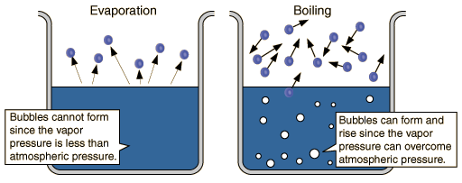

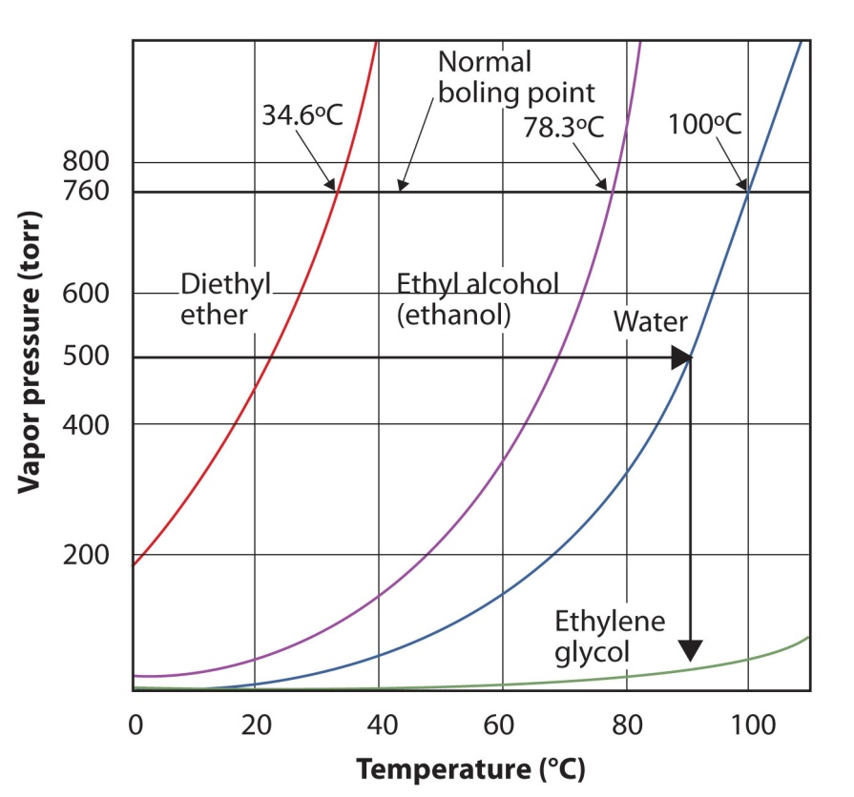

- Phase Diagrams:

- shows the temperature and pressure where the substance exists as

a solid, liquid and gas

- triple point – the temperature and pressure at which the substance exists in ALL THREE phases simultaneously (solid, liquid AND gas!!)  
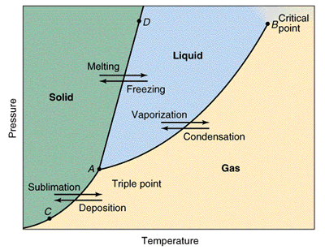

- Kinetic Molecular Theory of Gases:

- kinetic energy – energy of motion

1) all gases made of atoms or molecules

2) particles of a gas have lots of empty space in between (apart from each

other)

3) NO attractive or repulsive forces between particles

4) particles are constantly moving in random directions moving

independently of each other in straight directions

5) all collisions of particles are perfectly ELASTIC (no net loss of kinetic

energy)

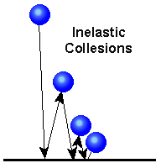 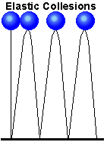

6) gases are compressible (particles can be packed closer together to

occupy LESS volume)

7) the average Kinetic Energy depends on the temperature

**- Gas Laws:**

- 4 variables that describe a gas:

1) Volume (V) – the amount of space the gas occupies

- typically measured in LITERS (L)

2) Temperature – the average kinetic energy of the particles

- ALL temperatures concerning gases MUST be measured in

KELVIN for the Gas Laws to work!!!!

3) amount of particles (moles) (n)

- measured in moles

4) Pressure (P) – the force per unit of area due to collisions of gas

particles with objects and container walls

- typically measured in kPa

- PRESSURE = Force / Area

- 1 atm = 760 torr = 760 mmHg = 101.3 kPa

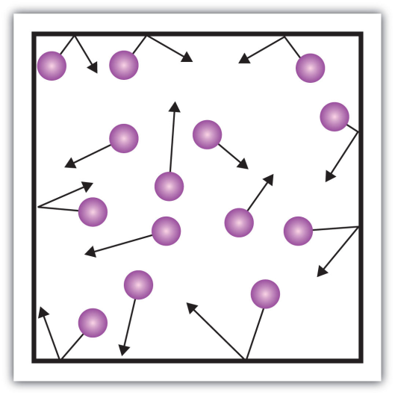

- Mathematics Review:

- 2 variables (X & Y) are DIRECTLY proportional if:

Y / X = k (k – proportionality constant)

- if Y INCREASES, X INCREASES

- if Y DECREASES, X DECREASES

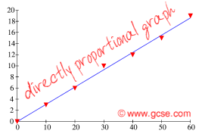

- 2 variables (X & Y) are INDIRECTLY (INVERSELY) proportional if:

Y * X = k (k – proportionality constant)

- if Y DECREASES, X INCREASES

- if Y INCREASES, X DECREASES

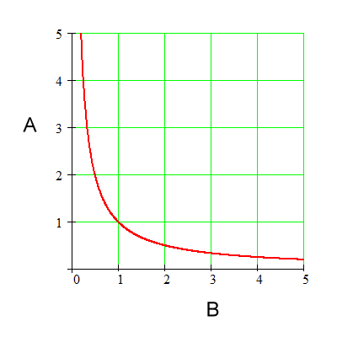

- **BOYLE’S LAW:**

- *if the temperature and amount are held constant, the PRESSURE of*

*a gas varies INVERSELY with the volume of that gas*

- so P and V are inversely proportional

- P x V = k

- for situation ONE: P1 x V1 = k

- for situation TWO: P2 x V2 = k

- so:

**P1 V1 = P2 V2**

- *Ex. A gas occupies a volume of 4.50 L at 3.0 atm. What would the*

*volume be at 1.00 atm?*

**V1 = 4.50 L P1 = 3.0 atm V2 = ?? P2 = 1.00 atm**

- **CHARLES’ LAW:**

- *if the pressure and amount of a gas are held constant, then the*

*VOLUME of a gas is DIRECTLY proportional to the KELVIN*

*TEMPERATURE*

- so V and T are directly proportional

- V / T = k

- for situation ONE: V1 / T1 = k

- for situation TWO: V2 / T2 = k

- so:

**V1 / T1 = V2 / T2**

- *Ex. A gas occupies a volume of 2.50 L at 25oC. What would the*

*volume of the gas be at 100oC??*

**V1 = 2.50 L T1 = 25oC + 273 = 298 K V2 = ?? T2 = 100oC + 273 = 373 K**

- **GAY-LUSSAC’S LAW:**

- *if the volume and amount of a gas is held constant, then the*

*PRESSURE of a gas is DIRECTLY proportional to the KELVIN*

*TEMPERATURE*

so P and T are directly proportional

- P / T = k

- for situation ONE: P1 / T1 = k

- for situation TWO: P2 / T2 = k

- so:

**P1 / T1 = P2 / T2**

- *Ex. A gas has a pressure of 2.00 atm at 25oC. What is the*

*temperature of the gas if the pressure doubles??*

**P1 = 2.00 atm T1 = 25oC + 273 = 298 K P2 = 4.00 atm T2 = ??**

- **COMBINED GAS LAW:**

- looks at how P, V and T affect each other when only the amount of   
 the gas is held constant

**P1 V1 P2 V2**

**------------ = -----------**

**T1 T2**

- *Ex. If a gas with a volume of 2.00 L is at 35oC and 1.5 atm, what*

*volume would it be at 50oC and 2.0 atm??*

**V1 = 2.00 L T1 = 35oC + 273 = 308 K P1 = 1.5 atm**

**V2 = ?? T2 = 50oC + 273 = 323 K P2 = 2.0 atm**

- **IDEAL GAS LAW:**

- all of the OTHER gas laws so far have been for situations where one

or more variables are CHANGING so you can measure the effect on

another variable

- the IDEAL GAS LAW simply relates the 4 variables that describe the

behavior of a gas together in one equation (NO CHANGES!!!)

- **PV = nRT**

- P is the pressure (usually in atm or kPa)

- V is the volume in LITERS

- n is the MOLES of gas

- T is the temperature in KELVIN

- R is the UNIVERSAL GAS CONSTANT

**R = 0.08206 L·atm/mol·K (if P is in ATM!!)**

**R = 8.314 L·kPa/mol·K (if P is in kPa!!)**

- *A 20.0 L container of He gas has 4.50 moles of He. What is the*

*pressure of this gas at 25oC??*

**V = 20.0 L n = 4.50 mol P = ?? T = 25oC + 273 = 298 K**

- **Standard Conditions for Gases:**

- Standard Temperature and Pressure (STP conditions) for gases are

PRESSURE = 1 atm ( = 760 mmHg = 101.3 kPa)

TEMPERATURE = 0oC ( = 273 K)

- Standard Molar Volume of a gas:

- the volume of ONE MOLE of any gas AT STP conditions would be:

- so ONE MOLE of ANY GAS at STP has a volume of 22.4 LITERS!!!

**- Gas Stoichiometry:**

- When an equation stoichiometry problem involves two gases at the same

temperature and pressure, the coefficients from the balanced equation

can be used to create a volume ratio that converts directly from volume

of one gas to volume of another.

Consider **two gases, A and B, at the same temperature and pressure**. The **ratio of their volume to the moles** of gas can be determined from the ideal gas equation.

http://www.mpcfaculty.net/mark_bishop/gas_st1.gif

http://www.mpcfaculty.net/mark_bishop/gas_st2.gif

If the two gases are **at the same temperature and pressure**, the **V/n ratio** for each gas must be the same.

http://www.mpcfaculty.net/mark_bishop/gas_st3.gif

**if   T = TA = TB   and   P = PA = PB**

If we ***rearrange*** the equation above, we see that ***the volume ratio of two gases at the same temperature and pressure is equal to their molar ratio***.

http://www.mpcfaculty.net/mark_bishop/gas_st4.gif

The **molar ratio** of the two gases is constructed from the **coefficients** in the balanced equation. Because the molar ratio is equal to the volume ratio for gases at the same temperature and pressure, the coefficients from the balanced equation can also be used to ***generate a factor that converts directly from volume of one gas to volume of another!!!!***

**- Gas Stoichiometry Problems:**

1) at STP conditions:

- the molar volume of a gas at STP = 22.4 L

- *If 37.5 g NaHCO3 reacts with an excess of HCl, how many L of CO2*

*are produced??*

NaHCO3 + HCl 🡪 NaCl + H2O + CO2(g)

37.5 g ? L

2) non standard (NOT STP) conditions:

- if the PRESSURE or TEMPERATURE changes, then the VOLUME IS

NOT 22.4 LITERS!!!!!

- *What volume of CO2 in LITERS will form if 550 g of CaCO3*

*decomposes and the CO2 that is formed is at a pressure of 2.5 atm*

*and a temperature of 30oC??*

***CaCO3 🡪 CaO + CO2***

**550 g ? L @ 2.5 atm & 30+273 = 303 K**

OR……….