**WORLD WAR II PROPAGANDA**

**POSTER PROJECT**

**(50 pts.)**

**Directions:**  You will be creating a propaganda poster based on the criteria below.  Each class will be assigned a specific country and you must create a poster that represents that country and its views.  **Your poster must be original, be your own work, and be colorful**.  **Do NOT copy and paste a poster from online onto your poster**.  If you do, you will receive a ZERO for this assignment!  You will not be graded on your ability as an artist, but rather your ability to create an interesting, visually appealing, and meaningful propaganda poster.  This project will be completed with a partner.    
   
**Requirements:**

* Made on an 8 ½ x11 (standard) piece of paper or larger
* Must include at least one image, have color, be visually appealing, and neatly presented.
* Must include a slogan that relates to the image and views of the poster.
* Must be written from one of the “viewpoints” listed below.
* Must represent a view that would be held in the country you are representing and be accurate to the views, beliefs, and culture of the country.
* Be free from grammatical and spelling errors.

**​​**  
Select one of the viewpoints listed below and create a propaganda poster using that viewpoint (and your country’s views/beliefs) as a guide when creating your poster.  Make sure to write what viewpoint you are using on your rubric in the assigned space!

* **Emotional Appeal**:  (i.e. fear, patriotism, guilt).  Appeals to the emotions of your audience.  For example, when a poster warns you that loose or careless talk could cost the lives of soldiers.
* **Bandwagon**:  The basic theme of a bandwagon appeal is that “everyone else is doing it, and so you should too”.
* **Glittering Generalities**: The act of referring to words or ideas that evoke a positive emotional response from the audience without proof of evidence or supporting information.  Virtue words are often used.  Glittering generalities include phrases such as “we believe in”, “fight for”, and “live by virtue”.  They may also include words about which we have deep set ideas in, such as religion, good, proper, right, democracy, patriotism, freedom, family, love, etc.
* **Transfer:** the act of relating something or someone we like or respect with the idea being represented.  Symbols are constantly used in this form of propaganda. Examples are Uncle Sam, the Nations flag, mascots, Nazi symbol (used positively in Germany), etc.
* **Name Calling:** The use of names that evoke fear or hatred in the viewer.  The name calling technique links a person, or idea to a negative symbol. (Please be careful if you select this one.  Posters must be appropriate for the classroom).

## Examples of GERMAN Propaganda

**Main German Viewpoints**:

* Members of the Axis Powers: their allies are Japan and Italy.
* Believe that the Germans are a master race and that all other races/peoples are inferior.
  + Especially the Jews (Juden).  Jews are treated/viewed like animals or sub-humans.
* Hitler is the supreme ruler and dictator.  He is considered the "father" of his nation.  Germans idolize him.
* Nazi Swastika is their main symbol and is also represented on their flag.
* Germans want to gain "Lebensraum" or living space for the German people by taking over Europe and beginning what they call the start of the Third Reich (or basically Third German Empire).
* Dislike:  Britain, France, America, Russia, the Jews, the Gypsies, homosexuals, those with physical or mental disabilities, Africans and African Americans, basically anyone and everyone that is not a German white Aryan.
* Hitler has shut down the majority of the churches and encouraged atheism or belief in the German state.
* [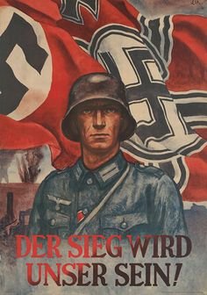](http://mrcolwellsworldhistoryclass.weebly.com/uploads/4/8/4/7/48478293/7546416_orig.jpg)[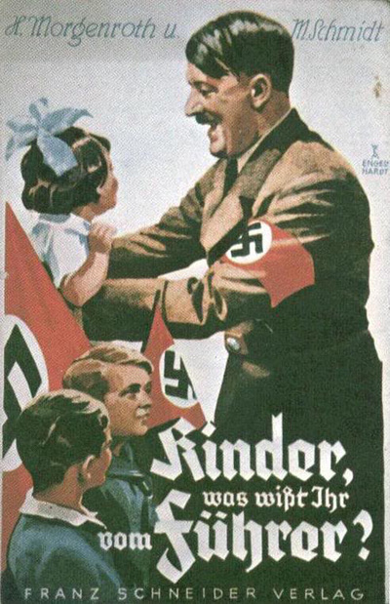](http://mrcolwellsworldhistoryclass.weebly.com/uploads/4/8/4/7/48478293/8394130_orig.jpg)Young children are sent away to Hitler Youth camps where they learn how to be good Nazi citizens, become members of the German army, and how to hate Jews and other undesirable races.

## Examples of USA Propaganda

**Main USA viewpoints**:

* You are a member of the Allied Powers:  you allies are Britain, France, and Russia.
* Your leader is President Franklin D. Roosevelt, better known as F.D.R.
  + He has been your president for 16 years (the longest anyone has ever been President of the United States).
* You value freedom, democracy, individual liberty, and the majority of you are Christian or believe in God in some form.
* Your women are entering the workforce to replace the men that went off to war. Children are collecting scrap metal and other resources to supply the war effort.  Everyone is encouraged to "do their part" for the war by buying war bonds, planting home gardens called victory gardens, and conserving resources.
* Your national mascot is Uncle Sam.  Your colors are red, white, and blue.
* Your enemies are the Japanese (who surprised attacked Pearl Harbor) and the Germans and Italians.
* [](http://mrcolwellsworldhistoryclass.weebly.com/uploads/4/8/4/7/48478293/2611580_orig.jpg)You think your nation is pretty awesome and that anyone would be lucky to live there. You think once again, you are going to go into the war and save the day (just like you did with WWI).  You believe Americans can do anything they put their minds to.

[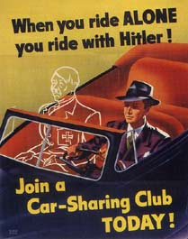](http://mrcolwellsworldhistoryclass.weebly.com/uploads/4/8/4/7/48478293/2035417_orig.jpg)

## Examples of BRITISH Propaganda

**Main British Viewpoints:**

* Members of the Allied Powers:  their allies are the French, Russia, America.
* Had to face Germany alone after France fell and before Russia and the USA entered the war.
  + survived the Battle of Britain and the London Blitz
* Leader is Winston Churchill. Many compare him to a bulldog which is also used as a symbol for the nation.  Considered fierce, loyal, and at times stubborn.
* Fought (and defeated) Germany in WWI.
* Encourages its citizens to help the war effort at home by saving resources, buying war bonds, supporting the troops, and having the women help in the workforce.
* Colors are navy blue, red, and white. Your flag is the union jack.
* You value freedom, individual rights, democracy, and the majority of you are either Catholic or Protestant (Christian).

[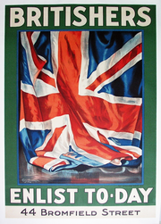](http://mrcolwellsworldhistoryclass.weebly.com/uploads/4/8/4/7/48478293/7316157_orig.png)[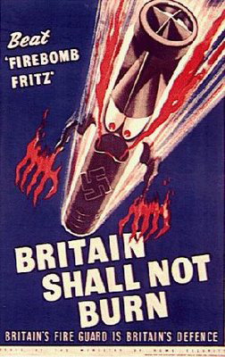](http://mrcolwellsworldhistoryclass.weebly.com/uploads/4/8/4/7/48478293/2295363_orig.jpg)

## Examples of JAPAN Propaganda

**Main Japanese viewpoints:**

* You are a member of the Axis Powers:  your allies are Germany and Italy.
* You are ruled by Emperor Hirohito, whom the Japanese worship as a god.  You believe he is a supreme being and that you must do whatever he says.
* Honor is very important to you!  You believe that it is better to kill yourself than be captured, or be dishonored in any way through defeat.
* You want to expand your empire just like Britain and America have done.  You call yourself the Empire of the Rising Sun.
* Your flag is red and white and has the outline of the sun on it.
* You value Japanese traditions, honor, family, the emperor, and your country.
* You dislike the Chinese, the Australians, the Americans, the British, and the Russians.  You think you should be able to establish your own colonies and empire just like other European nations have done so before.
* Your nation is highly militaristic and industrialized.
* A lot of your propaganda attacks "western" culture. You portray them as inferior, weak, dishonorable, and overly decadent.

[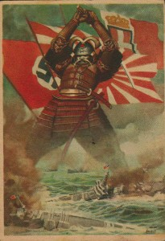](http://mrcolwellsworldhistoryclass.weebly.com/uploads/4/8/4/7/48478293/8989670_orig.jpg)[](http://mrcolwellsworldhistoryclass.weebly.com/uploads/4/8/4/7/48478293/3126679_orig.jpg)

|  |  |  |  |  |  |
| --- | --- | --- | --- | --- | --- |
|  | **SLOGAN** | **VIEWPOINT** | **VISUAL APPEAL** | **AUDIENCE** | **CONVENTIONS** |
| 10 points | The message of this poster is clearly identifiable | This poster clearly represents one of the viewpoints provided | The poster uses color, visual images, and words to clearly communicate the intended message. Poster is neat and visually appealing | The poster clearly and accurately represents the country assigned | The poster is free of grammatical and spelling errors that distract the reader from the content |
| 8 points | The message of the poster identifiable | This poster represents one of the viewpoints provided | The poster has color, visual images, and words to communicate the intended message. Poster is pleasing to eye | The poster represents the country assigned | The poster does not contain any grammatical and/or spelling errors that distract the reader from the content |
| 6 points | The message of the poster may or may not be identifiable | This poster may or may not represent a viewpoint provided | The poster makes some use of color, visual images, and words to communicate the intended message | The poster may or may not clearly and/or accurately represent the country assigned | The poster has some grammatical and/or spelling errors that distract from the content |
| 4 points | The message of the poster is not clearly identifiable | This poster does not represent one of the viewpoints provided | The poster hardly makes use of color, visual images, and words to communicate the intended message | The poster does not clearly and/or accurately represent the country assigned | The poster clearly has grammatical and/or spelling errors that distract from the content |
| 2 points | No clear message can be identified on the poster | This poster does not represent one of the given viewpoints provided | This poster does not use color, visual images, or words to communicate the intended message. Poster lacks visual appeal | There is no clear or accurate representation of the country assigned | The poster makes many grammatical and/or spelling errors that distract from the content |
| **TOTAL:** |  |  |  |  |  |