**Thermochemistry Notes**

**- Thermochemistry:**

- thermochemistry – study of heat changes during a chemical or physical

change

- energy is involved in ALL reactions!!

- energy—the ability to do work or supply heat

- potential energy—stored energy (chemical bonds)

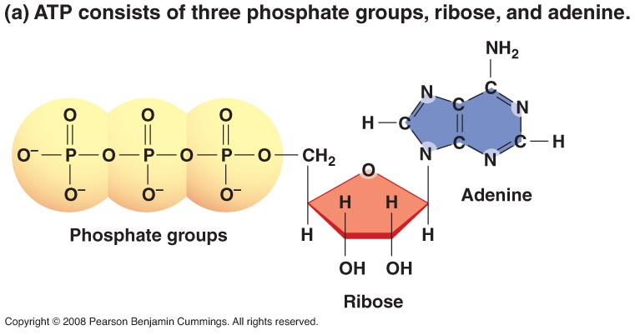

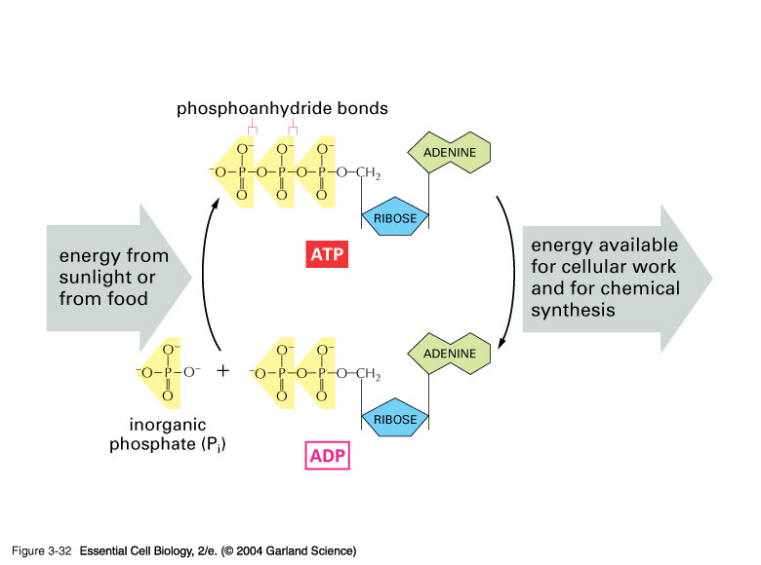

- kinetic energy—energy of motion (in chemistry this will usually be the

motion of particles of matter)

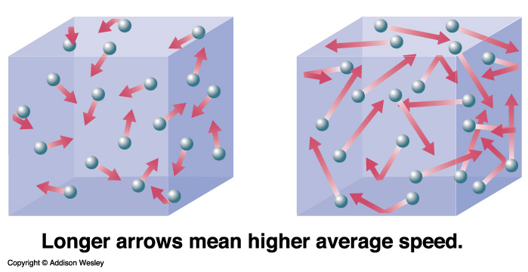

**- Heat and Temperature:**

- heat—energy that transfers from one object to another because of a

temperature difference between them

- heat is also defined as the SUM TOTAL of all the kinetic energies of all of

the particles in a sample of matter

- heat is a form of ENERGY and is typically measured in Joules (J) or calories

(cal)

- 1 cal = 4.184 J

- 1 Cal = 1,000 cal (nutritional calorie 🡪 a KILOcalorie!!)

- temperature—a measure of the AVERAGE kinetic energy of the particles

in a sample of matter

- heat is TOTAL ENERGY, temperature is AVERAGE energy!!!

- temperature is measured on a temperature scale (oF, oC, or K)

- heat and temperature are NOT the same thing, but they are closely

related (if heat increases, the temperature increases)

**- Thermodynamic Measurements:**

- system—the part of the universe that you are studying or focused on

- surroundings—everything else in the universe OUTSIDE of the system

- UNIVERSE = SYSTEM + SURROUNDINGS

- thermochemistry studies how heat flows between a system and its

surroundings

- heat always flows from the point of view of the SYSTEM!!!

- just like your checkbook, if you make a deposit of money it goes in as a

POSITIVE ($ goes IN) value in the check register and if you make a

withdrawal or pay by check it is written in the register as a NEGATIVE ($

comes OUT)

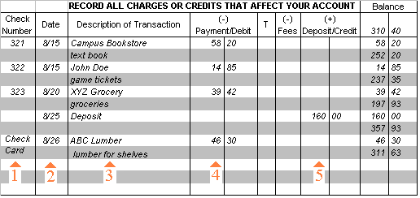

- ENDOTHERMIC—if the heat goes INTO the system then it is POSITIVE

(system gains heat) (q = (+))

- EXOTHERMIC—if the heat comes OUT of the system then it is NEGATIVE

(system loses heat) (q = (-))

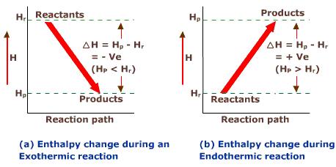

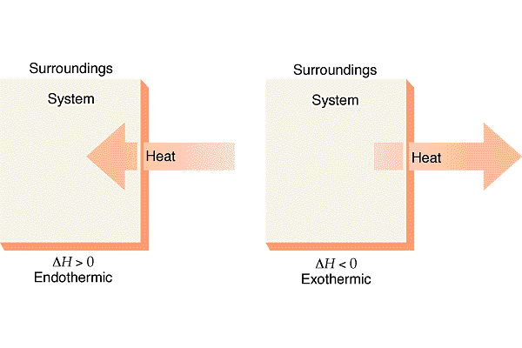

- **Specific Heat:**

- specific heat—the amount of heat needed to raise the temperature of

ONE GRAM of a substance by 1 Co

- measured in J/g·Co or cal/g·Co

- the higher the specific heat, the MORE heat a substance gains before it

changes temperature

- q = amount of heat gained or lost

- cp = specific heat

- m = mass

- ΔT = temperature difference = TFINAL – TINITIAL

**q = m cp ΔT**

(+) = (+) (+) (+)

(-) = (+) (+) (-)

- *Ex. Calculate how much heat is gained if 100. g of water increases in*

*temperature from 25oC to 75oC. The specific heat of water is 4.18 J/g·Co*

**q = ?? m = 100. g TI = 25oC TF = 75oC cp = 4.18 J/gCo**

- **Calorimetry:**

- calorimetry--the measurement of amounts of heat either absorbed or

released during a chemical or physical process

- uses a calorimeter

- measures heat by measuring what happens to the surroundings (water!!)

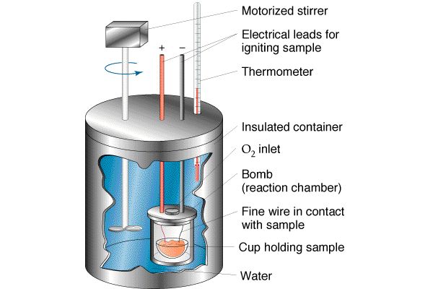

- can be used to measure a process by measuring what happens with the

water

- if the process in the reaction chamber (bomb) is ENDOTHERMIC then it

will absorb heat from the surroundings (water) and the water’s

temperature will DECREASE

- if the process in the reaction chamber (bomb) is EXOTHERMIC then it will

release heat to the surroundings (water) and the water’s temperature will   
 INCREASE

- since the calorimeter is ISOLATED from the outside (assuming no heat can

get in or out of the calorimeter itself) then ANY heat that is gained by the

system (bomb) had to come from the surroundings (water) or ANY heat

lost by the system (bomb) is going to be gained by the surroundings

(water)

**qSYS = – qSURR**

- so if the reaction LOSES 500J then the surroundings (water) GAINS 500J

- *Ex. How much heat is released when a 25 g pebble is heated and placed*

*into a calorimeter with 400. g of water at a temperature of 21.0oC if the*

*water reaches a maximum temperature of 24.5oC?*

**q = ?? mpebble = 25 g mwater = 400. g TI = 21.0oC TF = 24.5oC cpwater = 4.18 J/gCo**

**- Heats of Reaction:**

- thermochemical equation—an equation that includes the amount of heat

either absorbed or released during the reaction as it is written

- heat of reaction (∆Hrxn)—the quantity of heat absorbed or released during

a chemical reaction

- ∆Hrxn is a form of ENTHALPY (the heat content of a system at constant

pressure)

- only CHANGES in enthalpy can be measured (so ∆H instead of just H)

- enthalpy is a STATE FUNCTION (only depends on initial and final

conditions and is independent of the pathway)

- ENTHALPY CHANGE (∆H)—amount of heat absorbed or lost by a system

during a process at constant pressure

- ∆H = HPRODUCTS – HREACTANTS

- ∆H is (-) for EXOTHERMIC and (+) for ENDOTHERMIC

- for an EXOTHERMIC reaction, ∆H is (-) and the generic reaction would be

written as:

**A + B 🡪 C + D + energy**

- for an ENDOTHERMIC reaction, ∆H is (+) and the generic reaction would

be written as:

**A + B + energy 🡪 C + D**

- When using thermochemical equations:

1) the coefficients represent MOLES (so fractions are allowed!)

2) the state of matter (solid, liquid, gas) is important and should be

included in the thermochemical equation

3) the change in energy is directly proportional to the number of

moles of substances undergoing the change (if units are in kJ/mol

you must multiply by the number of moles!)

4) the ∆H value is not significantly affected by changing temperature

5) if a reaction is REVERSED, then ∆H has the OPPOSITE SIGN for the

reverse reaction

**- Types of values of ∆H:**

- there are many different measures of ∆H

- most of these measurements are named for the TYPE of reaction or   
 process that is being measured

- the important thing to remember is that is it STILL JUST ∆H!!!!

- no matter what the ∆H is called it is basically calculated the SAME way!!

- ∆HCOMBUSTION—the enthalpy of reaction for a COMBUSTION reaction

**CH4 + 2 O2 🡪 CO2 + 2 H2O + 890 kJ**

∆HCOMB = - 890 kJ/mol

- ∆Hf—the enthalpy of FORMATION of 1 mole of a compound from its

elements in their standard states

**Pb(s) + ½ O2(g) 🡪 PbO(s) + 217.3 kJ**

∆Hf = - 217.3 kJ/mol

- ∆HFUSION—the enthalpy change for a PHASE CHANGE from SOLID 🡪

LIQUID

**H2O(s) + 6.01 kJ 🡪 H2O(l)**

- ∆HFUSION for water is + 6.01 kJ/mol

- ∆HVAPORIZATION—the enthalpy change for a PHASE CHANGE from LIQUID 🡪

VAPOR

**H2O(l) + 40.79 kJ 🡪 H2O(g)**

- ∆HVAPRORIZATION for water is + 40.79 kJ/mol

- ***NOTE***: During a PHASE CHANGE, the TEMPERATURE stays the

same (all the heat added or released goes into changing the phase of

matter!!)

- no matter what the ∆H is called, it is all calculated the SAME WAY!!!

- **Thermochemical Reactions and Stoichiometry:**

- a BALANCED thermochemical equation may be used to determine the

amount of heat absorbed or released when certain amounts of

substances react or are formed in a chemical reaction

- the problem is set up like a regular stoichiometry problem, only the kJ are

used to go to from moles of another substance or vice versa

**2 NaHCO3(s) + 129 kJ 🡪 Na2CO3(s) + CO2(g) + H2O(l)**

- *Ex. How much heat in kJ is absorbed to decompose 250. g of NaHCO3?*

- *Ex. Calculate the TOTAL amount of energy in kJ that is required to take 100 g of*

*ICE at -20oC and completely convert it to STEAM (water vapor) at 110oC.*

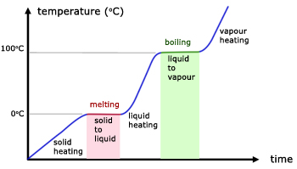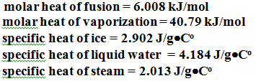

C

E

D

B

A

- **Calculating Heats of Reaction:**

- many values for ∆H are given in tables and charts to lookup

- thermochemical equations may be rearranged and added to give ∆H

values for those reactions that are NOT in tables or charts

- **HESS’S LAW: *The overall enthalpy change in a reaction is equal to the***

***SUM of the enthalpy changes for the individual steps in the process***

1) if a reaction is REVERSED, the SIGN of ∆H is OPPOSITE

2) multiply coefficients of known equations in order to get the

desired final equation (you must multiply ∆H by the same factor!!)

- *Ex. Calculate the* ∆H0f *for the following reaction:*

***C(s) + 2 H2(g) 🡪 CH4(g)***

*GIVEN: C(s) + O2(g) 🡪 CO2(g) ∆H0comb = -393.5 kJ/mol*

*H2(g) + ½ O2(g) 🡪 H2O(l) ∆H0comb = -285.8 kJ/mol*

*CH4(g) + 2 O2(g) 🡪 CO2(g) + 2H2O(l) ∆H0comb = -890.8 kJ/mol*

- The general relationship between standard heat of reaction and the

standard heats of formation is:

**∆H0 = SUM of ∆H0f PRODUCTS – ∆H0f REACTANTS**

- *Ex. Calculate the heat of reaction for the following reaction:*

***NO(g) + ½ O2(g) 🡪 NO2(g)***

*GIVEN: ∆H0f of NO(g) = +90.29 kJ/mol*

*∆H0f of O2(g) = 0.00 kJ/mol*

*∆H0f of NO2(g) = +33.2 kJ/mol*