**Bonding & Bonding Theories**

**- Chemical Bonds:**

- chemical bond—an attraction formed by the interaction of 2 atoms

through the sharing or transfer of ELECTRONS

- it is the VALENCE ELECTRONS that are involved in bonding

- valence electrons are the “s” and “p” electrons in OUTER energy level

- can tell the number of valence electrons for any main group element right

from the Periodic Table

- Group 1 = 1 valence electron

- Group 2 = 2 valence electrons

- Groups 13 – 18 = Group # - 10

- Transition metals (Groups 3 – 12) may have EXPANDED valences

(using “d” electrons as well!!)

- Lewis Dot Structures – show ONLY the valence electrons along with the

symbol (since these electrons are the ONLY ones involved in bonding!)

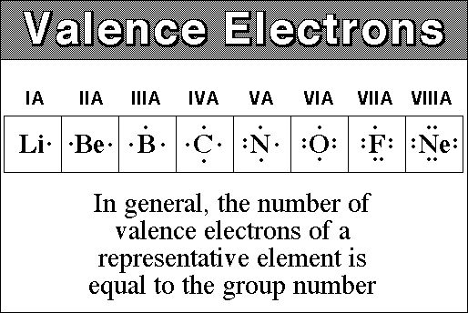

**- Ionic Bonds & Formation of Cations & Anions**

- Ionic Bond—formed from the complete transfer of electrons from a metal

to a nonmetal atom

- results in FULL (+) and (-) charges which gives a very STRONG attraction

- metals LOSE electrons and form CATIONS (+)

- Na 1s22s22p6**3s1** 🡪 Na+ 1s2**2s22p6** {now it has an OCTET!}

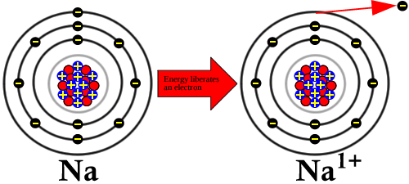

- nonmetals GAIN electrons to form ANIONS (-)

- Cl 1s22s22p6**3s23p5 🡪** Cl- 1s22s22p6**3s23p6 {now an OCTET!}**

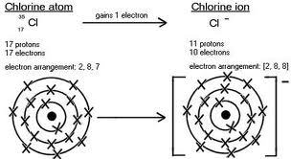

17 protons

18 electrons

- both the cation and anion that are formed have a STABLE OCTET like the

nearest Noble Gas but they are CHARGED!!!

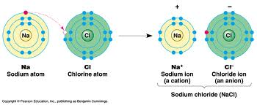

- the (+) and (-) ions are held together by a STRONG attraction

(electrostatic forces) called an IONIC BOND

- ionic compounds are made of CHARGED ions but they are overall

NEUTRAL (the (+) charge = the (-) charge!!)

- chemical formula—shows the SMALLEST whole number ratio for an ionic

compound

- formula unit—the lowest whole number ratio of ions in an ionic

compound

- ions of an ionic compound form a CRYSTAL LATTICE structure (systematic

arrangement of particles in a substance)

- ex. NaCl:

Each Na is surrounded by 6 Cl and each Cl is surrounded by 6 Na (so overall the ratio of Na:Cl is 1:1)

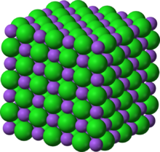

- in order for NaCl to form:

1) atomization of Na: Na(s) 🡪 Na(g) ΔH = +109 kJ

2) ½ bond energy of Cl2 Cl2(g) 🡪 2 Cl(g) ΔH = +243 kJ

3) ionization energy Na(g) 🡪 Na+(g) + e- ΔH = +496 kJ

4) electron affinity Cl(g) + e- 🡪 Cl-(g) ΔH = -349 kJ

5) lattice energy Na+(g) + Cl-(g) 🡪 NaCl(s) ΔH = -789 kJ

- notice we have to SPEND ENERGY (+) for steps 1,2 and 3 but

energy is RELEASED (-) for steps 4 and 5

- so overall the Heat of Formation of NaCl (ΔHf0) is:

***ΔHf0NaCl = ΔH0atom Na + ½ ΔH0BE Cl2 + ΔH0IE Na + ΔH0EA Cl + ΔH0LATTICE***

***ΔHf0NaCl =***  +109 kJ + ½ (243 kJ) + 496 kJ + (-349 kJ) + (-789 kJ)

***ΔHf0NaCl = - 411.5 kJ***

- Properties of Ionic Compounds:

1) form a crystal lattice (not molecules)

2) have very high melting and boiling points {most are SOLIDS}

3) good insulators

4) solid form does not conduct electricity

5) conduct electricity as a liquid or aqueous solution

- **Formation of Covalent Bonds:**

- covalent bond—formed by the sharing of a pair (2) electrons between 2

atoms that BOTH NEED electrons in order to form a stable octet

- usually happens with NONMETALS and METALLOIDS

- single covalent bond—formed by sharing ONE PAIR (2) electrons

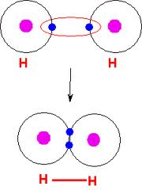

- double covalent bond—formed by sharing TWO PAIR (4) electrons

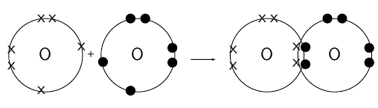 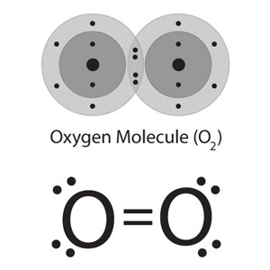

- triple covalent bond—formed by sharing THREE PAIR (6) electrons

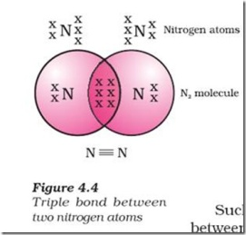

**- Types of Covalent Bonds:**

1) NONPOLAR covalent—formed by EQUAL sharing of electrons between

the 2 atoms

2) POLAR COVALENT—formed by UNEQUAL sharing of electrons between

the 2 atoms

- the atom that gets the electrons MORE OFTEN is partial (-) (δ-)

- the atom that gets the electrons LESS OFTEN is partial (+) (δ+)

- results in POLARITY in the bond (different charge at each end of the

bond)

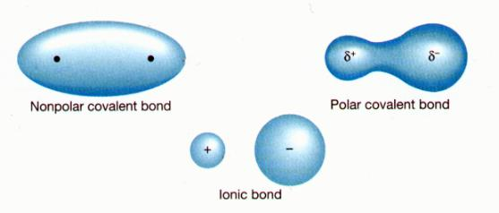

3) COORDINATE COVALENT—a covalent bond formed by sharing 2

electrons between 2 atoms where BOTH ELECTRONS come from the

SAME ATOM (not one from each!!!)

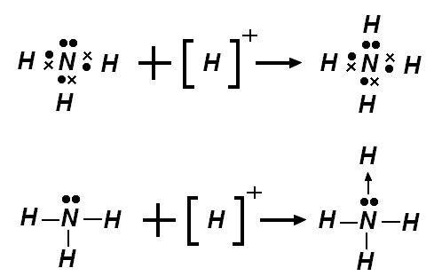

A coordinate covalent bond MAY BE nonpolar or polar!!!

It is just FORMED a different way!!

- **Bond Type and Electronegativity Difference:**

**-** Electronegativity—a measure of how much an atom wants to KEEP

electrons to itself when sharing/transfering them in a bond

- scale developed by Linus Pauling

- each element assigned a value from 0.7 – 4.0

- Noble gases have NO VALUES for EN (don’t form bonds!!)

- EN difference = ENA – ENB

- use the ABSOLUTE VALUE of EN difference and apply to the following

scale:

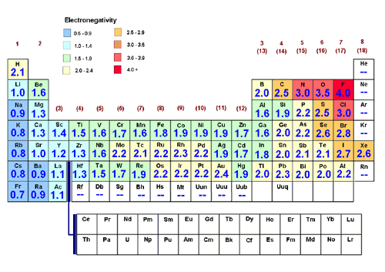

|  |  |  |
| --- | --- | --- |
| **NONPOLAR** | **POLAR** | **IONIC** |

0.0 0.3 1.7 4.0

- *Ex. What kind of bond is between the following??*

*A. I and I*

*B. Na and Cl*

*C. H and Br*

- **Drawing Structural Formulas:**

- structural formula—shows the ARRANGEMENT of atoms in a molecule

(atoms, bonds and lone pairs of electrons)

- atoms are represented by the element SYMBOL

- bonds are represented as DASHED LINES ( --, = or ≡)

- lone pairs of electrons represented as pairs of DOTS

- Rules for Drawing Structural Formulas: (***ex: CH3Cl***)

- STEP 1: Determine the NUMBER of atoms of each element from

the MOLECULAR FORMULA

**CH3Cl = 1 C, 3 H and 1 Cl**

- STEP 2: Draw the Lewis Dot Structure for each different ELEMENT

in the formula

**C H Cl**

- STEP 3: Calculate the TOTAL NUMBER of valence electrons in the

molecule (THIS WORK MUST BE SHOWN!!)

**C: 1 x 4e- = 4e-**

This means that the FINAL DRAWING MUST have 14 ELECTRONS – no more, no less!!!

**H: 3 x 1e- = 3e-**

**Cl: 1 x 7e- = 7e-**

**-----------------------------------**

**14e-**

- STEP 4: Connect the Lewis Structures together and share electrons

to connect them by BONDS (the LEAST EN atom should go in the

center!!)

**H**

Carbon is the LEAST EN (and it has 4 single dots!!) H and Cl only have ONE single dot—they will NOT be in the center!! (only on the ends!)

**H C Cl**

**H**

- STEP 5: Move electrons around to make sure that EACH ATOM has

an OCTET (or H has 2)

- all atoms have an octet already (H has 2)

- STEP 6: Count the TOTAL number of electrons in your drawing

(each – line is 2 electrons and each DOT is 1 electron). Make sure

that this is the SAME number as the total calculated in step 3!!

4 dashes = 4 x 2 = 8e- + 6 dots (6e-) = 8 + 6 = 14e-

|  |  |  |  |  |  |
| --- | --- | --- | --- | --- | --- |
| **Group** | **Example Element** | **# of Valence e- (# of dots)** | **# of SINGLE dots (not paired up)** | **# of e- NEEDED for an OCTET (or 2)** | **# of BONDS FORMED** |
| 1 | H | 1 | 1 | 1 | 1 |
| 14 | C | 4 | 4 | 4 | 4 |
| 15 | N | 5 | 3 | 3 | 3 |
| 16 | O | 6 | 2 | 2 | 2 |
| 17 | F | 7 | 1 | 1 | 1 |
| 18 | Ne | 8 | 0 | 0 | 0 |

**- Molecular Polarity & Geometry:**

- the polarity of a BOND is determined by the EN DIFFERENCE of the 2

atoms

- the polarity of a MOLECULE is determined by:

1) the TYPES of bonds (polar vs. nonpolar)

2) the GEOMETRY (SHAPE) of the molecule

- in general, if a molecule is made of ALL NONPOLAR bonds, then the

molecule is NONPOLAR!!

- however, the same is NOT necessarily true of POLAR bonds!! (depends on

the SHAPE!!)

- VSEPR Theory (Valence Shell Electron Pair Repulsion)

- the shape (geometry) of a molecule is determined by the

interaction of valence electrons that are involved in bonding and

nonbonding electrons all trying to maximize their distance from

each other

- according to VSEPR theory, the shape of the molecule is

determined by:

1) number of atoms bonded to the CENTER atom (called

LIGANDS)

2) number of LONE PAIRS of electrons on the CENTER atom

- diatomic molecules – made of ONLY TWO atoms (no center!!) are

ALL LINEAR!!

|  |  |  |  |  |  |  |  |
| --- | --- | --- | --- | --- | --- | --- | --- |
| **Structure** | **Formula** | **VSEPR** | **# of LIGANDS** | **# of LONE PAIRS on CENTER** | **SHAPE** | **Valence Bond hybridi-zation** | **Bond Angles** |
| O=C=O | CO2 | AB2 | 2 | 0 | Linear | **sp** | 180 |
| ..  Sn  Cl Cl | SnCl2 | AB2E | 2 | 1 | Bent | **sp2** | 109 |
| .. ..  O  H H | H2O | AB2E2 | 2 | 2 | Bent | **sp3** | 105 |
| F  B  F F | BF3 | AB3 | 3 | 0 | Trigonal Planar | **sp2** | 120 |
| ..  N  H H  **H** | NH3 | AB3E | 3 | 1 | Triangular Pyramid | **sp3** | 107 |
| .. ..  F Cl F  F | ClF3 | AB3E2 | 3 | 2 | T-Shaped | **sp3d** | 90 & 180 |
| H  C  H H  **H** | CH4 | AB4 | 4 | 0 | Tetrahedral | **sp3** | 109.5 |
| ..  F S F  F **F** | SF4 | AB4E | 4 | 1 | See-Saw | **sp3d** | ~108 |
| F .. F  Xe  **F** .. **F** | XeF4 | AB4E2 | 4 | 2 | Square Planar | **sp3d2** | 90 |
| Cl  Cl  Cl P  **Cl**  Cl | PCl5 | AB5 | 5 | 0 | Triangular Bipyramidal | **sp3d** | 90, 120 and 180 |
| F  F F  Br  **F .. F** | BrF5 | AB5E | 5 | 1 | Square Pyramidal | **sp3d2** | 90 |
| F  F F  S  **F F**  F | SF6 | AB6 | 6 | 0 | Octahedral | **sp3d2** | 90 |

**- Hybridization of orbitals:**

- hybrid orbital—formed by a combining of multiple orbitals from sublevels

that are very close in energy

- result is a MIX of energies and orbital shapes (HYBRID)

- hybridizations are named after ALL of the orbitals that actually combine

together to form the new hybrid sublevel

1) sp hybridization – combines 1 “s” and 1 “p” orbital

- linear shape

- 180o bond angle

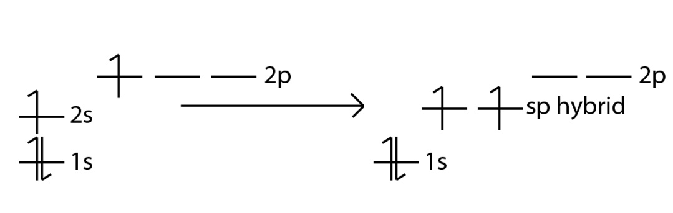

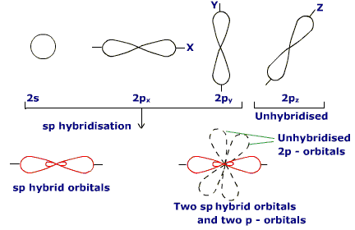

2) sp2 hybridization—combines 1 “s” and 2 “p” orbitals

- triangular planar shape

- 120o bond angles

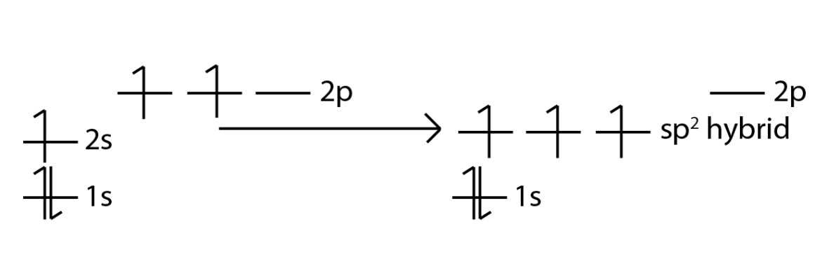

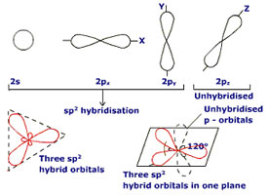

3) sp3 hybridization—formed by combining 1 “s” and 3 “p” orbitals

- tetrahedral shape

- 109.5o bond angles

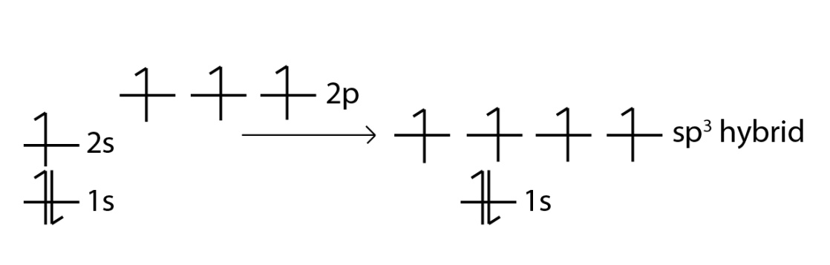

[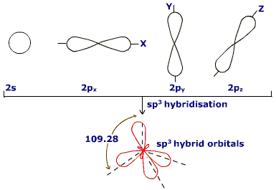](http://www.goiit.com/posts/downloadAttach/23267.htm)

4) sp3d hybridization—combines 1 “s”, 3 “p” and 1 “d” orbitals

- Triangular Bipyramid shape

- 90o and 120o bond angles

- can ONLY happen with 3RD PERIOD elements or higher!!!

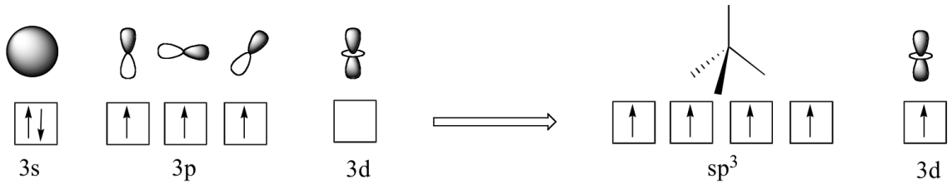

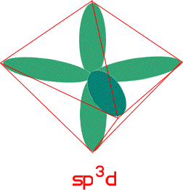

5) sp3d2 hybridization—combines 1 “s”, 3 “p” and 2 “d” orbitals

- octahedral shape

- 90o bond angles

- can ONLY happen with 3rd PERIOD elements or higher!!

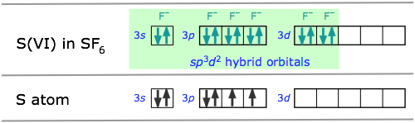

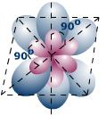

**- Intermolecular forces:**

- intermolecular force—forces of attraction or repulsion BETWEEN 2

molecules

- categorized by the TYPE of molecules that are involved

1) Dipole – Dipole:

- 2 polar molecules

- ex. HCl

[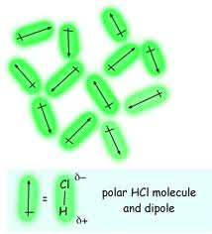](http://www.google.com/imgres?q=dipole-dipole+attractions&hl=en&safe=active&biw=1024&bih=532&tbm=isch&tbnid=5VCqvU6b4pji7M:&imgrefurl=http://pegasus.cc.ucf.edu/~jparadis/chem2046/outline11.html&docid=9KkRf6M7uBH__M&imgurl=http://pegasus.cc.ucf.edu/~jparadis/chem2046/weekly%2520pics/dipole%2520dipole.gif&w=269&h=297&ei=QEAgT472DuHc0QGF3bD0Aw&zoom=1)

2) Hydrogen Bonding:

- special case of dipole – dipole

- δ+ HYDROGEN from ONE molecule attracted to a LONE PAIR

of electrons on a (δ-) O, F, or N on ANOTHER molecule

- ex. H2O

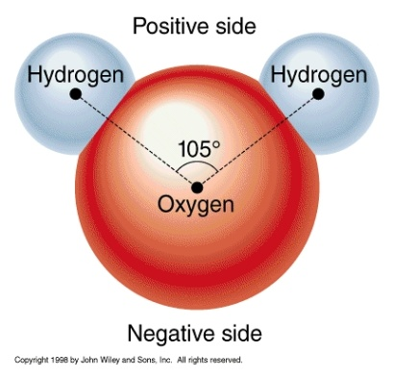 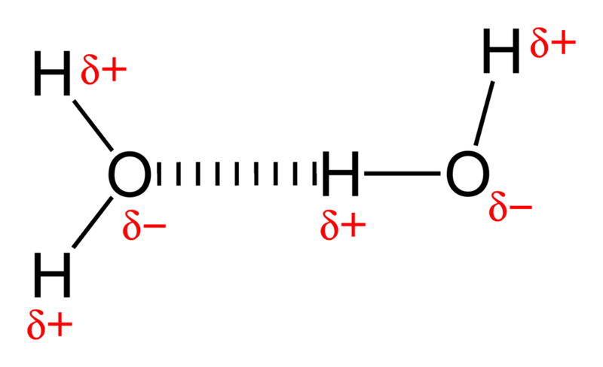

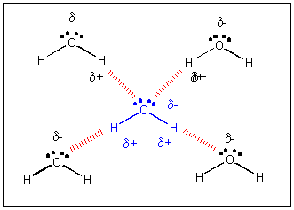

3) Dipole – Induced Dipole:

- a POLAR and NONPOLAR molecule

- the polar molecule INDUCES a dipole on the nonpolar

(because of proximity) and then the attraction occurs

- Ex. HCl and I2

[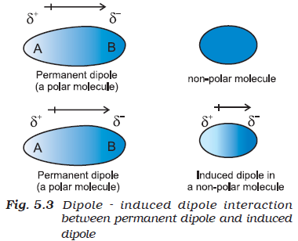](http://textbook.s-anand.net/wp-content/uploads/2011/03/fig5.3.png)

4) Induced Dipole – Induced Dipole (van der Waals Forces)

- 2 non polar molecules

- a temporary induced dipole on ONE molecule then induces a

dipole on a second molecule that is close by

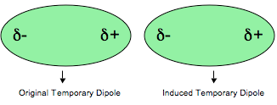

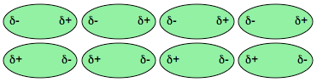

**- Properties Of Molecules:**

1) covalent bonds in molecules are WEAKER than ionic bonds

- these covalent bonds are STRONG (but weaker than ionic!!)

- also the covalent bonds are only WITHIN the molecule

- molecules are held together (to each other) by VERY WEAK

intermolecular forces

2) molecules have LOWER MELTING and BOILING POINTS than ionic

compounds

- when a molecule melts or boils, the molecules are simply separated

from each other (VERY WEAK intermolecular forces are broken…but

the STRONG COVALENT bonds holding the molecule’s ATOMS

together STAYS INTACT!!)

- when ice melts (or water boils) it is STILL THE SAME

MOLECULE!!! (H2O)

3) molecules do NOT have ions (no full CHARGES)

- most molecules will NOT conduct electricity

- although the molecules themselves will NOT conduct electricity,

when POLAR molecules are dissolved in aqueous solution they will

slightly conduct electricity (but NOT as good as ionic compounds!!)

4) only SOME molecules will dissolve in water

- LIKE DISSOLVES LIKE (water is polar so it will dissolve most ionic

compounds and polar molecules…but NONPOLAR molecules like oil

will NOT dissolve in water!!)

**- Metallic Bonding:**

- metallic bond—strong attractive force between IONS of a metal and the

delocalized “ELECTRON SEA” of free flowing electrons throughout the

metal substance

- the atoms of the metal do not technically form “IONS” (electrons actually

move or share between overlapping orbitals of adjacent metal atoms that

form an interconnected “network” which delocalize the electrons)

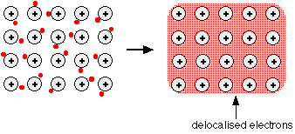

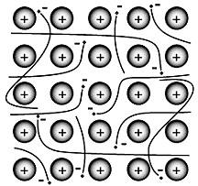

**- Properties Of Metals:**

- all of the properties of metals can be explained by metallic bonding

1) GOOD CONDUCTORS of heat and electricity

2) HIGH melting and boiling points

3) luster – shiny

4) malleable – can be hammered into thin sheets

5) ductile – can be drawn into thin wires